Australian Jobs 2025

Acknowledgement of Country
The Department of Employment and Workplace Relations acknowledges the Traditional Owners and custodians of country throughout Australia and acknowledge their continuing connection to land, water and community. We pay our respects to the people, the cultures and the elders past and present. The Department of Employment and Workplace Relations acknowledges diversity and respectfully uses the term ‘Aboriginal and/or Torres Strait Islander’ throughout the publication.
ISSN 1832-7230 [PRINT] 2205-5371 [ONLINE]

With the exception of the Commonwealth Coat of Arms, the Department’s logo, any material protected by a trade mark and where otherwise noted all material presented in this document is provided under a Creative Commons Attribution 4.0 International (https://creativecommons.org/licenses/by/4.0/) licence.
The details of the relevant licence conditions are available on the Creative Commons website (accessible using the links provided) as is the full legal code for the CC BY 4.0 International (https://creativecommons.org/licenses/by/4.0/legalcode)
The document must be attributed as the Australian Jobs 2025.
Contents
Introduction 6
Your career journey 8
Job searching and skills development 9
What are jobs advertised? 9
What do employers look for? 12
Winning the job 14
Education and training options 17
Vocational Education and Training 20
Australian Apprenticeships 24
Higher Education 26
Skills for the future 29
Jobs and Skills Councils 31
What are the Jobs and Skills Councils? 31
BuildSkills Australia 33
Future Skills Organisation 34
HumanAbility 36
Industry Skills Australia 37
Manufacturing Industry Skills Alliance 39
Mining and Automotive Skills Alliance 40
Powering Skills Organisation 42
Public Skills Australia 43
Service and Creative Skills Australia 45
Skills Insight 46
Jobs by location 48
National employment overview 48
New South Wales 50
Victoria 52
Queensland 54
South Australia 56
Western Australia 57
Tasmania 59
Northern Territory 60
Australian Capital Territory 62
Jobs by industry 64
Industry overview 65
Health Care and Social Assistance 70
Education and Training 72
Construction 74
Manufacturing 76
Professional, Scientific and Technical Services 78
Financial and Insurance Services 80
Retail Trade 82
Wholesale Trade 84
Mining 86
Agriculture, Forestry and Fishing 88
Accommodation and Food Services 90
Arts and Recreation Services 92
Transport, Postal and Warehousing 94
Electricity, Gas, Water and Waste Services 96
Administrative and Support Services 98
Public Administration and Safety 100
Information Media and Telecommunications 102
Rental, Hiring and Real Estate Services 104
Jobs by major occupational group 106
Occupational overview 107
Managers 110
Professionals 112
Technicians and Trade Workers 114
Community and Personal Service Workers 116
Clerical and Administrative Workers 118
Sales Workers 120
Machinery Operators and Drivers 122
Labourers 124
Occupation Matrix 126
Guide to the Occupation Matrix 126
Useful websites and links 148

Introduction
Welcome to the 2025 edition of Australian Jobs, a celebration of 30 years of labour market insights!
For 3 decades, this publication has provided an overview of the Australian labour market to support young people, job seekers, employment service providers, career practitioners, those considering future training and people interested in the pulse of the Australian workforce.
For 30 years, Australian Jobs has been informing diverse readers about changes in occupations, industries and the skills of our labour market. From technological advancements to shifts in workplace culture, workforces across the country are constantly transforming. Australian Jobs 2025 isn’t just reporting on the current labour market – this publication also looks to the future of work in Australia, empowering individuals and organisations to navigate the workforce of tomorrow.

How to use Australian Jobs
Australian Jobs 2025 is designed to step you through all aspects of the labour market. It is more important than ever to understand what employers are looking for and to gain an understanding of the labour market as you navigate a career.
The publication opens with advice on how employers advertise job vacancies and what they are looking for in their ideal candidate. There is information on applying for jobs and how to navigate the interview process. If you are weighing up education and training options, you will find information on vocational education and training (VET), Australian Apprenticeships, as well as university. This is followed by an exploration of emerging skills in the workforce that are transferrable between different occupations.
This year features a section highlighting new skills employers want and the interesting work offered by a range of careers, contributed by the Jobs and Skills Councils (JSCs), which are strengthening industry’s role in shaping Australia’s VET sector.
The second half of the publication includes analysis from Jobs and Skills Australia (JSA) providing an overview of Australia’s diverse labour markets, with detail provided for each state and territory. Comprehensive analysis outlining employment opportunities across industries and occupations is also provided by JSA, illustrating the diversity of our labour market.
It is important to remember the labour market can change quickly. It isn’t easy to forecast future labour market conditions and it isn’t recommended to base employment and training decisions only on projected or current shortages. Sometimes job seekers can still face significant competition for positions in high demand. Conversely, employers can have difficulty recruiting for occupations which have limited growth or are in decline.
It is far better to train in an area in which you have an interest and aptitude than to choose a career solely based on expectations about future conditions.

If after reading this publication you want more detailed information, the following websites are available:
- Jobs and Skills Australia (jobsandskills.gov.au) for detailed labour market data.
- Department of Employment and Workplace Relations (dewr.gov.au) for information on government programs on skills, training, employment and workplace relations.
- Workforce Australia (workforceaustralia.gov.au) is a place Australians can search and apply for jobs or find more information on their pathway to employment.
- Your Career (yourcareer.gov.au) for careers information and resources and where Australian Jobs is available for download.
Inquiries about Australian Jobs 2025 should be directed to yourcareer@dewr.gov.au
The contents of Australian Jobs 2025 are based on information available at the time of publication. Over time, the currency of the data and analysis may diminish. The Commonwealth, its officers, employees and agents do not accept responsibility for any inaccuracies contained in the report or for any negligence in the compilation of the report and disclaim liability for any loss suffered by any person arising from the use of this report. Labour market information must be used cautiously as employment prospects can change over time and vary by region.
It is important in making and assessing career choices to consider all factors, including interest and aptitudes, remuneration and expectations, and the requirements of occupations.

Your career journey
Are you thinking about what tertiary education and training options are right for you?
Are you ready to redefine your career path and explore new directions?
Are you looking for information about what industries and occupations are out there?
No matter what stage you are at in your education, training or career journey, now is the perfect time to consider your options. The future is brimming with potential, and your next move could lead to opportunities that align with your passions and ambitions.
Change can be challenging, but you don’t have to navigate your journey alone!
yourcareer.gov.au
The home of career information.
There has never been a more important time for people to have access to reliable information about education, training and work pathways. Your Career is an Australian Government website, designed to help people of all ages and circumstances better plan and manage their career. Information and data on Your Career is evidence based and comes from trusted sources like Jobs and Skills Australia, the Australian Bureau of Statistics, the National Centre for Vocational Education Research and up to date course and provider details from training.gov.au.

Career information can be overwhelming, so we have made it simple.
On Your Career, you can:
- find occupations based on your skills and interests
- complete a career quiz to start your career journey or to explore options later on in life
- search study and training options in the VET sector that meet your career goals
- access information and links to support services
- read real life case studies and training highlights from the Australian VET Alumni
- find resources and information guides to support careers conversations
- find out about news and events on the What’s New page.


Job searching and skills development

What are jobs advertised?
The first step on the road to employment is to find out what jobs are available. Employers use a number of methods to advertise their job vacancies and find candidates. JSA surveys employers on a range of topics, including the recruitment methods they use. Common ways employers advertise job vacancies include on the internet, through recruitment agencies, and newspapers.
Unsurprisingly, employer surveys suggest newspaper usage has declined significantly in the last decade or so. There is a growing trend to recruit using social media, especially region-based or industry-based Facebook job groups, which are an inexpensive way for employers to post vacancies.

It’s important to know not all positions are advertised! Another popular method employers use is ‘word of mouth’, asking existing employees, friends, or family members if they know anyone who may be interested in the position. They may also approach people directly about job opportunities. JSA’s research suggests over a quarter of all employers used word of mouth to fill positions. Telling friends, family contacts, schoolteachers or neighbours that you are looking for work can help improve your chances of hearing about a job opening or being recommended for one when an opening occurs.

Don’t forget social media is a perfectly good way to contact employers in some sectors too! However, don’t ask for a job straight away – send a short message about what work, education and training you have been doing, let them know you are looking to start working or move on from your previous job, and ask for some advice or insight. This way, if whoever you tell does become aware of an opportunity, they will be more likely to think of you. But take care! There are scammers who target job seekers online. If the message or email doesn’t look right, or if it sounds too good to be true, delete the message.
HOT TIP: Meeting and talking to employers is a chance to make a good impression. Showing enthusiasm in person gives you a better chance at a job over someone who simply drops off their resume.
HOT TIP: Ask friends, family and former co-workers if they know of any work available. Over a quarter of all employers used word of mouth to promote their positions in 2024.
HOT TIP: Make sure your public social media profile is presentable! Employers often look at profiles to review potential employees.
*In the employer’s most recent recruitment activity within the previous month
JSA, Recruitment Experiences and Outlook Survey, 2024; JSA, How employers recruit, July 2024

Methods of recruitment differ between city and regional areas
Recruitment methods can differ significantly depending on where the employer or vacancy is located. Internet job boards are more popular in Australia’s major cities than regional areas:
- in major cities, 64% of recruiting employers used internet job boards
- in regional areas this was just over half (55%) of recruiting employers.
However, regional employers tend to use social media and word of mouth more than in the cities:
- in regional areas, 31% of employers used social media and 33% used word of mouth
- in major cities, 16% used social media and 25% used word of mouth.
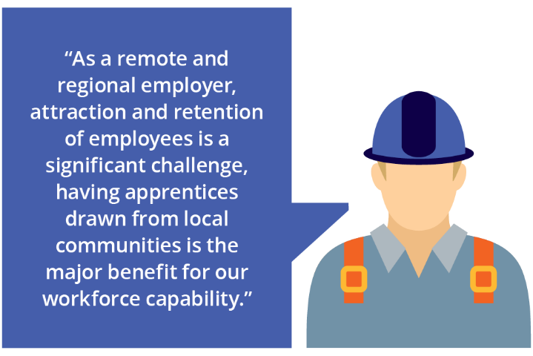

Recruitment methods used by employers, by capital city and rest of state, 2024
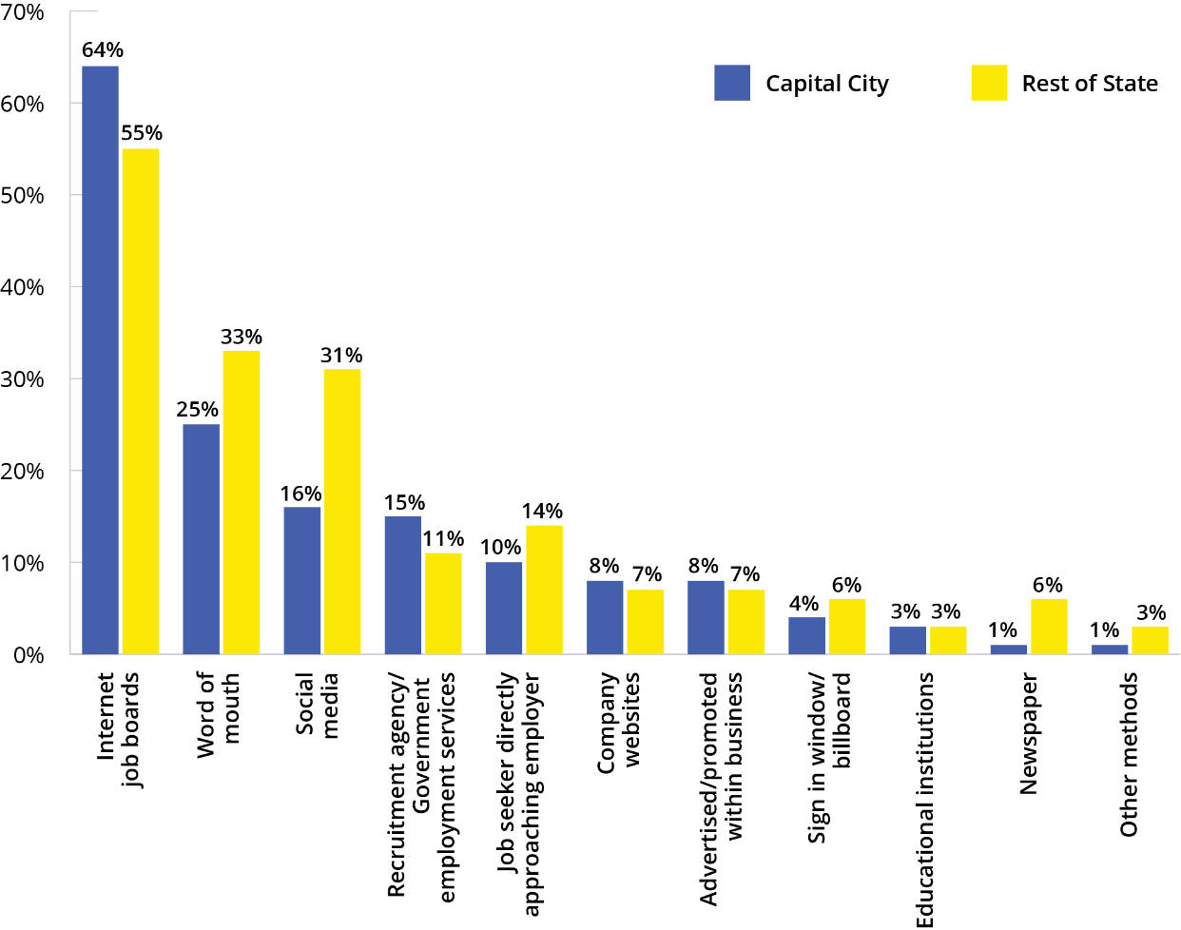
Note: Employers can report multiple methods so numbers will not add to 100%.
JSA, Recruitment Experiences and Outlook Survey, 2024

What do employers look for?
When recruiting, employers are looking for a person who is the right fit for their job and business. Generally, employers are looking for someone with a range of qualities: the right qualifications and/or work experience, and employability skills!
Employers may be willing to compromise on some aspects, depending on the type of job, but not on others. For example, an employer may hire someone as a Checkout Operator without any work experience but will insist on employability skills like good teamwork and communication skills.
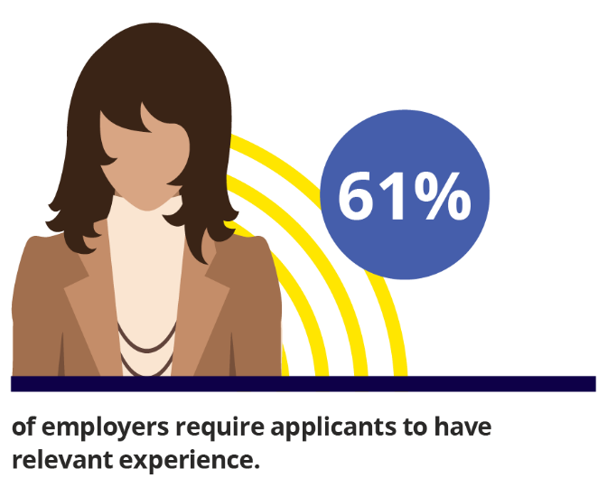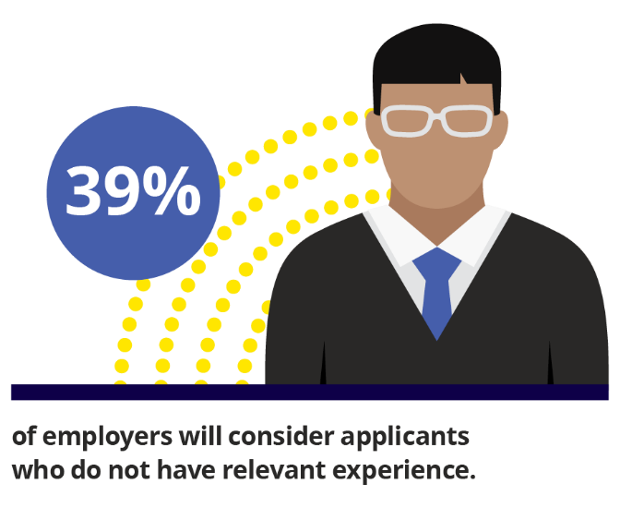

Qualifications
Overall, work is becoming more highly skilled, and most of the jobs in the future will require a vocational education and training (VET) or university qualification.
JSA employment projections suggest that over 90% of employment growth over the next 10 years will require post-secondary-school training and education. While there are jobs at all skill levels, labour market outcomes improve for those that have post-school education.
In 2024, 69% of Australians aged 15 to 74 years held, or were currently studying, post-school qualifications. This is up from 63% a decade ago.
Importantly, university is not the only pathway to a good job. Apprenticeships, traineeships, diplomas, or Certificate III or IV level qualifications are all good options that will also set you up for a stable and rewarding career.
If you are considering a qualification, the best type of training is related to the job you want to do. You can find information on your options in the Education and Employment section starting on page 17.

Work Experience
All jobs will give you valuable work experience and help you develop vital employability skills. As well as role specific skills, you will also gain an understanding of what is expected in the workplace and be able to demonstrate to employers that you are committed to work, reliable and trustworthy. Importantly, it gives you a foot in the door and provides you with an opportunity to build your network and gain referees. Experience can be gained through part-time, casual, or temporary jobs, work experience placements, and internships.
What if you don’t have any work experience?
If you don’t have any work experience, think about other ways to demonstrate you have the skills employers are looking for. You could provide examples from your school activities or group projects, working with your local sports club, even participating in debating, theatre, dance performances or chess competitions. Employers are also very encouraged by young people who participate in the community or volunteering activities.
Employment Projections produced by Victoria University for Jobs and Skills Australia (May 2024 to May 2034); ABS, Education and Work, 2024
Proportion of recruiting employers who did not require relevant work experience, selected occupations, 2024
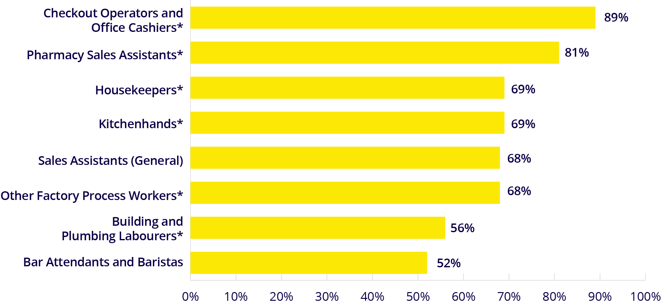
* Result based on a small number of records and should be used with caution

Employability Skills
Employability skills are the basic building block skills common across most jobs and include a set of
non-specialist skills gained in early life and schooling. They provide a base to further develop skills and specialties. Communication, teamwork and problem-solving skills are all examples of employability skills. Popular terms for these include ‘foundation skills’, ‘soft skills’, ‘personal skills’, ‘core competencies’ and ‘21st century skills.’
Employers often place a high value on these as they want someone who will be a good fit for their business. While you can gain these skills through work experience, they are not job-specific and transfer across different occupations and industries.
JSA, Recruitment Experiences and Outlook Survey, 2024

Winning the job

Talk to employers
Approaching employers directly to ask if they have any positions available can also lead to a job and can make you stand out amongst other job seekers who just drop off their resume. This lets you show your communication skills, initiative and motivation – traits that many employers are looking for. This can be a daunting prospect for many, however, it can be an opportunity to have a conversation and make a lasting impression if you are well presented and prepared.


Writing your job application and resume
Your resume and application are often your first chance to market yourself to potential employers. To improve your chances of reaching the next stage in the recruitment process, your application will need to stand out.
Before you start, research the business so you can tailor your application and show your interest in the position. This may include ringing the employer to ask questions about the job to help you understand the position and demonstrate your enthusiasm. Talking directly to the employer may mean they will look out for your application.
Tips for writing your application:
- Make sure you read any instructions or guidelines about how to apply for the job carefully and follow them accurately.
- Keep your application and resume succinct and around 1–2 pages each.
- Include examples from your current job, work history or extracurricular activities and explain how these directly relate to the position on offer to demonstrate your skills and experience.
- Double and triple-check that there are no spelling or grammatical errors in your application.
Every job and business is different, so write your application specifically for each job. Employers want the right match for their business and showing that you have read the job description carefully and researched their organisation will help set you apart from other candidates.
More advice on writing resumes and job applications can be found at workforceaustralia.gov.au.

Get ready for the interview: prepare, plan, practise and presentation
The interview is usually the second stage of marketing yourself and landing a job and is considered the most important step of the recruitment process by 77% of employers. Interviews can be nerve-wracking, but some preparation beforehand can really help you stand out. What employers are mostly looking for is your approach and attitude to work (49%) and your cultural fit, personality and presentation (43%). Some good ways to prepare for an interview include:
- Practise interview questions with a friend or family member.
- Prepare some questions about the job and business to ask at the interview. This demonstrates your interest and shows that you are prepared.
- Think about your presentation and what you will wear. Remember, first impressions count!
- Don’t be late! Find out where you need to be, plan your trip and aim to arrive about 10 minutes early.
- Explain the skills that you would bring to the job (including your employability skills) using examples from previous experience.
Employers want to know who they will be working with and the interview is your opportunity to demonstrate this.

JSA, How employers recruit, July 2024

What if your approach is not working?
You may need to consider:
- Whether your expectations are realistic – you may need to show you are willing to work your way up from the bottom.
- Widening your search to different types of jobs, locations and industries.
- Applying for contract or casual work, part-time or shift work.

Don’t be afraid to ask for feedback if you are unsuccessful. Many employers will tell you why you didn’t get the job. With each application and interview you gain experience you can use to improve your job search skills. It is all part of the job search experience.
Looking for a job is hard work and can be competitive. It can take a while to secure a position and you may receive knockbacks in the process, but if you keep trying, your efforts will pay off.
The jobs market is constantly evolving. We now see many opportunities available in the health and care sector, in IT and software development jobs, in the education and training sector and in construction and trades roles (more information on these industries can be found from page 64).
The key message is to think broadly: the perfect opportunity may be waiting, but it could be in a role you hadn’t considered before! But remember, whether it is a short-term job or one that is part of your long-term career plan, all jobs provide valuable skills, experience and give you references for the future.
What employers look for:
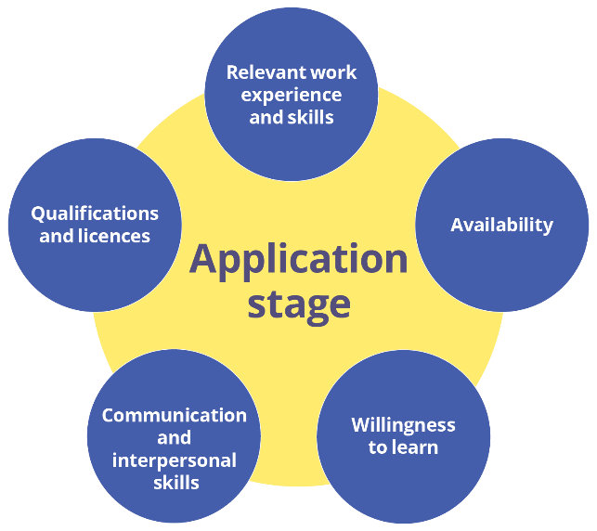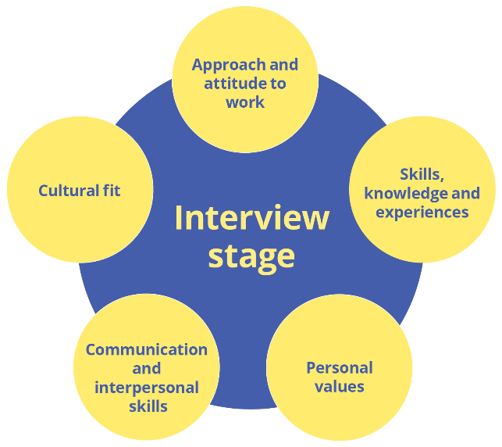
JSA, How employers recruit, July 2024

Education and training options
There are many options for education and training – whether you are leaving school or are entering or re-entering the workforce at an older age. For some people, the thought of further study is exciting, but for others it isn’t a favoured choice. On page 148, you will find a range of websites with information about support that can help you on your journey.
If you are considering gaining additional, post-school qualifications, there are 2 main training pathways for you to consider:
- The VET system develops workplace-specific skills and knowledge by delivering nationally recognised training. VET includes publicly owned TAFE institutes, private providers (including enterprise and industry providers), community organisations and schools. It provides training for a vast array of occupations, including highly skilled Technician and Trades Worker roles.
  - Australian Apprenticeships are a part of the VET system, and offer an opportunity to learn through practical work experience and formal training.
- Australia’s higher education system is made up of universities and other institutions that offer undergraduate degrees and higher qualifications. Higher education is the pathway to a range of jobs, including many of the most highly skilled professional occupations.
Employment and training decisions should be based on a variety of factors including aptitude, interests, expectations of pay and working conditions, and career goals.

Educational attainment is rising
The number of people undertaking tertiary training is increasing and more of the workforce now holds post-school qualifications.
In 2024, 69% of Australians aged 15 to 74 years held, or were currently studying, post-school qualifications. This is up from 63% a decade ago.

Post-school qualifications are beneficial in today’s job market
People with higher level qualifications generally have better employment outcomes than those who have not completed further education after leaving school.
Of jobs currently being advertised:
- Almost 90% require post-school qualifications.
- Around 50% require a VET qualification.
- Almost 40% require a Bachelor degree or higher.
As well as better employment outcomes, higher qualifications also generally lead to increased wages. Some lower skill level occupations are an exception with relatively high pay to compensate for unsociable working hours or difficult working conditions.

Unemployment rates, persons aged 25–34, by highest level of education, Australia, 2024 (%)
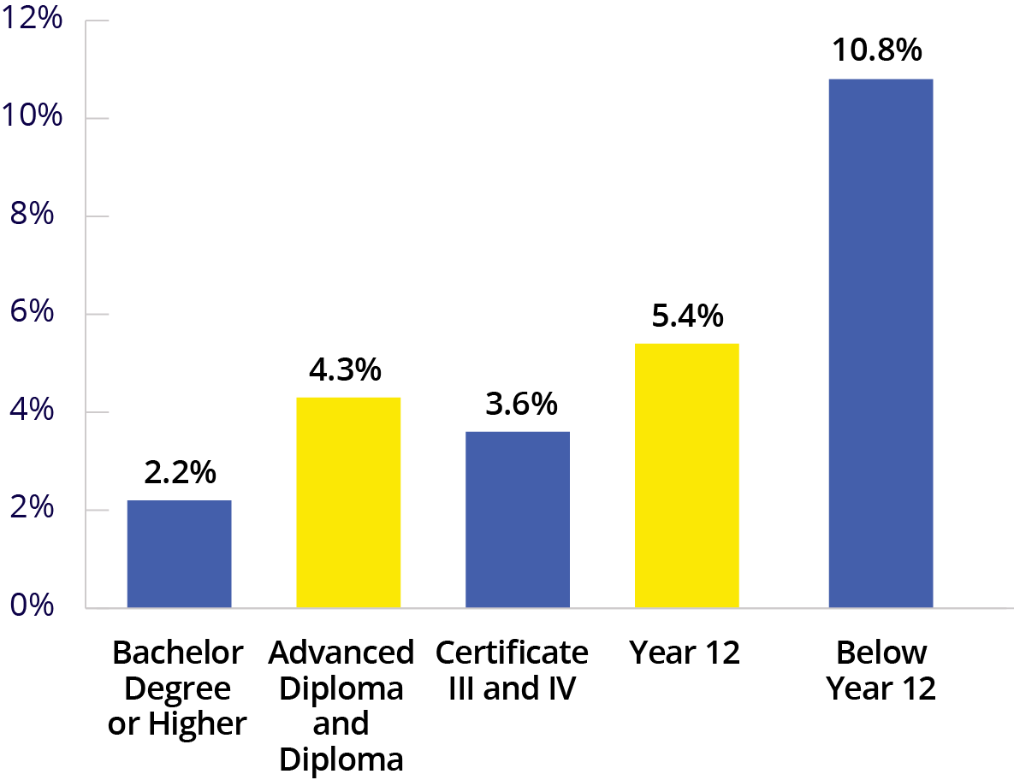
Note: Below Year 12 includes certificates I and II levels.
Median weekly earnings in main job, by highest level of post-school qualification, Australia, 2024 ($)
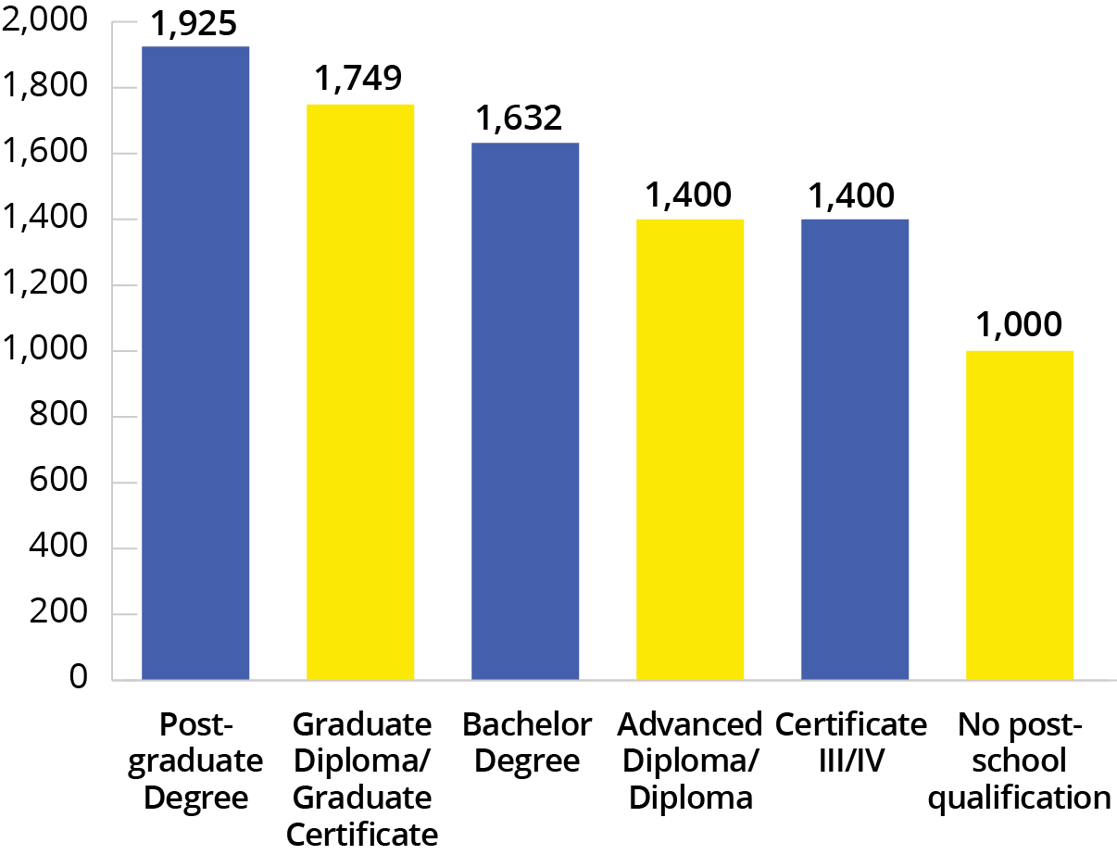
ABS, Education and Work, 2024; ABS, Characteristics of Employment, 2024; JSA, Internet Vacancy Index, seasonally adjusted data, December 2024

What if I don’t complete further education?
Although most new jobs created in recent years (and those expected in the future) are in skilled occupations, there will continue to be jobs in lower skill level occupations (that is, jobs which do not usually require post-school qualifications). Lower skill level occupations generally have higher turnover rates than those which require post-school qualifications and many job openings are available each year across all industries.
Significant proportions of people working as Labourers (61%), Sales Workers (59%) and Machinery Operators and Drivers (53%) do not hold post-school qualifications. This includes occupations like General Sales Assistants, Waiters, Kitchenhands, Checkout Operators and Office Cashiers.
There are opportunities in all industries for people who do not have post-school qualifications. For example, more than half of the jobs in Accommodation and Food Services and Retail Trade are held by workers who do not have such qualifications. These jobs can be an important first step into the workforce, opening up pathways to learn on the job or access further training and qualifications.
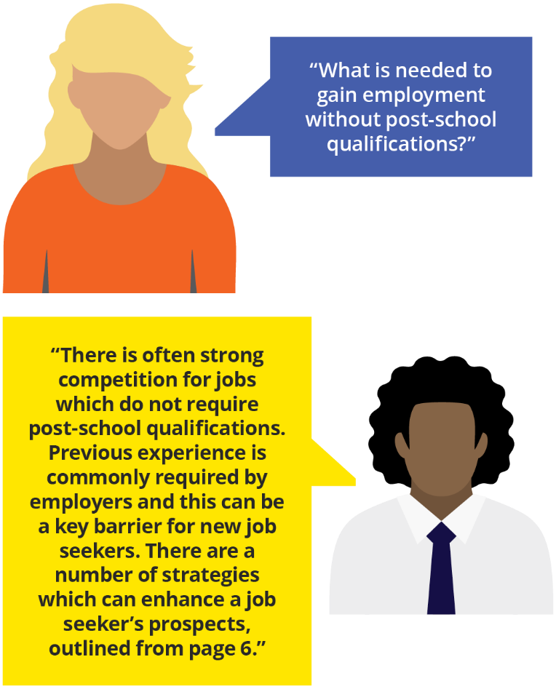

Proportion of workforce without post-school qualifications, top 5 industries, 2024 (%)
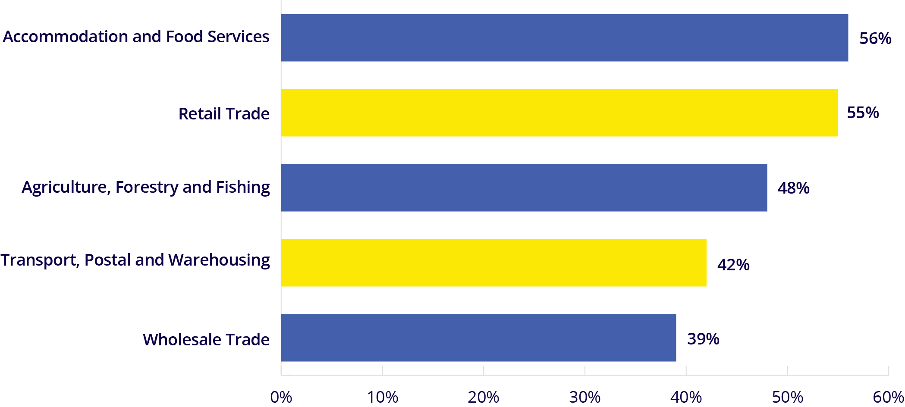
ABS, Education and Work, 2024

Vocational Education and Training
The Vocational Education and Training (VET) system provides a skilled workforce with nationally recognised qualifications and knowledge-based competencies. Students can enrol in qualifications (with around 1,200 on offer), accredited courses, industry recognised skill sets and units of competency, allowing them to gain the specific skills they need, when they need them. Training takes place in classrooms, at work and online, and can be full-time or part-time.
The VET system provides training in all fields of education. Management and Commerce had the largest number of program enrolments in 2023, followed by Society and Culture (which is a diverse field of education including studies in law, psychology, human welfare and society, language and linguistics, economics and sport and recreation), and Engineering and Related Technologies.
There were more than 5 million VET students in 2023, and around 3.5 million of these students were enrolled in training outside of a full program. This type of study, known as nationally accredited stand-alone subjects, includes training that is critical to supporting employers and the Australian economy. Examples include enabling employers to meet workplace and public health and safety requirements, such as ‘construction white cards’ for building sites, responsible service of alcohol and first-aid certifications.
Further information on VET enrolments can be found at ncver.edu.au/research-and-statistics.
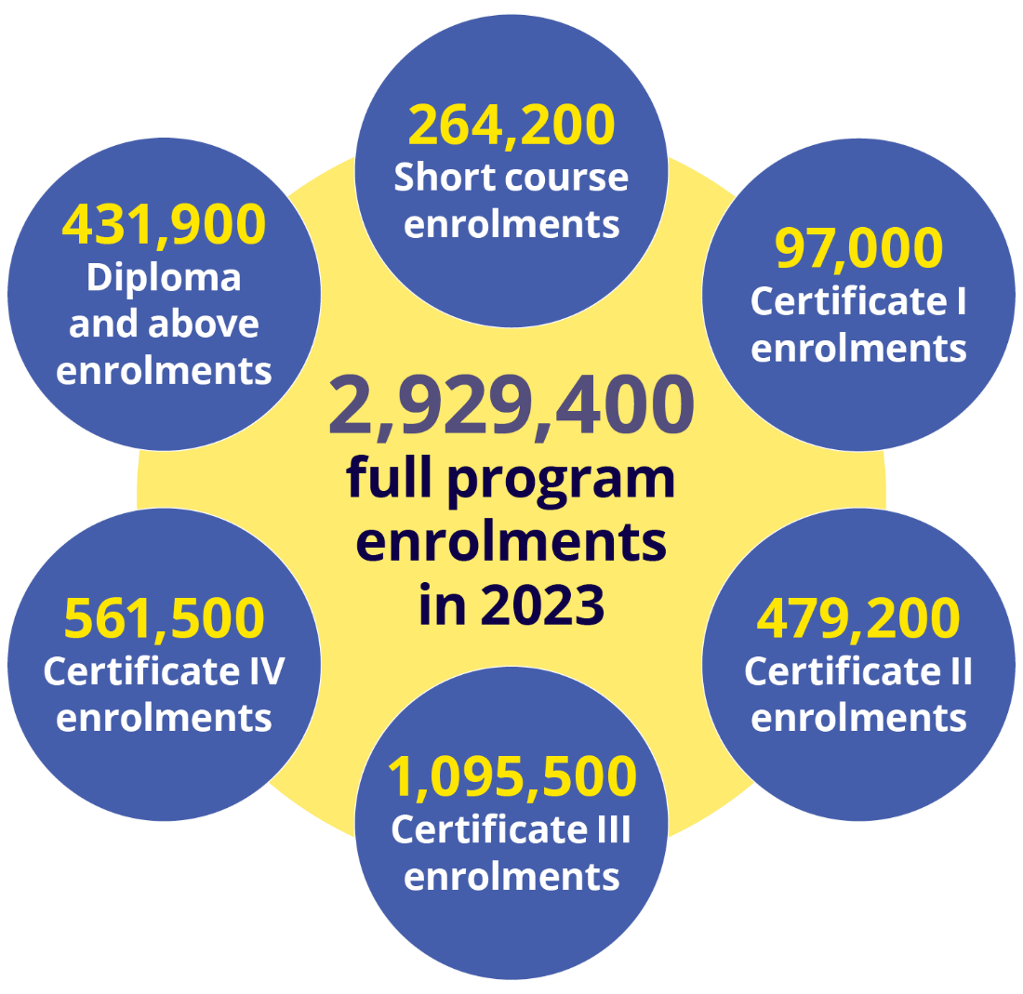
VET program enrolments, by field of education, 2023
 | Total program enrolments | Student aged  under 25 years | Education provider type
 | Total program enrolments | Student aged  under 25 years | TAFE | Private RTO
Field of Education | (‘000) | (%) | (%) | (%)
Natural and Physical Sciences | 20.0 | 49 | 25 | 63
Information Technology | 64.4 | 50 | 52 | 33
Engineering and Related Technologies | 454.1 | 50 | 35 | 55
Architecture and Building | 244.6 | 56 | 37 | 52
Agriculture, Environmental and Related Studies | 59.0 | 49 | 42 | 39
Health | 197.2 | 40 | 32 | 56
Education | 224.8 | 32 | 30 | 61
Management and Commerce | 546.9 | 36 | 20 | 68
Society and Culture | 483.0 | 38 | 17 | 71
Creative Arts | 64.5 | 71 | 40 | 39
Food, Hospitality and Personal Services | 260.1 | 64 | 22 | 61
Mixed field programmes | 187.1 | 42 | 58 | 13
Not known | 123.7 | 31 | 17 | 71
All fields of education | 2,929.4 | 44 | 29 | 58
NCVER 2024, Total VET students and courses 2023

Does VET improve employment outcomes?
VET students graduating in 2023 in the fields of Education, Engineering and Related Technologies, and Architecture and Building reported strong employment outcomes from their study, with more than 70% of these graduates stating they improved their employment status after training.
High proportions of VET graduates have moved on to further study or are employed after training, with the highest rates for those who studied Education (92%) and Health (89%).
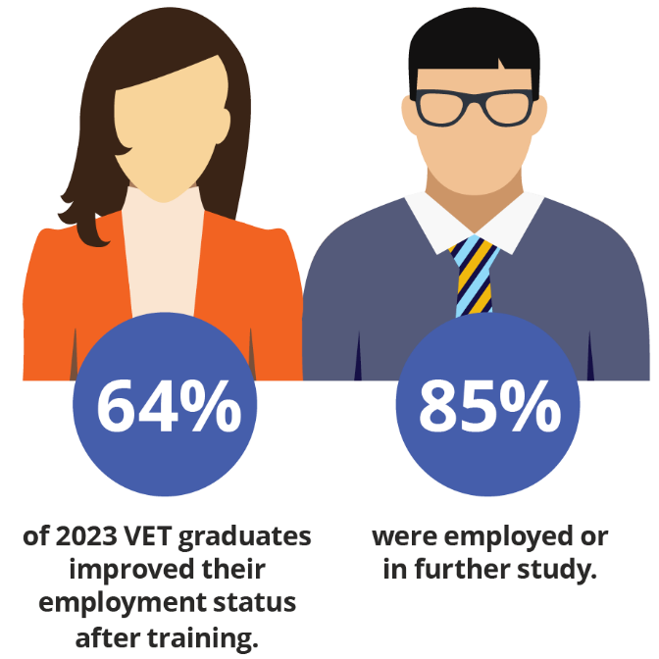

Do VET graduates have high earnings?
Workers who hold a VET qualification at the Certificate III or higher level generally earn more than those who have not studied after leaving school (see page 17). For 2023 graduates at the Certificate II level or higher working full-time after completing their training, the median annual income was $67,800.
The highest median full-time, annual salaries were for those who studied:
- Engineering and Related Technologies ($78,300)
- Education ($73,000)
- Management and Commerce ($70,400).
VET graduate income, 2023 graduates employed full-time after training
Level of education | Median annual full-time income ($)
Diploma or higher | $78,200
Certificate IV | $78,300
Certificate III | $62,600
Certificate II | $52,100
VET graduate employment outcomes, by field of education, 2023 graduates
 | Employed after training | Employed or in further study after training | Improved employment status after training
Field of Education | (%) | (%) | (%)
Natural and Physical Sciences | 62.6 | 72.8 | 45.6
Information Technology | 58.5 | 78.2 | 41.3
Engineering and Related Technologies | 82.7 | 87.9 | 71.0
Architecture and Building | 81.5 | 87.3 | 70.8
Agriculture, Environmental and Related Studies | 77.7 | 85.6 | 65.0
Health | 80.6 | 89.1 | 65.0
Education | 87.9 | 91.6 | 76.9
Management and Commerce | 78.1 | 86.1 | 64.7
Society and Culture | 77.2 | 84.7 | 66.4
Creative Arts | 59.2 | 79.7 | 37.9
Food, Hospitality and Personal Services | 74.8 | 82.8 | 63.6
Mixed field programmes | 49.1 | 72.3 | 35.4
All fields of education | 77.1 | 85.4 | 64.4

Australian Apprenticeships
Imagine starting a career where you learn on the job, earn income and gain a qualification, all at once. That is exactly what you can do with an Australian Apprenticeship.

What is an apprenticeship?
An apprenticeship or traineeship is an employment contract between an apprentice and an employer and combines practical work experience with formal education, enabling you to earn while gaining hands-on training and a nationally recognised qualification.
There are so many career choices available. You could start a career in sectors like:
- construction and building trades
- hairdressing and beauty services
- information technology
- healthcare and patient services
- hospitality and culinary arts
- early childhood education
- veterinary and animal care
- automotive services and repair.
Whatever your passion, there’s an apprenticeship pathway for you.

Why choose an apprenticeship?
- Earn while you learn: An apprenticeship means you don’t have to choose between education and income.
- Practical experience: Work directly with industry experts to gain real-world skills and knowledge.
- Nationally recognised qualification: Complete your training with skills and knowledge that can be used nationwide.

Who is eligible for an Australian Apprenticeship?
You can start an apprenticeship if you:
- are 18 years or older (or have guardian approval if under 18); and
- are an Australian citizen, a permanent resident or a New Zealand passport holder with at least 6 months residence in Australia; and
- can commit to full-time or part-time hours.

Available financial support
As an Australian Apprentice, you may be eligible for support from the Australian Government and your state or territory government.
- Financial support may include payments of up to $10,000 over the course of your apprenticeship, depending on your occupation.
- If you have to move away from home to take up or continue training as an Australian Apprentice, you may be eligible for the Living Away From Home Allowance (LAFHA) to support you with the additional costs of living.
- You may also be eligible for an Australian Apprenticeship Support Loan (AASL), which is an interest free loan to help you buy trade tools and supplies for your apprenticeship. You can borrow up to a total of $25,374 (2024/25 rate), which is paid in monthly payments.

What other supports are available?
Apprentice Connect Australia Providers are the gateway into the Australian Apprenticeships system and are available to support you to get the most out of your apprenticeship.
Apprentice Connect Australia Providers are a free national service available to support you by providing:
- helpful advice to manage your apprenticeship journey and understand your obligations along the way
- personalised support – services provided are based on your individual needs and may include mentoring, career guidance, peer support, conflict resolution and referral to other specialist services
- expert advice on eligibility for extra support and incentives.
For guidance and support on your apprenticeship journey, contact your local Apprentice Connect Australia Provider, or visit apprenticeships.gov.au/who-to-contact.

Women in Apprenticeships
Women are more likely to enrol in apprenticeships in industries where they make up the majority of the workforce, for example, childcare or hairdressing. However, the last few years have seen a positive trend towards women entering male-dominated trades, with an increase of 2.7 percentage points since 2019. This trend was replicated across 3 of the largest trades.
A qualification obtained through an apprenticeship can act as a stepping-stone to a variety of roles that can be pursued in employment and further training. Once qualified, apprentices can continue with their employer, further upskill or start their own business. Around 94% of apprentices who completed their training in 2022 reported they are employed or are in further study.

Proportion of apprentices identifying as female in training in selected male-dominated trades
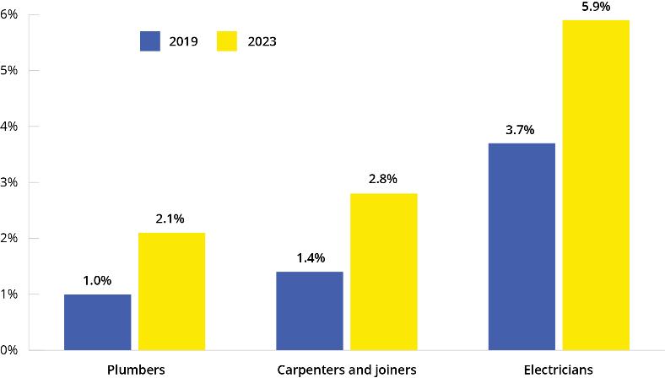
NCVER, 2024, Apprentices and trainees 2023: December quarter, NCVER
Analysis for graph based on NCVER, 2024, Apprentices and trainees 2023: December quarter

Higher Education
Universities offer courses at the undergraduate and postgraduate levels, including associate degrees, bachelor degrees, masters and doctorate qualifications. Most higher education students study at the bachelor degree level (60% in 2023). Higher education usually involves a commitment to at least 3 years of full-time equivalent study to attain a bachelor degree, but many courses involve longer periods of study.
There were 1.6 million students enrolled in higher education in 2023 (up 21.8% over the past decade).

What subject areas are available?
The higher education sector provides training in all fields of education. Management and Commerce had the largest number of enrolments in 2023 (360,200), followed by Society and Culture (which is a diverse field of education including studies in law, psychology, human welfare and society, language and linguistics, economics and sport and recreation) (326,500), and Health (283,100).
Further information on higher education enrolments can be found at education.gov.au/higher-education-statistics.

Higher education graduate employment outcomes
Higher education graduates generally have strong employment outcomes, especially as they gain experience in the labour market. In 2023, 88.9% of undergraduates were employed 4 to 6 months after completing their degree. For graduates who had completed their degree 3 years earlier (in 2020), 92.5% were employed in 2023.
Vocationally oriented study areas (such as Pharmacy, Medicine, Rehabilitation, Veterinary Science, Teacher Education, and Engineering) generally have stronger employment outcomes immediately after graduation. Graduates with more generalist degrees (such as Communications, Science and Mathematics, and Humanities, Culture and Social Sciences) have weaker employment outcomes immediately after graduation, but they do improve significantly over time.
Higher education student enrolments, by field of education, Australia, 2023
Field of education | 2023 enrolments (‘000) | 10 year change
Natural and Physical Sciences | 132.4 | 23%
Information Technology | 143.3 | 174%
Engineering and Related Technologies | 115.2 | 18%
Architecture and Building | 42.2 | 41%
Agriculture, Environmental and Related Studies | 19.3 | 1%
Health | 283.1 | 43%
Education | 137.4 | 10%
Management and Commerce | 360.2 | 5%
Society and Culture | 326.5 | 12%
Creative Arts | 92.5 | 5%
Food, Hospitality and Personal Services | 0.6 | 94%
Mixed field programs | 9.1 | -16%
Non-award courses | 16.4 | -10%
All fields of education* | 1,600.6 | 22%
* The total is less than the sum of all fields of education because students undertaking Combined Courses are counted in both fields of education while the total represents the unique student count.
Department of Education, Higher Education Statistics, 2023 Student Data; Quality Indicators for Learning and Teaching (QILT), 2023 Graduate Outcomes Survey (students surveyed approximately 4 to 6 months after completion of their studies

Bachelor degree graduates employed 4 to 6 months after graduation, by study area, 2023 (%)
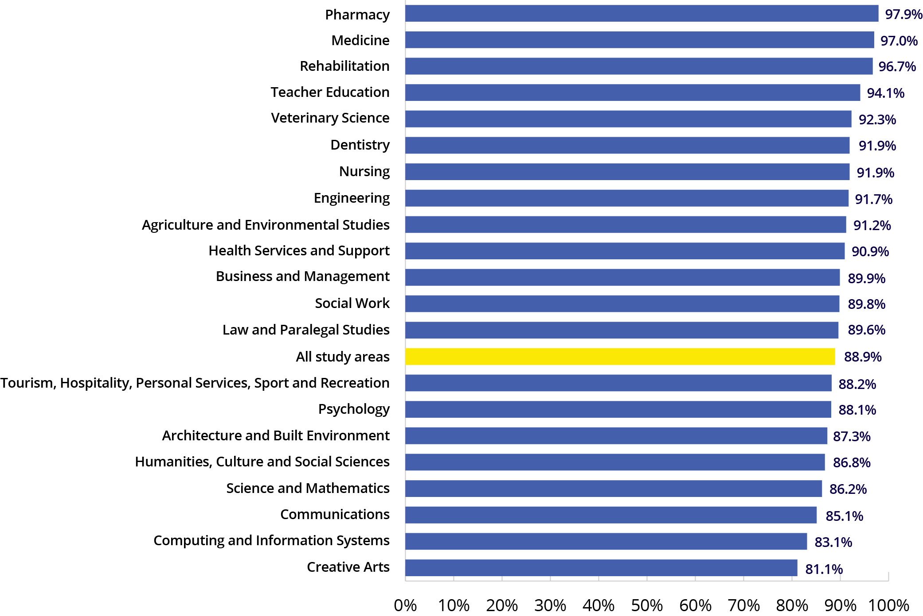

Salaries
In 2023, the median annual full-time salary for an undergraduate was $71,000. Study areas with the highest median salaries included:
- Dentistry – $94,400
- Medicine – $85,000
- Social Work – $77,300
- Teacher Education – $75,000.
Postgraduate coursework graduates had a median salary of $96,600 and for postgraduate research graduates it was $100,000.

Further information on training and education pathways
There are many websites that can support you when making further education and training decisions. Some of these are listed on page 148, however yourcareer.gov.au is a great place to start as it combines information on both the VET and higher education systems.
QILT, 2023 Graduate Outcomes Survey (students surveyed approximately 4 to 6 months after completing their course); QILT, 2023 Graduate Outcomes Survey – Longitudinal (students surveyed 3 years after completing their course)

Skills for the future
Adopting an approach of lifelong learning will help you keep up-to-date with emerging skills and occupations in the workforce, some of which haven’t been invented yet and may be difficult to imagine. We also know it is important to have the skills that help you work with technology. Almost all jobs will require the use of at least one technology tool, and several technology tools are so universal they are likely to be used by most, if not all jobs. These common technology tools include using the internet, sending emails, texts or instant messages, and video conferencing.

Can skills gained in one job be transferred to another job?
Many jobs have a similar set of skills. If you are looking for work or need to change jobs, the good news is that you are likely to have many transferable skills that can be used in other jobs or industries. Your transferrable skills might be your employability skills, or could be other skills, abilities or knowledge you acquired through your work experience, formal education, or on-the-job training.
Resources such as yourcareer.gov.au can help you identify the skills required for different occupations. The work activities or tasks undertaken in one job can often look similar across a range of other jobs, such as planning or solving problems. When considering a new job, reviewing your full range of skills can open a broader range of job opportunities.

Will training and qualifications be necessary?
There are many pathways to work and it is important to make decisions based on your own strengths. In a competitive labour market, training and qualifications matter. It also helps to understand the skills you acquire through your education, training and work experience.
Skills development and lifelong learning will expand your opportunities as some jobs change, new jobs emerge, and technological progress continues.


Jobs with similar skills
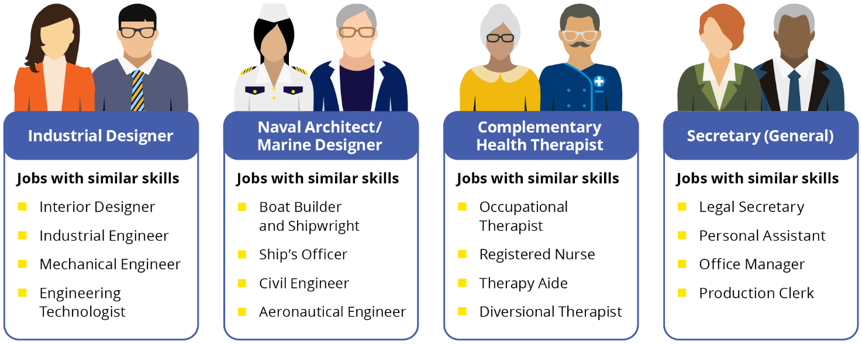

Jobs and Skills Councils

What are the Jobs and Skills Councils?
Jobs and Skills Councils (JSCs) are strengthening industry’s role in shaping Australia’s VET sector. JSCs are a not-for-profit network of industry-led organisations bringing together employers and unions to work in partnership with governments and the education and training sector. The JSCs also work closely with Jobs and Skills Australia (JSA) to provide an industry perspective of the economy beyond just data and analytics.
JSCs will identify skills and workforce needs for their industry sectors, map career pathways across education sectors, develop contemporary VET training products, support collaboration between industry and training providers to improve training and assessment practice, and act as a source of intelligence on issues affecting their industries.

Which sectors do the JSCs represent?
The 10 JSCs were set up as part of national reforms to the VET sector and work across a range of industries:
- BuildSkills Australia: Construction, property, and water infrastructure.
- Future Skills Organisation: Finance, technology, and business.
- HumanAbility: Health, aged care, children’s education and care, community services and sports and recreation.
- Industry Skills Australia: Transport and logistics including warehousing, rail, maritime and aviation.
- Manufacturing Industry Skills Alliance: Manufacturing, engineering, and pharmaceuticals.
- Mining and Automotive Skills Alliance: Mining operations and automotive industries.
- Powering Skills Organisation: Energy, gas, and renewables.
- Public Skills Australia: Fire and emergency services, police, correctional services, government, and defence.
- Service and Creative Skills Australia: Arts, retail, tourism, hospitality and personal services.
- Skills Insight: Agriculture, textiles, forestry, and food production.

Employment by Jobs and Skills Council
 | Employment |  |  | Employment Profile |  | Projected Employment
 | Nov 2024 | 5 year change to  Nov 2024 |  | Part-time | Female | 5 year change  to May 2029
Jobs and Skills Council | ‘000 | ‘000 | % | % | % | %
Build Skills Australia | 1,968.1 | 238.6 | 13.8 | 20 | 24 | 6.9
Future Skills Organisation | 1,826.6 | 210.0 | 13.0 | 17 | 47 | 9.6
HumanAbility | 3,220.4 | 693.6 | 27.4 | 43 | 75 | 10.0
Industry Skills Australia | 742.7 | 99.0 | 15.4 | 23 | 22 | 5.0
Manufacturing Industry Skills Alliance | 747.9 | 12.0 | 1.6 | 17 | 28 | 0.7
Mining and Automotive Skills Alliance | 641.7 | 71.0 | 12.5 | 10 | 20 | 1.7
Powering Skills Organisation | 286.6 | 55.8 | 24.2 | 11 | 18 | 7.1
Public Skills Australia | 909.3 | 112.8 | 14.2 | 16 | 51 | 4.4
Service and Creative Skills Australia | 3,161.9 | 247.2 | 8.5 | 50 | 54 | 5.0
Skills Insight | 666.2 | 0.1 | 0.0 | 29 | 37 | 1.8
National employment* | 14,535.5 | 1,658.6 | 12.9 | 31 | 48 | 6.6
* National employment includes around 370,000 people employed in the non-school education sector which is not covered by a JSC
ABS, Labour Force, Australia, November 2024; ABS, Labour Force, Australia, Detailed, November 2024; Employment Projections produced by Victoria University for Jobs and Skills Australia, 2024 (May 2024 to May 2034)

BuildSkills Australia
BuildSkills Australia is the JSC for the construction, property and water sectors. They play a role in supporting development of the Built Environment workforce and, using immersive technologies, aim to improve students’ understanding of available occupations. BuildSkills is assisting young people to broaden their knowledge of the Construction, Property and Water sectors.
BuildSkills Australia is using innovation to connect with students and promote career opportunities, with a focus on broadening the talent pipeline by reaching a more diverse audience. Engaging students early can help to build a more inclusive workforce. Providing opportunities for students to experience what a career in the Built Environment workforce entails is invaluable for those who may not have considered it as a career option.
The construction sector offers diverse career opportunities. This includes skilled trades and professional and managerial roles. BuildSkills helps highlight progression within the sector, from apprenticeships to leadership positions.
A key focus for BuildSkills is increasing diversity within the Construction workforce. The aim is to show that there are roles for people from any background in construction, with a range of occupations available. As well as more well-known occupations such as Project Builders and Carpenters, other occupations include but are not limited to:
- Environmental Engineers
- Insulation and Home Improvement Installer
- Heritage and Restoration Bricklayer.
The property sector encompasses many occupations. This includes real estate, property management, urban planning, and facilities management. There are a breadth of roles available in this sector, from frontline sales positions through to specialised asset management roles.
The work of BuildSkills has highlighted the career growth potential in this sector. Occupations that exist within this industry include:
- Stock Agents
- Real Estate Investment Advisors
- Land Economist
- Landscape Architects.
The water sector is critical to Australia’s infrastructure and sustainability efforts. Despite its importance, career awareness in this sector remains low among students. BuildSkills is developing ways for students to explore careers in water management, and better understand the wide-reaching impact and opportunities of the sector. The deployment of real-world applications enhances practical knowledge of work in the sector.
Occupations that students might otherwise be unfamiliar with include:
- Water Quality Scientists
- Water Treatment Plant Operators
- Geotechnical Engineers
- Hydrographic Surveyors.
We want to empower a generation of students to choose fulfilling long-term careers. Our approach supports workforce supply and contributes to a resilient Built Environment sector.
Find out more at: buildskills.com.au
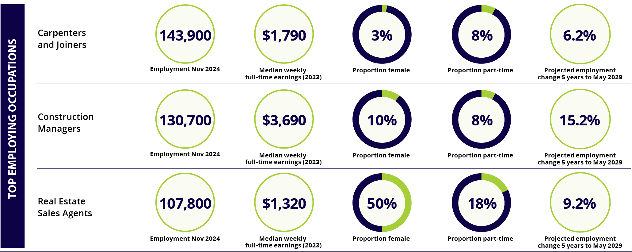
Note: figures are for occupation employment across all industries. *na = not available
ABS, Labour Force, Australia, Detailed, November 2024; Employment Projections produced by Victoria University for Jobs and Skills Australia, 2024 (May 2024 to May 2034); ABS Survey of Employee Earnings and Hours, May 2023

Future Skills Organisation
Future Skills Organisation (FSO) is the JSC for finance, technology and business. FSO partners with industry and the education and training sector to fast-track training solutions which meet the demand for the most important finance, technology and business skills.
Finance, technology, and business offer exciting and versatile career paths with endless opportunities for growth and innovation. Workers today can expect to explore multiple career paths throughout their working life. This allows the flexibility to gain diverse experiences and skills and adapt to changing industry demands.
By 2030, digital technologies will impact a majority of jobs. The future job market is calling for adaptable workers who can navigate technological changes with confidence. Building a solid foundation in digital skills is essential, regardless of your chosen industry.
Employers in finance, technology, and business are increasingly focused on the skills you bring to a role rather than just your qualifications. While technical skills are important, employers also value well-rounded individuals with employability skills such as communication, teamwork, and problem solving. These skills will create opportunities for you at all levels right across the employment market.
Traineeships and other earn-while-you-learn pathways are more valuable than ever. They offer paid, real-world experience and help you develop the transferable skills all employers are seeking.
The key to success in these fields is being a lifelong learner. Employers want individuals who are ready to grow and evolve with emerging technologies. The finance, technology, and business sectors are exciting and diverse, offering dynamic pathways to kickstart your career.
In-demand skills in finance, technology and business:
- Critical thinking
- Information analysis
- Communication
- Problem solving
- Adaptability.
Growing finance, technology and business careers:
- Risk managers
- Artificial Intelligence specialists
- Data analysts
- Project managers
- Sustainability managers.
The exciting part of these roles is that they aren’t limited to one field; there are opportunities to use these skills in industries as varied as healthcare, retail, mining, marketing, and even government.
Find out more at:
www.futureskillsorganisation.com.au
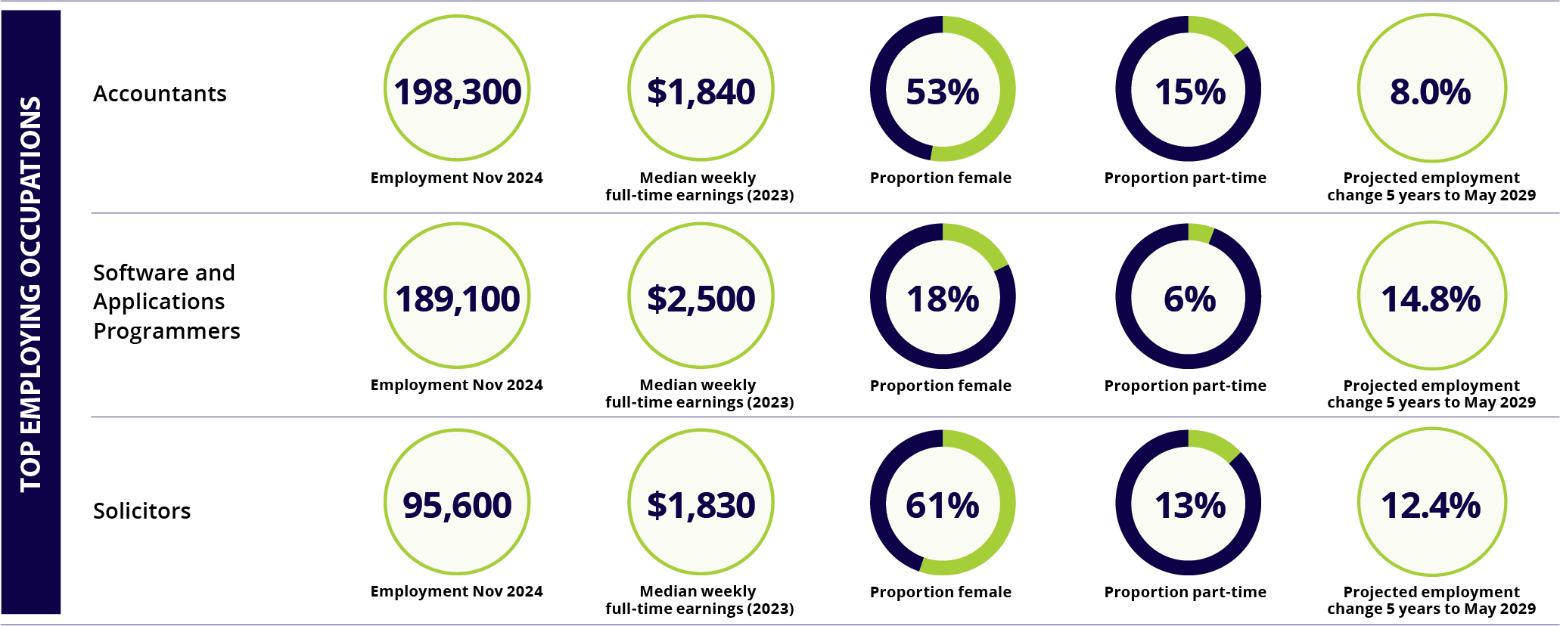
Note: figures are for occupation employment across all industries
ABS, Labour Force, Australia, Detailed, November 2024; Employment Projections produced by Victoria University for Jobs and Skills Australia, 2024 (May 2024 to May 2034); ABS Survey of Employee Earnings and Hours, May 2023

HumanAbility
HumanAbility supports Australia’s care and support workforce. These sectors play a vital role in supporting individuals, families and communities, and provide meaningful and rewarding career opportunities. HumanAbility collaborates with industry, government, unions and training providers to develop career pathways, tackle workforce challenges, and ensure individuals can access the skills needed via up-to-date training.
Care and support careers are about people, purpose and possibility. These sectors provide opportunities to support others, while also providing pathways into leadership, service design, education and health promotion. With workforce demand rising across aged care and disability support, early childhood education and care, health and human services, and sport and recreation there’s never been a better time to explore a career in the care and support sector.
The care and support workforce is projected to experience strong growth over the next decade, requiring skilled professionals in a range of crucial roles. These industries value skills such as communication, adaptability, problem solving and teamwork, all essential to delivering high quality services to communities and individuals. Employers increasingly recognise the importance of hands-on experience, with structured training pathways such as vocational education and training, apprenticeships and traineeships providing real world learning to help people to start and grow their careers.
While many people are drawn to roles working directly to support others, these industries also offer opportunities in program development, service innovation and community leadership. Careers in aged care and disability support, can mean helping people maintain independence, improving wellbeing, or designing new ways to enhance care. In sport and recreation, careers span coaching, fitness leadership and creating programs that promote active lifestyles.
With structured training pathways, traineeships and vocational programs, there are many ways to start and grow a meaningful career. Whether you want to support individuals one on one, shape the future of services, or strengthen communities, there’s a place for you.
Find out more at humanability.com.au

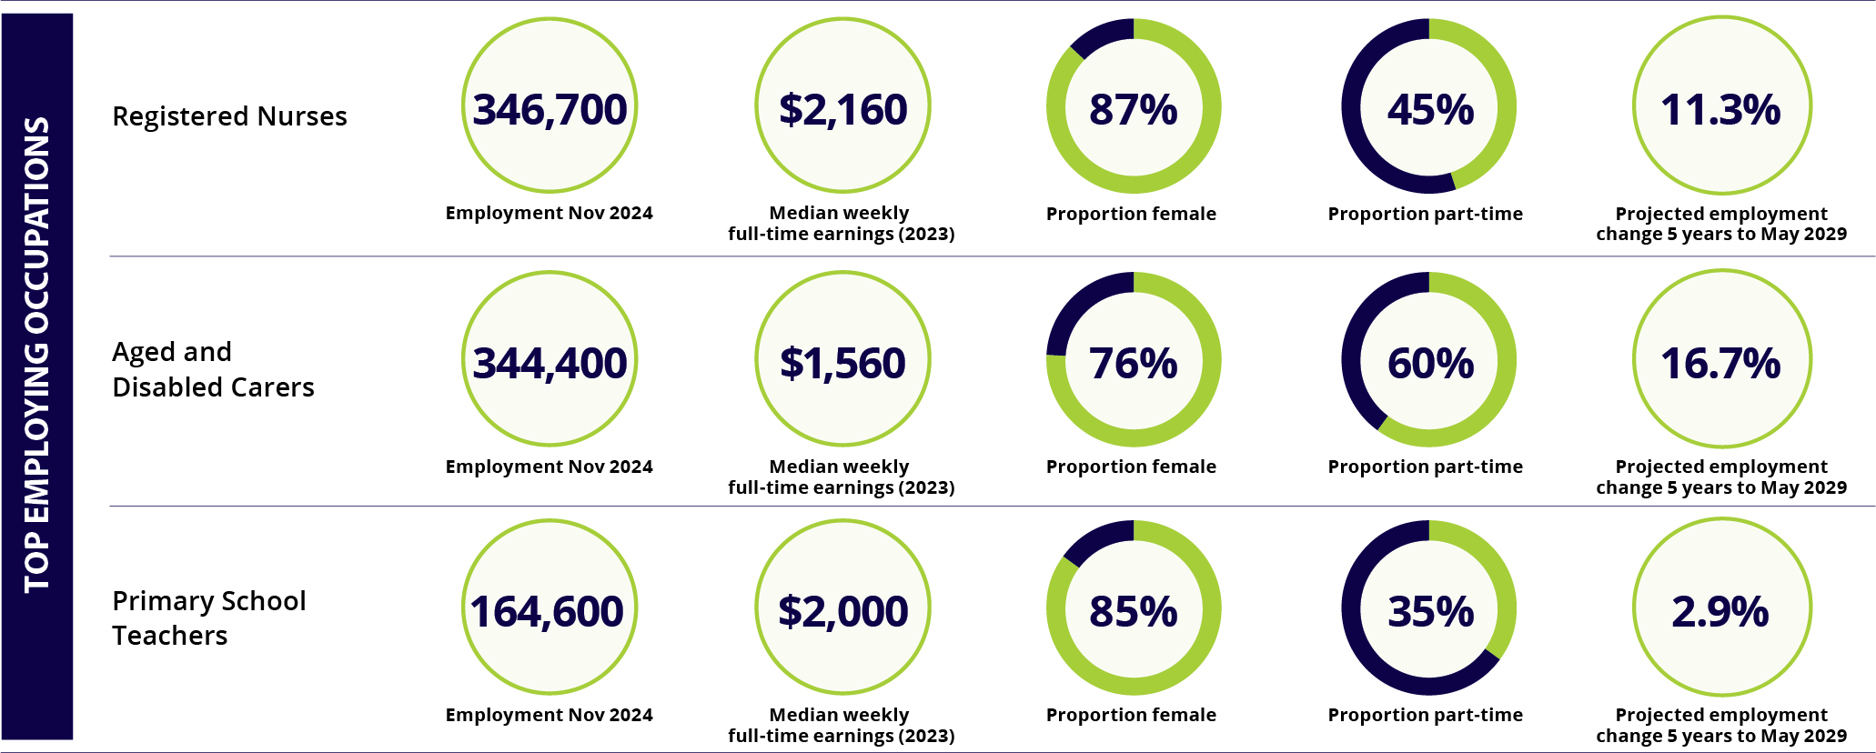
Note: figures are for occupation employment across all industries
ABS, Labour Force, Australia, Detailed, November 2024; Employment Projections produced by Victoria University for Jobs and Skills Australia, 2024 (May 2024 to May 2034); ABS Survey of Employee Earnings and Hours, May 2023.

Industry Skills Australia
Industry Skills Australia has been established to support the nation’s Transport and Logistics industry sectors. This includes Aviation, Maritime, Rail, Transport and Logistics, and the emerging sectors of Omnichannel Logistics and Distribution, and Air and Space Transport and Logistics.
Owned and led by industry, Industry Skills Australia is committed to building a world-class supply chain workforce to increase productivity, create better jobs and build opportunities for individuals.
The Transport and Logistics (T&L) sectors have a huge range of business types from small local businesses to large international businesses and are spread right across Australia including in regional, rural and remote locations.
Transport is one of Australia’s most important sectors and is an essential service for the country’s social and economic wellbeing. An efficient supply chain and transport network is vital for the movement of products and people. This contributes to the growth of the Australian economy and the liveability of our cities and regions. Many other industries rely on the T&L sectors for their survival, such as agricultural producers who depend on transport services to deliver their products to market, tourism operators that rely on services to move people across the country and manufacturers that need to transport goods globally. Transport functions are an intrinsic part of the Australian economy and as such, the sector’s overall condition is a commonly used indicator for gauging the broader strength of the economy.
Workers in today’s T&L sectors have many exciting and diverse career paths with strong employment security. T&L sectors are at the forefront of zero-emissions technologies and their practical application in our economy including new types of fuels and autonomous vehicles.
The workforce is projected to grow by 4.2% to May 2029 and 9.1% to May 2034. The entry opportunities for young people are growing with the sector becoming more attractive as old stereotypes are discarded.
People with a commitment to adaptability, an interest in machines, and a passion for problem solving can have very successful careers. Employers are looking for people with a positive attitude and willingness to learn as the industry adopts new technologies, to join this growing industry.
Transport & Logistics
Known occupations  - Bus driver  - Truck driver | Lesser-known occupations  - Crane operators  - Freight forwarder

Aviation
Known occupations  - Pilot  - Cabin crew | Lesser-known occupations  - Drone operator  - Rescue crew officer

Rail
Known occupations  - Train/tram driver  - Railway track worker | Lesser-known occupations  - Railway signal operator  - Travel attendant

Maritime
Known occupations  - Ship master  - Ships officer | Lesser-known occupations  - Vessel traffic officer  - Autonomous vessel operator
Find out more at: www.industryskillsaustralia.org.au
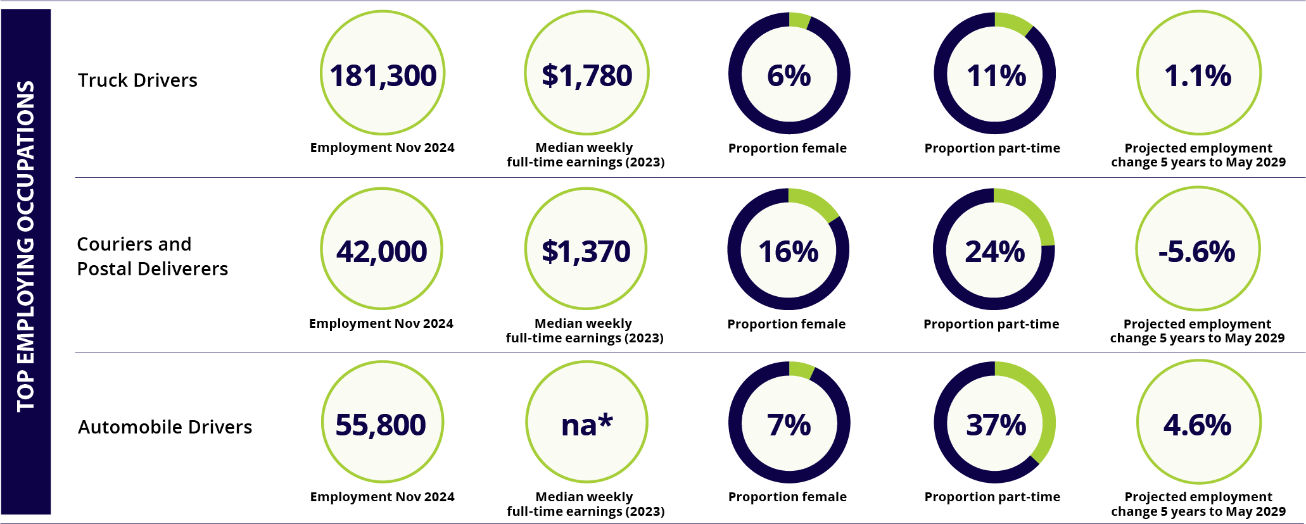
Note: figures are for occupation employment across all industries. *na = not available
ABS, Labour Force, Australia, Detailed, November 2024; Employment Projections produced by Victoria University for Jobs and Skills Australia, 2024 (May 2024 to May 2034); ABS Survey of Employee Earnings and Hours, May 2023

Manufacturing Industry Skills Alliance
The Manufacturing Industry Skills Alliance (MISA) is the JSC for the manufacturing sector. MISA works closely with stakeholders to identify and address skills and workforce challenges faced by the industry. MISA’s goal is to ensure that the manufacturing industry can access workers with the skills needed to shape an innovative future made right here in Australia.
MISA contributes to Australia’s future by allowing industry to grow and take advantage of opportunities like the clean energy transition, strengthening national defence, and advancing the use of AI and robotics. Their work includes delivering initiatives that build the pipeline of apprentices, and the understanding of the valuable and secure careers manufacturing can offer.
General manufacturing and engineering relates to work performed primarily in metal, engineering and associated industries, including the design, installation, maintenance, and repair of products in areas such as boatbuilding, jewellery making, and locksmithing.
The aerospace sector covers the maintenance, modification, repair and overhaul of civil (commercial and general) and military aircraft and their components.
Food and beverage manufacturing is one of Australia’s largest industries, and a significant proportion of the workforce are factory process workers (such as food and beverage process workers, and quality controllers) or food trade workers such as bakers and pastry cooks.
The print and graphic arts sector facilitates the effective communication of messages through paper, publishing, and graphic media for visual communication. This includes items like books, magazines, newspapers, packaging products, consumer products, printed clothing and outdoor advertising products.
The chemicals, hydrocarbons, and refining sector plays a critical role in Australia’s industrial landscape by producing essential chemicals, fuels, and refined products including the manufacturing and refining of metals products.
Pharmaceutical and biomed tech manufacturing includes the development and manufacture of safe medicinal and pharmaceutical products for humans and animals. These products can range from advanced vaccines, biologic drugs and molecular medicines to diagnostic testing agents, vitamins and skincare products.
The plastics, rubber, and cablemaking sectors are within the polymer processing industry. This industry is a sector largely made up of manufacturers of products and components made from natural or synthetic polymers, including thermoplastics and thermosetting polymers.
The manufactured mineral products sector uses minerals extracted from the earth through excavating, quarrying, dredging or tunnelling to produce a range of materials that are typically used by other industries rather than directly consumed by the public. Supported industries include building and construction, civil construction and landscaping.
Emerging sub-sectors include defence and space manufacturing, a rapidly expanding sector creating equipment and spacecraft for national defence and exploration beyond Earth. 3D printing is a process that builds objects layer by layer from a digital model using materials like plastic filament, resin, or metal powder. A specialised subset, bio-printing, uses materials such as living cells to create tissue-like structures. 4D printing (where objects transform over time), and nanoscale printing (manipulating materials at the atomic level) are pushing the boundaries of what printing can achieve.
Find out more at: manufacturingalliance.org.au
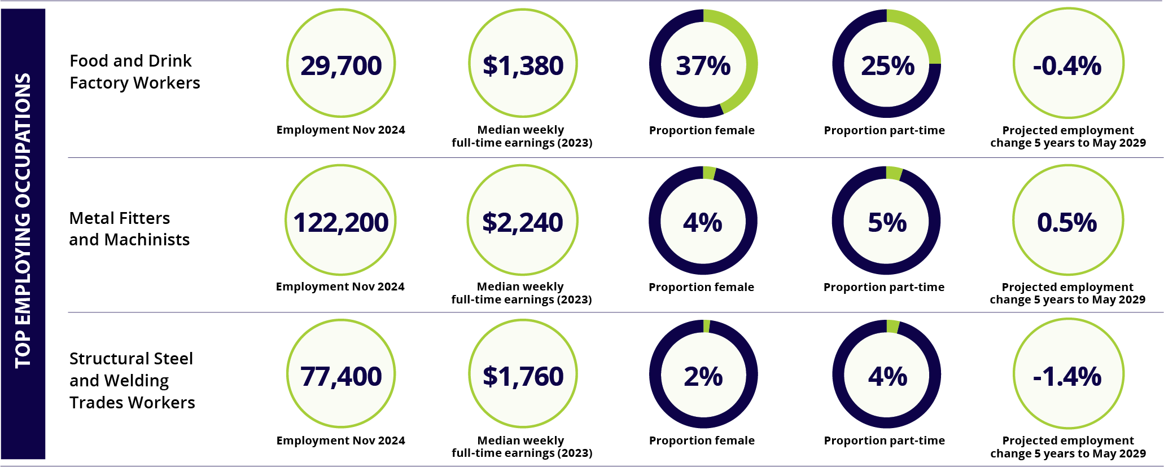
Note: figures are for occupation employment across all industries
ABS, Labour Force, Australia, Detailed, November 2024; Employment Projections produced by Victoria University for Jobs and Skills Australia, 2024 (May 2024 to May 2034); ABS Survey of Employee Earnings and Hours, May 2023

Mining and Automotive Skills Alliance
The Mining and Automotive Skills Alliance (AusMASA) brings together stakeholders in Australia’s mining and automotive industries. This covers a combined workforce of approximately 641,700 workers, and industry coverage that spans the entire mining division (including oil and gas extraction) and 3 automotive subdivisions. As a JSC, AusMASA bring together employers, unions, training organisations, and governments in a tripartite arrangement to find solutions to skills and workforce challenges, while also considering those of other related industries.
The road to Net Zero, Decarbonisation, and Electrification in many ways depends heavily on the mining and automotive sectors. For example, without the mining of critical minerals, there can be no Advanced Manufacturing, Super Computing (or AI), Renewables, or MedTech. These industries rely on mined critical minerals to provide essential circuitry components and other energy solutions. Mining is also a large investor in the development and implementation of autonomous operations – which are critical to the future of AI.
The automotive industry on the other hand, is essential to the deployment of Net Zero and Decarbonisation strategies as it enables the establishment and running of re-charging stations, and the ownership of electric vehicles (EVs). As EVs become increasingly important, skills necessary to diagnose, service, and repair these EVs will become even more important. Having EVs present everywhere is impossible without a robust and thriving automotive sector. Both industries offer promising career options.
A key focus of AusMASA's work involves ensuring that the VET system is fit for purpose for learners, employees, and employers alike. As part of this, AusMASA is responsible for the following nationally recognised training packages:
- AUM – Automotive Manufacturing
- AUR – Automotive Retail, Service and Repair
- RII – Resources and Infrastructure Industry
AusMASA also studies workforces of these industries, including but not limited to; demographic analysis, workforce needs, workforce planning, skills forecasting, and stewardship of industry (including higher education). AusMASA has a dedicated research division that explores the short and long-term strategic workforce and relevant industry level trends, disruptors, and challenges surrounding the industries within their remit, including the industries VET and apprenticeship streams.
Occupations of relevance to the industries within AusMASA’s remit are:
Mining
- Mine Engineer
- Driller
- Process Operator.
Automotive
- Light Vehicle Technician
- EV Technician
- Automotive Electrician.
Find out more at: ausmasa.org.au
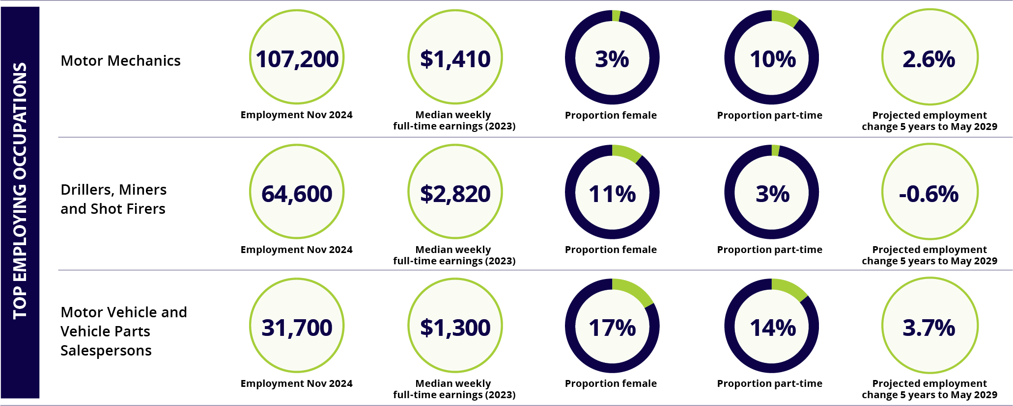
Note: figures are for occupation employment across all industries
ABS, Labour Force, Australia, Detailed, November 2024; Employment Projections produced by Victoria University for Jobs and Skills Australia, 2024 (May 2024 to May 2034); ABS Survey of Employee Earnings and Hours, May 2023

Powering Skills Organisation
Powering Skills Organisation (PSO) works across the energy sector, focusing on electricity, renewables and gas. PSO helps Australia’s energy sector and those entering it to train in the relevant skills needed to work and grow in its sectors.
PSO supports qualifications that sit across a range of career choices, including roles as electricians, wind turbine technicians, environmental engineers, solar consultants and more. A role in the energy sector could be in a residential home or in an office; it could be at a large power station or at a Registered Training Organisation (RTO). Everyone’s energy sector story looks different, but all paths offer an enjoyable career.
The energy workforce can be a rewarding experience for environmentally motivated individuals. By repurposing existing power station infrastructure and incentivising entering the energy workforce PSO will support Australia to continue to support energy production in the future. This is partly why electricians are one of the highest in-demand jobs to fight climate change.
Employment in the energy, gas and renewables sectors could include roles such as:
- Cable Jointing
- Rail Traction
- Air-conditioning and Refrigeration Technician
- Electronics Technicians
- Gas Supply and Distribution roles.
There are also pathways into emerging technologies such as hydrogen which are becoming increasingly important in the gas industry.
PSO is aiming to build an energy sector that is not just diverse in job opportunities, but in people too. In 2024, PSO’s research team published a paper on an uptick of women entering electrical trades. The latest data showed 4,900 women signed up for electrical apprenticeships between 2018 and 2023 in Australia – a 65% increase from the period of 2012 to 2017.
The work towards further diversification and growth of the energy sector will continue with PSO’s contributions.
Find out more at: poweringskills.com.au
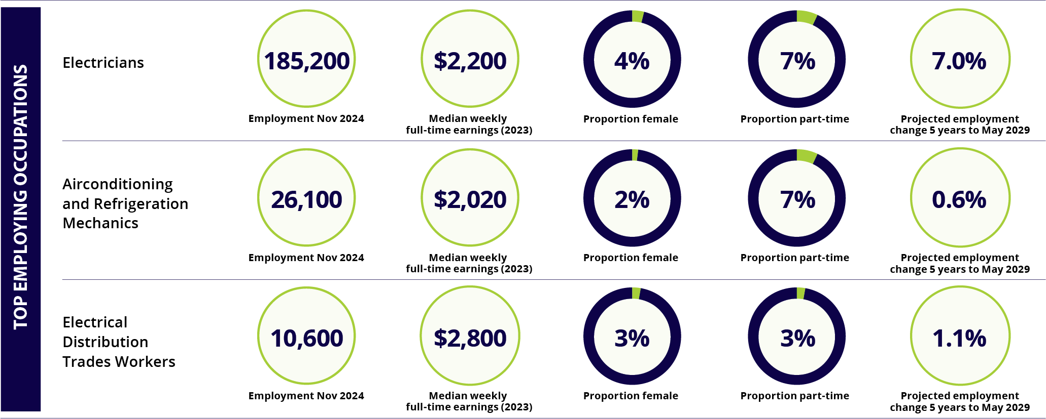
Note: figures are for occupation employment across all industries
ABS, Labour Force, Australia, Detailed, November 2024; Employment Projections produced by Victoria University for Jobs and Skills Australia, 2024 (May 2024 to May 2034); ABS Survey of Employee Earnings and Hours, May 2023. PSO Research Brief, Shifting Currents: elevating diversity in energy careers, November 2024

Public Skills Australia
Public Skills Australia supports the Australian Public Safety and Government sector. This includes correctional services, defence, government (local and state/territory and federal), fire and emergency services, and police. These sectors are responsible for keeping Australia safe and prosperous through emergency response, disaster recovery and public service. There are interesting career options across all sectors.
Many people will have limited experience with correctional services with their perceptions informed by the media or news stories. The sector is actively recruiting and working to keep communities safe and offer support to those who will benefit from rehabilitation. As part of this Public Skills Australia is working with training organisations to enhance the Correctional Services Training Package. This project will ensure students are empowered to build successful careers in Correctional Services.
Australia’s defence sector consists of the Australian Army, Royal Australian Air Force and Royal Australian Navy. Defence represents a critical workforce and has exciting careers spanning almost all occupations for those with the right attributes. Public Skills Australia work closely with the defence sector through the Defence Training Package.
The Australian fire and emergency service sector is a deeply inclusive and varied sector. It is a sector that values its career, volunteer and diverse workforces. This sector offers people the chance to join either as a career or through volunteering and offers a wide array of interesting job roles. As the effects of climate change continue to increase, this sector currently has a high demand for new recruits. Similar to the other sectors, Public Skills Australia supports this sector through the Public Safety Training Package.
Local government is the backbone of all our urban, regional and remote communities. Local Government takes care of their community’s town planning, infrastructure emergency response, waste management, community health, and more. There are so many opportunities for those who wish to work with and support their communities as a local government employee. The LGA Local Government Training Package contains key qualifications to support a robust Local Government workforce.
The Federal and State/Territory Government sector collectively shapes the civil and public service delivery landscape of Australia. Public sector employees are responsible for delivering essential public services and overseeing the physical, economic, and social wellbeing of its citizens. The Government workforce represents a microcosm of the broader Australian labour market, including health, Information Technology (IT), business administration, policy, education and training. Public Skills Australia supports the sector through the Public Sector Training Package.
The policing sector across Australia includes Federal (Australian Federal Police) and state and territory police agencies. Policing is diversifying, offering a range of unique experiences for its workforces spanning forensic services, to dog handling and traditional policing roles. Careers in policing can include many paths not seen in crime dramas or news reports. From keeping local communities safe to gathering intelligence, there are many accessible policing career pathways to explore through certificates, diplomas, and graduate certificates in policing. Public Skills Australia works with the Australia New Zealand Policing Advisory Agency in the development and review of the Police Training Package.
Find out more at: publicskillsaustralia.org.au
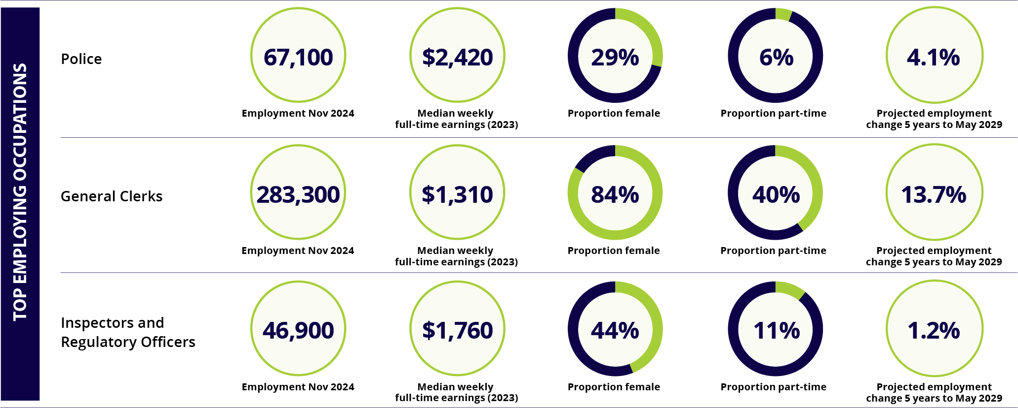
Note: figures are for occupation employment across all industries
ABS, Labour Force, Australia, Detailed, November 2024; Employment Projections produced by Victoria University for Jobs and Skills Australia, 2024 (May 2024 to May 2034); ABS Survey of Employee Earnings and Hours, May 2023

Service and Creative Skills Australia
Service and Creative Skills Australia (SaCSA) represents the arts, personal services, retail, tourism and hospitality industry sectors. SaCSA collaborates with industry stakeholders, unions and government to address workforce needs and ensure Australia’s VET sector delivers stronger outcomes for employers, workers, learners, and educators.
One of the key roles of SaCSA is outlining and promoting career opportunities and pathways across our industries. This includes identifying the key in-demand roles and opportunities in each of the industry sectors that they cover. The workforce planning SaCSA has undertaken has highlighted several exciting characteristics within our industries.
The arts sector plays a pivotal role in cultural expression, creativity and entertainment. From screen-based and performing arts to visual arts and literature, the industry thrives on innovation and individual expression and is essential to community wellbeing. Key occupations in focus, which are in-demand by the sector and often experiencing shortages, include Light Technicians and Sound Technicians. Opportunities can be found at both the junior and senior levels.
The personal services sector is characterised by a diverse workforce spread across various subsectors, which includes Hairdressing, Barbering, Beauty Services, Floristry and Funeral Services. Key occupations in focus include Hairdressers, Barbers, Beauty Therapists and those working in tattooing – providing an opportunity for people aspiring to enter the industry.
The retail sector is a vital component of the national economy and employs workers across many business types. The sector is characterised by a young workforce and flexible employment. Key occupations in focus include General Sales Assistants, Pharmacy Sales Assistants, and Retail Managers.
The tourism sector is an exciting and multifaceted industry that includes the exploration, enjoyment and appreciation of diverse cultures, landscapes and experiences. Key occupations in focus include Tour Guides, Travel Consultants, and Tourism Information Officers.
The hospitality sector is the cornerstone of Australia’s service economy and provides exceptional service experiences, including across food and beverage and events. Key occupations in focus include Cooks, Chefs, Waiters, and Bar Attendants.
Find out more at: sacsa.org.au
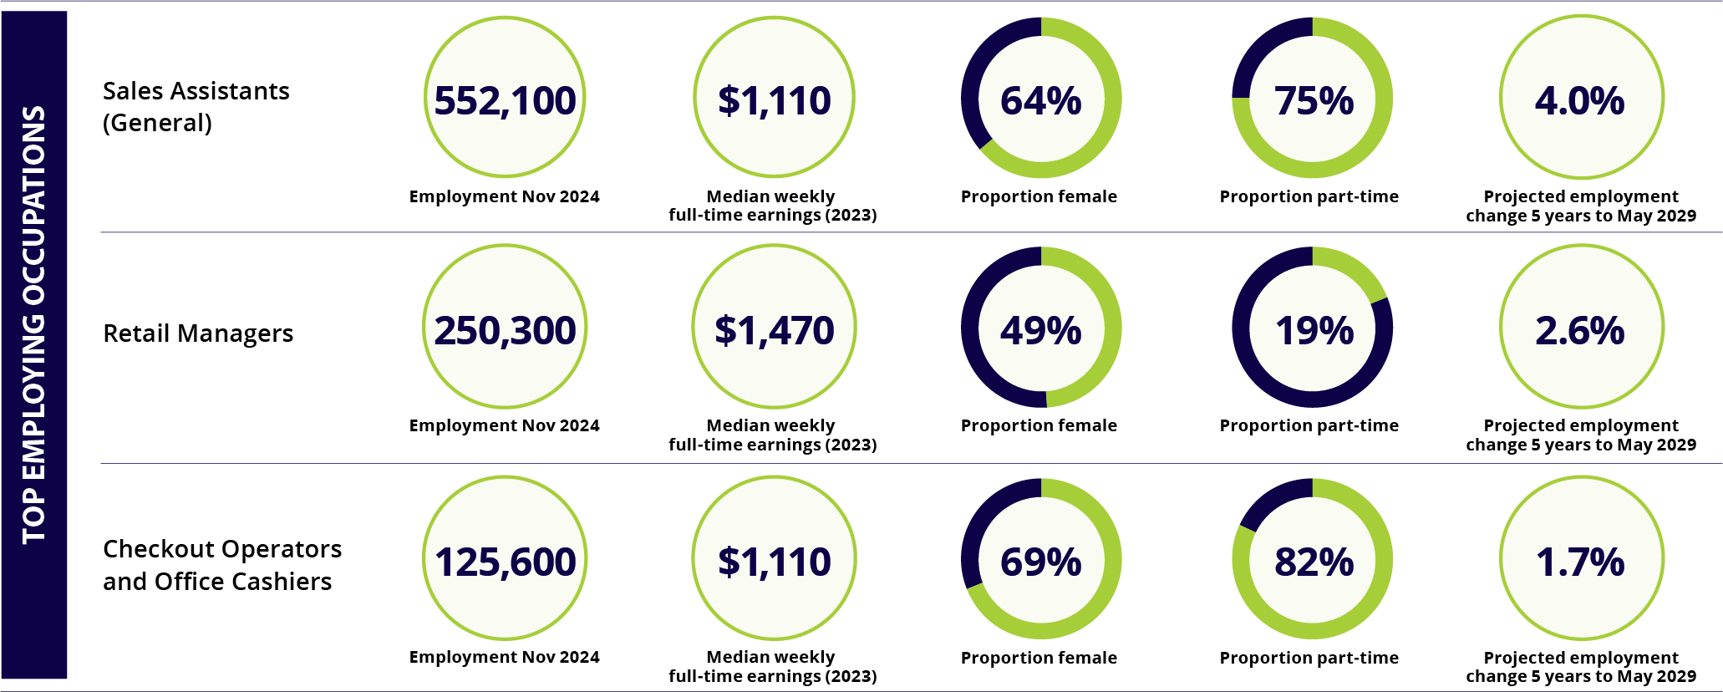
Note: figures are for occupation employment across all industries
ABS, Labour Force, Australia, Detailed, November 2024; Employment Projections produced by Victoria University for Jobs and Skills Australia, 2024 (May 2024 to May 2034); ABS Survey of Employee Earnings and Hours, May 2023

Skills Insight
Skills Insight is the JSC for the agribusiness, fibre, furnishing, food, animal and environment care sectors. They work with industry, training providers, unions and government to explore possible solutions to skills challenges and identify opportunities.
The sectors Skills Insight works with are crucial to Australia’s communities, ecosystems and prosperity. They are especially significant in rural, regional and remote areas, with 60% of jobs based outside of major cities.
These sectors play a crucial role in food security and in solutions for a changing climate. Using a broad range of skills, the workforce cares for plants and animals, maintains land and water bodies, and produces and processes the raw materials used for essential items such as housing, clothing, and hygiene products.
While this workforce spans diverse areas of expertise, the value chain shares similar priorities, including protecting Australia’s $6.5 trillion in environmental assets. Through biosecurity, ecosystem management and animal welfare practices, they sustain our flora, fauna and farm production.
Many occupations are often perceived as physically demanding, low-skilled work, but today’s sectors tell a different story. Workers use technology and science to grow drought-resistant, higher-yielding crops, care for our pets and wildlife, milk cows using robotic systems, and produce fibre, clothing, and furnishings to meet growing demand for locally made, ethical, and sustainable products. Blockchain and digital traceability systems are also being used to support sustainable supply chains. Drones and LiDAR (Light Detection and Ranging) are used by the forest and harvesting industry for improved efficiency and environmental practices. Large aquaculture companies are using remotely operated vehicles, drones and biosensors for more efficient monitoring, and improved welfare and biosecurity practices.
A career in agriculture, for example, requires skills in agronomy, animal science, automation systems, digital technologies, mechanical operations, supply chains, logistics, as well as the ability to analyse data to improve production and business management. By the end of the decade, technology is expected to transform 41% of agricultural jobs, creating demand for new skills.
Career pathways in these industries are not always linear. Understanding them helps with recruitment, retention and attraction. Skills Insight is exploring agricultural career pathways to overcome challenges in promoting and defining roles, aligning them with qualifications, and enhanced skills and training delivery. This work also supports the development of a potential agricultural apprenticeship.
View all Skills Insight projects at skillsinsight.com.au/projects
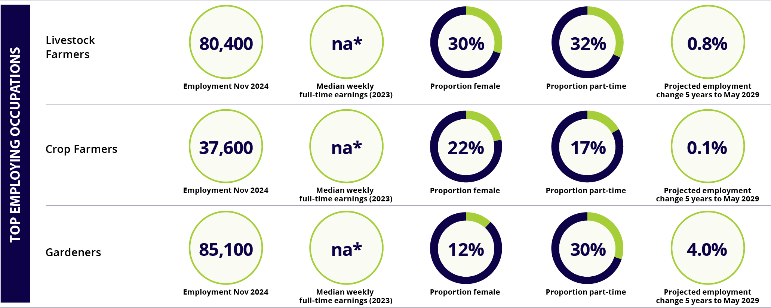
Note: figures are for occupation employment across all industries. *na = not available
ABS, Labour Force, Australia, Detailed, November 2024; Employment Projections produced by Victoria University for Jobs and Skills Australia, 2024 (May 2024 to May 2034). KPMG, Skills Impact, Agricultural workforce digital capability framework, 2019

Jobs by location

National employment overview
The Australian labour market was strong over the year to November 2024, with the number of people employed increasing by 334,500 (or 2.4%), to stand at a record high of 14,535,500. Full-time employment accounted for more than two thirds (68.2%) of the increase over the period. Reflecting the underlying strength and resilience of the Australian labour market, the unemployment rate stood at just 3.9% in November 2024, while the participation rate, at 67.0%, remained close to its equal record high of 67.1%.
Nationally, the number of advertised job vacancies has trended down over the year to December 2024 (down by 17.4%). Despite this, vacancy numbers remain relatively high at around 25% above levels recorded in 2019.
Unemployment rate and annual employment growth, Australia, November 2014 to November 2024
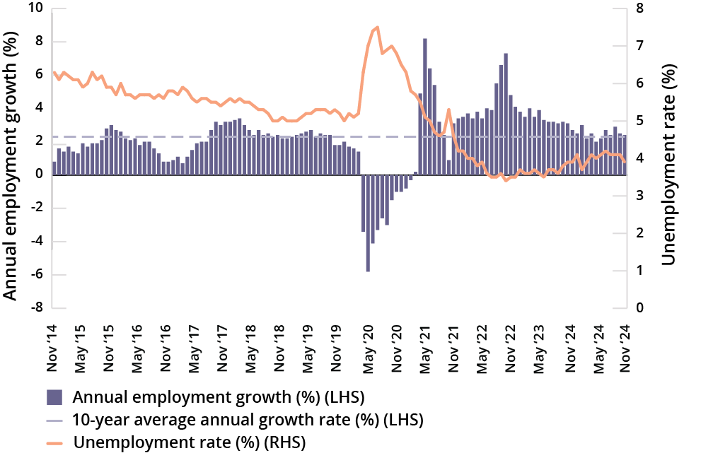

Youth labour market
There were a record 2,254,300 young people (15–24 years) employed in November 2024, up by 72,600 (or 3.3%) over the year. The increase in employment for young people was due to strong growth in part-time employment (up by 90,200 or 7.4%). The youth unemployment rate fell by 1.1 percentage points over the year, to 8.8% in November 2024, although it remains more than double the rate recorded for all people. The participation rate for young people also fell, by 0.7 percentage points over the year, to 70.9% in November 2024.
Despite reasonably strong labour market conditions, the number of young people who were long-term unemployed rose significantly, by 10,300 (or 46.6%) over the year, to 32,400 in November 2024. Youth also comprised 27.0% of the total long-term unemployment pool in November 2024, above the 21.1% recorded a year earlier.
It is important to note that young people are particularly vulnerable during economic downturns, as they tend to have fewer skills and less experience than older people and are often the first to be let go by employers during times of economic difficulty.
Employment by state and territory
 | Employment |  |  | Employment profile |  | Unemployment rate |  | Participation rate
 | Nov 2024 | Change over the year |  | Part-time | Female | Nov 2024 | Change over the year | Nov 2024 | Change over the year
Region | ‘000 | ‘000 | % | % | % | % | % pts | % | % pts
New South Wales | 4,483.4 | 48.2 | 1.1 | 30 | 48 | 3.9 | 0.4 | 66.2 | -0.3
Victoria | 3,805.8 | 129.9 | 3.5 | 32 | 47 | 4.2 | 0.1 | 68.2 | 0.7
Queensland | 2,987.1 | 107.2 | 3.7 | 30 | 49 | 3.9 | -0.4 | 67.4 | 0.4
South Australia | 947.4 | -3.4 | -0.4 | 34 | 47 | 3.9 | 0.0 | 62.7 | -1.2
Western Australia | 1,631.6 | 51.2 | 3.2 | 31 | 46 | 3.3 | -0.5 | 68.8 | -0.3
Tasmania | 279.8 | -5.0 | -1.8 | 37 | 48 | 3.9 | 0.1 | 60.2 | -1.4
Northern Territory | 138.0 | 0.8 | 0.6 | 22 | 51 | 3.9 | 1.0 | 71.6 | -1.2
Australian Capital Territory | 273.4 | 8.2 | 3.1 | 23 | 49 | 2.9 | -0.8 | 72.4 | 0.1
Australia | 14,535.5 | 334.5 | 2.4 | 31 | 48 | 3.9 | 0.0 | 67.0 | 0.0
ABS, Labour Force, Australia, November 2024; Jobs and Skills Australia, Internet Vacancy Index, seasonally adjusted, December 2024

New South Wales
New South Wales is the largest employing state in Australia, with Sydney accounting for more than two-thirds of state employment.
The largest employing industry in New South Wales is Health Care and Social Assistance, followed by Professional, Scientific and Technical Services. Retail Trade, Construction and Education and Training are also major employing industries in this state.

Current conditions
There were a record 4,483,400 people employed in New South Wales in November 2024, up by 48,200 (or 1.1%) over the year but down from the strong growth of 117,600 (or 2.7%) recorded in the previous year.
Top employing industries
 | Employ’t  Nov 2024 | Share of  state emp't | 5 year  change to  Nov 2024
Industries | ‘000 | % | ‘000 | %
Health Care and Social Assistance | 684.2 | 15 | 138.6 | 25.4
Professional, Scientific and Technical Services | 471.8 | 10 | 60.8 | 14.8
Retail Trade | 418.0 | 9 | 14.7 | 3.6
Construction | 414.0 | 9 | 41.2 | 11.0
Education and Training | 378.2 | 8 | 50.4 | 15.4
The unemployment rate in New South Wales increased by 0.4 percentage points over the year, to 3.9% in November 2024. The state’s participation rate decreased by 0.3 percentage points over the same period, to 66.2% in November 2024, and is lower than the 67.0% recorded nationally.
Reflecting the overall softening labour market in the state, conditions for young people have also weakened. Youth employment in New South Wales fell slightly (by 1,900 or 0.3%) over the year, to 681,100 in November 2024, while the youth unemployment rate increased by 1.6 percentage points over the period, to 8.7% in November 2024. The participation rate for young people decreased over the period, by 1.4 percentage points, to 68.9% in November 2024.
Over the year to December 2024, the number of job advertisements in New South Wales fell by 17.8%. However, vacancy numbers overall remain at relatively high levels with plenty of job opportunities available. Over the year, vacancies in New South Wales continued to increase for Secondary School Teachers, Commercial Cleaners, and Real Estate Sales Agents. More information on these occupations can be found in the Occupation Matrix (page 126).
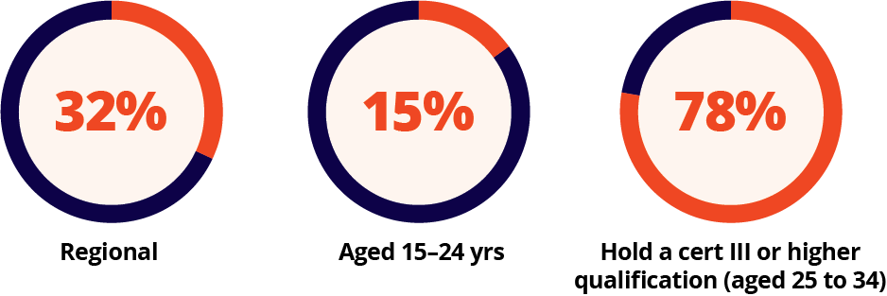
Employment by region, New South Wales
 | Employment |  |  | Employment profile |  | Unemployment rate |  | Participation rate
 | Nov 2024 | Change over the year |  | Part-time | Female | Nov 2024 | Change over the year | Nov 2024 | Change over the year
Region | ‘000 | ‘000 | % | % | % | % | % pts | % | % pts
Greater Sydney | 3,051.8 | 32.7 | 1.1 | 28 | 47 | 3.8 | 0.5 | 68.2 | -0.8
Capital Region | 124.0 | 1.2 | 1.0 | 33 | 47 | 2.9 | 0.4 | 63.3 | 0.5
New South Wales – Central West | 115.8 | 1.0 | 0.8 | 32 | 48 | 3.1 | 0.0 | 68.7 | 0.4
Coffs Harbour – Grafton | 66.5 | 1.0 | 1.5 | 39 | 48 | 4.2 | 0.4 | 55.7 | 0.7
Far West and Orana | 56.5 | 0.3 | 0.6 | 27 | 46 | 3.9 | 0.5 | 62.1 | 0.6
Hunter Valley exc Newcastle | 151.0 | 3.7 | 2.5 | 31 | 47 | 3.5 | 0.2 | 62.6 | 0.7
Illawarra | 167.2 | 1.8 | 1.1 | 35 | 51 | 3.9 | 0.1 | 64.7 | 0.1
Mid North Coast | 99.4 | 1.9 | 1.9 | 39 | 50 | 3.9 | 0.4 | 51.8 | 0.8
Murray | 66.3 | 0.1 | 0.2 | 26 | 47 | 3.6 | 0.3 | 66.0 | -0.1
New England and North West | 97.5 | 0.8 | 0.8 | 33 | 47 | 4.3 | 0.4 | 66.1 | 0.6
Newcastle and Lake Macquarie | 220.8 | 3.8 | 1.7 | 33 | 49 | 3.5 | -0.1 | 67.8 | 0.3
Richmond – Tweed | 128.7 | 1.9 | 1.5 | 43 | 50 | 3.3 | 0.2 | 61.0 | 0.8
Riverina | 83.6 | -0.3 | -0.4 | 30 | 50 | 3.4 | 0.6 | 65.9 | 0.4
Southern Highlands and Shoalhaven | 73.3 | 0.3 | 0.4 | 39 | 52 | 3.4 | 0.5 | 56.0 | 0.4
New South Wales | 4,483.4 | 48.2 | 1.1 | 30 | 48 | 3.9 | 0.4 | 66.2 | -0.3
Australia | 14,535.5 | 334.5 | 2.4 | 31 | 48 | 3.9 | 0.0 | 67.0 | 0.0
ABS, Labour Force, Australia, November 2024; ABS, Labour Force, Australia, Detailed, November 2024; ABS, Education and Work, Australia, 2024; Jobs and Skills Australia, Internet Vacancy Index, seasonally adjusted and 3-month average data, December 2024.

Victoria
Victoria is Australia’s second largest employing state, with around 3.8 million workers. Almost 80% of state employment is in Melbourne.
The largest employing industry in Victoria is Health Care and Social Assistance, followed by Professional, Scientific and Technical Services. Construction, Retail Trade and Education and Training are also major employing industries in this state.

Current conditions
Labour market conditions were strong in Victoria over the year to November 2024. There were a record 3,805,800 people employed in the state in November 2024, up by 129,900 (or 3.5%) over the year. Full-time employment accounted for the majority (54.5%) of growth over the period.
While the unemployment rate in Victoria increased by 0.1 percentage points over the year, to 4.2% in November 2024, this occurred concurrently with a strong rise in the state’s participation rate (up by 0.7 percentage points) to 68.2%, above the 67.0% recorded nationally.
Top employing industries
 | Employ’t  Nov 2024 | Share of  state emp't | 5 year  change to  Nov 2024
Industries | ‘000 | % | ‘000 | %
Health Care and Social Assistance | 591.6 | 16 | 143.3 | 32.0
Professional, Scientific and Technical Services | 386.9 | 10 | 68.9 | 21.7
Construction | 359.0 | 10 | 49.5 | 16.0
Retail Trade | 356.1 | 9 | 13.8 | 4.0
Education and Training | 331.3 | 9 | 49.1 | 17.4
Despite an overall strengthening in the state’s labour market, conditions for young people have softened. Youth employment in Victoria increased by a moderate 8,500 (or 1.6%) over the year, to a record 546,700 in November 2024, while the youth unemployment rate rose by 1.6 percentage points over the period, to 10.5% in November 2024. The participation rate for young people decreased over the period, by 0.7 percentage points, to 68.6% in November 2024.
Over the year to December 2024, the number of job advertisements in Victoria fell by 23.5% (the largest decline of any state or territory). Although, vacancy numbers overall remain at relatively high levels with plenty of job opportunities available. Over the year, vacancies in Victoria continue to increase for Chefs, General Practitioners and Resident Medical Officers, and Insurance Investigators, Loss Adjusters and Risk Surveyors. More information on these occupations can be found in the Occupation Matrix (page 126).
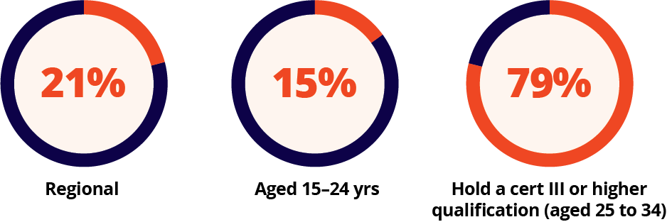
Employment by region, Victoria
 | Employment |  |  | Employment profile |  | Unemployment rate |  | Participation rate
 | Nov 2024 | Change over the year |  | Part-time | Female | Nov 2024 | Change over the year | Nov 2024 | Change over the year
Region | ‘000 | ‘000 | % | % | % | % | % pts | % | % pts
Greater Melbourne | 2,991.2 | 112.9 | 3.9 | 31 | 47 | 4.2 | 0.2 | 69.6 | 0.6
Ballarat | 91.0 | 2.7 | 3.1 | 34 | 49 | 3.3 | 0.3 | 62.4 | 1.2
Bendigo | 86.7 | 2.3 | 2.7 | 36 | 52 | 3.1 | 0.1 | 62.9 | 1.2
Geelong | 184.6 | 5.3 | 3.0 | 34 | 49 | 3.1 | 0.3 | 66.2 | 0.9
Hume | 97.5 | 1.5 | 1.6 | 36 | 49 | 2.7 | 0.1 | 64.2 | 0.6
Latrobe – Gippsland | 148.1 | 3.1 | 2.1 | 35 | 48 | 3.5 | -0.2 | 59.3 | 0.5
Victoria – North West | 77.9 | 0.6 | 0.7 | 31 | 47 | 3.0 | 0.0 | 62.7 | 0.6
Shepparton | 68.0 | 0.5 | 0.7 | 33 | 44 | 3.4 | 0.1 | 61.8 | 0.5
Warrnambool and South West | 66.9 | 0.4 | 0.6 | 34 | 47 | 2.5 | 0.1 | 64.1 | 0.3
Victoria | 3,805.8 | 129.9 | 3.5 | 32 | 47 | 4.2 | 0.1 | 68.2 | 0.7
Australia | 14,535.5 | 334.5 | 2.4 | 31 | 48 | 3.9 | 0.0 | 67.0 | 0.0
ABS, Labour Force, Australia, November 2024; ABS, Labour Force, Australia, Detailed, November 2024; ABS, Education and Work, Australia, 2024; Jobs and Skills Australia, Internet Vacancy Index, seasonally adjusted and 3-month average data, December 2024.

Queensland
Queensland is the third largest employing state in Australia. Regional Queensland accounts for a relatively large share of state employment, while around half of employment is located in Brisbane and a further 13% is in the Gold Coast area.
Health Care and Social Assistance is the largest employing industry in Queensland, with around 16% of the state’s employment, followed by Retail Trade and Construction.

Current conditions
The Queensland labour market strengthened over the year to November 2024. There were 2,987,100 people employed in the state in November 2024, up by 107,200 (or 3.7%) over the year. Full-time employment accounted for the vast majority (87.1%) of growth over the period.
The unemployment rate in Queensland declined by 0.4 percentage points over the year, to 3.9% in November 2024, while the state’s participation rate rose by 0.4 percentage points to 67.4%, above the 67.0% recorded nationally.
Top employing industries
 | Employ’t  Nov 2024 | Share of  state emp't | 5 year  change to  Nov 2024
Industries | ‘000 | % | ‘000 | %
Health Care and Social Assistance | 474.9 | 16 | 110.5 | 30.3
Retail Trade | 296.0 | 10 | 44.2 | 17.5
Construction | 286.9 | 10 | 48.3 | 20.3
Education and Training | 253.1 | 9 | 39.0 | 18.2
Professional, Scientific and Technical Services | 228.4 | 8 | 45.4 | 24.8
Young people in the state also recorded strong employment growth over the year, up by 15,800 (or 3.4%) to a record 486,000 in November 2024. The youth unemployment rate in Queensland rose by 0.6 percentage points over the year, to 9.3% in November 2024, although the participation rate for young people also increased over the period, by 0.2 percentage points, to 74.5%.
Over the year to December 2024, the number of job advertisements in Queensland fell by 10.1%. While the number of new advertisements has slowed over the year, there remains plenty of job opportunities available. Over the year, vacancies in Queensland continued to increase for Welfare Support Workers, Truck Drivers and Retail Managers. More information on these occupations can be found in the Occupation Matrix (page 126).
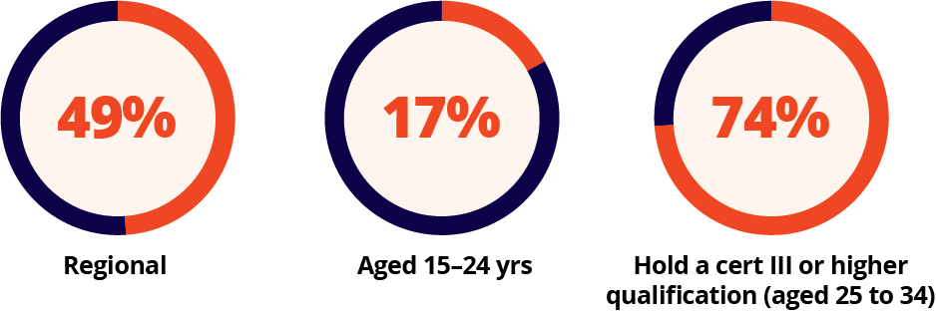
Employment by region, Queensland
 | Employment |  |  | Employment profile |  | Unemployment rate |  | Participation rate
 | Nov 2024 | Change over the year |  | Part-time | Female | Nov 2024 | Change over the year | Nov 2024 | Change over the year
Region | ‘000 | ‘000 | % | % | % | % | % pts | % | % pts
Greater Brisbane | 1,519.0 | 56.9 | 3.9 | 30 | 49 | 3.8 | -0.4 | 68.9 | 0.2
Cairns | 147.6 | 3.7 | 2.6 | 29 | 50 | 3.7 | -0.4 | 68.9 | 0.2
Darling Downs – Maranoa | 70.0 | 1.8 | 2.6 | 34 | 45 | 2.9 | -0.1 | 66.3 | 0.9
Central Queensland | 131.1 | 3.8 | 3.0 | 25 | 47 | 4.1 | -0.4 | 70.5 | 0.6
Gold Coast | 397.4 | 16.8 | 4.4 | 34 | 48 | 2.9 | -0.1 | 69.4 | 1.0
Mackay – Isaac – Whitsunday | 112.2 | 3.2 | 3.0 | 26 | 45 | 2.5 | -0.4 | 73.3 | 0.5
Queensland – Outback | 40.3 | 0.3 | 0.8 | 25 | 49 | 5.5 | -0.3 | 66.8 | 0.2
Sunshine Coast | 225.5 | 8.5 | 3.9 | 39 | 49 | 2.8 | -0.3 | 63.4 | 0.6
Toowoomba | 86.1 | 2.7 | 3.2 | 31 | 50 | 3.3 | -0.4 | 62.9 | 0.3
Townsville | 129.4 | 3.5 | 2.8 | 27 | 50 | 4.3 | -0.3 | 68.2 | 0.6
Wide Bay | 140.5 | 5.0 | 3.7 | 39 | 50 | 4.9 | -1.3 | 52.5 | 0.1
Queensland | 2,987.1 | 107.2 | 3.7 | 30 | 49 | 3.9 | -0.4 | 67.4 | 0.4
Australia | 14,535.5 | 334.5 | 2.4 | 31 | 48 | 3.9 | 0.0 | 67.0 | 0.0
ABS, Labour Force, Australia, November 2024; ABS, Labour Force, Australia, Detailed, November 2024; ABS, Education and Work, Australia, 2024; Jobs and Skills Australia, Internet Vacancy Index, seasonally adjusted and 3-month average data, December 2024.

South Australia
South Australia has a relatively small workforce, with around 7% of national employment. Employment is concentrated in Adelaide, which accounts for 80% of state employment.
While there are employment opportunities available across all industries, Health Care and Social Assistance is South Australia’s largest employing industry, followed by Retail Trade. Construction, Education and Training and Manufacturing are also major employing industries in this state.

Current conditions
The South Australian labour market softened over the year. The number of employed people in the state fell by 3,400 (or 0.4%) over the period, to 947,400 in November 2024.
The unemployment rate in South Australia was steady over the year, at 3.9% in November 2024, although the state’s participation rate decreased by 1.2 percentage points, to 62.7%, well below the 67.0% recorded nationally.
Top employing industries
 | Employ’t  Nov 2024 | Share of  state emp't | 5 year  change to  Nov 2024
Industries | ‘000 | % | ‘000 | %
Health Care and Social Assistance | 173.0 | 18 | 39.6 | 29.7
Retail Trade | 92.0 | 10 | 2.4 | 2.7
Construction | 83.6 | 9 | 12.9 | 18.2
Education and Training | 76.5 | 8 | 7.2 | 10.4
Manufacturing | 71.2 | 7 | 0.7 | 1.0
Reflecting the overall softening labour market in the state, conditions for young people have also weakened. Youth employment in South Australia fell slightly (by 1,900 or 1.3%) over the year, to 145,100 in November 2024, while the youth unemployment rate increased by 0.6 percentage points over the period, to 9.6% in November 2024. The participation rate for young people decreased considerably over the period, by 2.1 percentage points, to 70.8% in November 2024.
Over the year to December 2024, the number of job advertisements in South Australia fell by 11.5%, but there remains plenty of job opportunities available. Over the year, vacancies in South Australia continue to increase for Registered Nurses, Chefs and Forklift Drivers. More information on these occupations can be found in the Occupation Matrix (page 126).
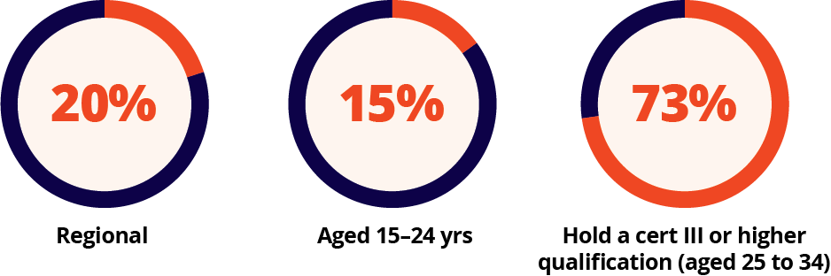
Employment by region, South Australia
 | Employment |  |  | Employment profile |  | Unemployment rate |  | Participation rate
 | Nov 2024 | Change over the year |  | Part-time | Female | Nov 2024 | Change over the year | Nov 2024 | Change over the year
Region | ‘000 | ‘000 | % | % | % | % | % pts | % | % pts
Greater Adelaide | 760.6 | -1.2 | -0.2 | 35 | 48 | 3.6 | -0.1 | 64.2 | -1.3
Barossa – Yorke – Mid North | 55.1 | -0.7 | -1.3 | 36 | 45 | 3.6 | 0.1 | 56.8 | -1.2
South Australia – Outback | 39.2 | -0.8 | -1.9 | 33 | 46 | 5.3 | 0.4 | 58.9 | -1.0
South Australia – South East | 94.1 | -0.7 | -0.8 | 38 | 46 | 3.3 | 0.0 | 56.7 | -0.9
South Australia | 947.4 | -3.4 | -0.4 | 34 | 47 | 3.9 | 0.0 | 62.7 | -1.2
Australia | 14,535.5 | 334.5 | 2.4 | 31 | 48 | 3.9 | 0.0 | 67.0 | 0.0
ABS, Labour Force, Australia, November 2024; ABS, Labour Force, Australia, Detailed, November 2024; ABS, Education and Work, Australia, 2024; Jobs and Skills Australia, Internet Vacancy Index, seasonally adjusted and 3-month average data, December 2024.

Western Australia
Western Australia is the fourth largest employing state (accounting for 11% of the national workforce).
The largest employing industry in Western Australia is Health Care and Social Assistance. A large proportion of Western Australian workers are employed in the Mining industry (around one in ten workers). Reflecting this, around 50% of national Mining employment is in this state.

Current conditions
There were a record 1,631,600 people employed in Western Australia in November 2024, up strongly, by 51,200 (or 3.2%) over the year, but down from the robust growth of 64,100 (or 4.2%) recorded in the previous year.
The unemployment rate in Western Australia fell by 0.5 percentage points over the year, to 3.3% in November 2024. While the state’s participation rate also declined, by 0.3 percentage points, to 68.8% in November 2024, it remains well above the 67.0% recorded nationally.

Top employing industries
 | Employ’t  Nov 2024 | Share of  state emp't | 5 year  change to  Nov 2024
Industries | ‘000 | % | ‘000 | %
Health Care and Social Assistance | 236.2 | 14 | 63.1 | 36.5
Mining | 162.8 | 10 | 39.2 | 31.7
Construction | 157.3 | 10 | 28.3 | 21.9
Education and Training | 134.8 | 8 | 24.1 | 21.8
Retail Trade | 134.5 | 8 | 11.1 | 9.0
The number of young people employed in Western Australia increased by 5,400 (or 2.3%) over the year, to a record 235,500 in November 2024, although the youth unemployment rate increased by 0.9 percentage points over the period, to 9.4% in November 2024. The participation rate for young people decreased over the period, by 0.6 percentage points, to 71.2% in November 2024.
Over the year to December 2024, the number of job advertisements in Western Australia fell by 20.2%, but there remains plenty of job opportunities available. Over the year, vacancies in Western Australia continue to increase for Café Workers, General Practitioners and Resident Medical Officers and Electrical Distribution Trades Workers. More information on these occupations can be found in the Occupation Matrix (page 126).
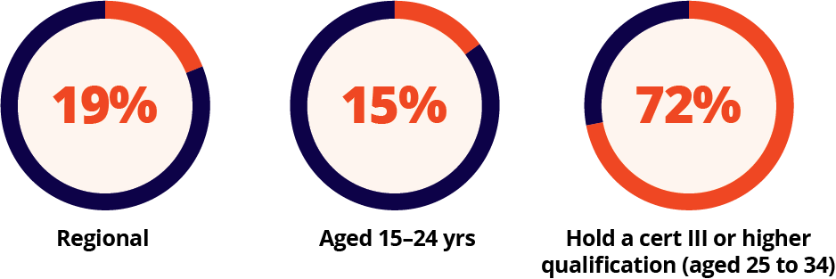
Employment by region, Western Australia
 | Employment |  |  | Employment profile |  | Unemployment rate |  | Participation rate
 | Nov 2024 | Change over the year |  | Part-time | Female | Nov 2024 | Change over the year | Nov 2024 | Change  over the year
Region | ‘000 | ‘000 | % | % | % | % | % pts | % | % pts
Greater Perth | 1,337.4 | 47.7 | 3.7 | 32 | 47 | 3.0 | -0.5 | 69.7 | -0.3
Bunbury | 109.8 | 2.2 | 2.1 | 34 | 48 | 2.6 | -0.4 | 66.5 | -0.2
Western Australia – Outback (North and South) | 122.0 | 1.5 | 1.2 | 23 | 44 | 3.7 | -0.7 | 69.9 | -0.4
Western Australia – Wheat Belt | 76.4 | 0.7 | 1.0 | 30 | 46 | 2.5 | 0.0 | 64.3 | -0.2
Western Australia | 1,631.6 | 51.2 | 3.2 | 31 | 46 | 3.3 | -0.5 | 68.8 | -0.3
Australia | 14,535.5 | 334.5 | 2.4 | 31 | 48 | 3.9 | 0.0 | 67.0 | 0.0
ABS, Labour Force, Australia, November 2024; ABS, Labour Force, Australia, Detailed, November 2024; ABS, Education and Work, Australia, 2024; Jobs and Skills Australia, Internet Vacancy Index, seasonally adjusted and 3-month average data, December 2024

Tasmania
While Tasmania is the smallest employing state, there are employment opportunities available across all industries.
Health Care and Social Assistance is the largest employing industry (accounting for around 17% of the Tasmanian workforce), followed by Retail Trade and Construction.
Tasmania has the most regionally diverse workforce in Australia, with more than half of all workers employed outside of Hobart.

Current conditions
The Tasmanian labour market softened over the year, with the number of employed people in the state falling by 5,000 (or 1.8%) over the period, to 279,800 in November 2024.
The unemployment rate in Tasmania increased by 0.1 percentage points over the year, to 3.9% in November 2024, while the state’s participation rate decreased by 1.4 percentage points to 60.2%, well below the 67.0% recorded nationally.
Top employing industries
 | Employ’t  Nov 2024 | Share of  state emp't | 5 year  change to  Nov 2024
Industries | ‘000 | % | ‘000 | %
Health Care and Social Assistance | 47.9 | 17 | 7.2 | 17.8
Retail Trade | 28.1 | 10 | 0.9 | 3.4
Construction | 25.9 | 9 | 4.4 | 20.3
Education and Training | 25.2 | 9 | 2.6 | 11.6
Public Administration and Safety | 23.2 | 8 | 4.0 | 20.7
The number of young people employed in Tasmania was at a similar level as the year before to stand at 39,500 in November 2024. The youth unemployment rate in the state decreased by 0.1 percentage points over the year, to 10.3% in November 2024, although the participation rate for young people also decreased over the period, by 0.2 percentage points, to 69.2% in November 2024.
Over the year to December 2024, the number of job advertisements in Tasmania decreased by 14.4%, but there remains plenty of job opportunities available. Over the year, vacancies in Tasmania continued to increase for General Practitioners and Resident Medical Officers, Retail Managers, and Contract, Program and Project Administrators. More information on these occupations can be found in the Occupation Matrix (page 126).
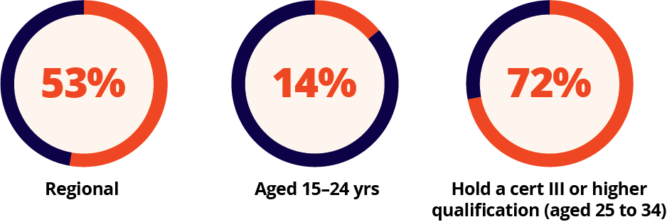
Employment by region, Tasmania
 | Employment |  |  | Employment profile |  | Unemployment rate |  | Participation rate
 | Nov 2024 | Change over the year |  | Part-time | Female | Nov 2024 | Change over the year | Nov 2024 | Change  over the year
Region | ‘000 | ‘000 | % | % | % | % | % pts | % | % pts
Greater Hobart | 129.6 | -2.4 | -1.8 | 38 | 50 | 3.5 | 0.1 | 62.7 | -1.6
Launceston and North East | 76.5 | -1.4 | -1.9 | 34 | 48 | 3.6 | 0.0 | 60.4 | -1.4
Tasmania – South East | 20.1 | -0.1 | -0.3 | 44 | 46 | 3.7 | 0.0 | 54.9 | -0.8
Tasmania – West and North West | 54.7 | -1.1 | -2.0 | 37 | 47 | 3.8 | 0.0 | 56.6 | -1.3
Tasmania | 279.8 | -5.0 | -1.8 | 37 | 48 | 3.9 | 0.1 | 60.2 | -1.4
Australia | 14,535.5 | 334.5 | 2.4 | 31 | 48 | 3.9 | 0.0 | 67.0 | 0.0
ABS, Labour Force, Australia, November 2024; ABS, Labour Force, Australia, Detailed, November 2024; ABS, Education and Work, Australia, 2024; Jobs and Skills Australia, Internet Vacancy Index, seasonally adjusted and 3-month average data, December 2024.

Northern Territory
The Northern Territory has the smallest workforce of any state or territory. Around 60% of Northern Territory employment is in Darwin.
Health Care and Social Assistance is the Northern Territory’s largest employing industry, accounting for almost 20% territory workers, followed by Public Administration and Safety. These 2 industries together account for more than a third of all workers in the Northern Territory.

Current conditions
There were 138,000 people employed in the Northern Territory in November 2024, a similar level to the year before.
The unemployment rate in the Northern Territory decreased by 1.0 percentage point over the year, to 3.9% in November 2024. While the territory’s participation rate also fell over the period, by 1.2 percentage points, to 71.6% in November 2024, it remains well above the 67.0% recorded nationally.
Top employing industries
 | Employ’t  Nov 2024 | Share of  state emp't | 5 year  change to  Nov 2024
Industries | ‘000 | % | ‘000 | %
Health Care and Social Assistance | 26.1 | 19 | 6.2 | 31.5
Public Administration and Safety | 21.6 | 16 | 0.6 | 2.9
Education and Training | 12.9 | 9 | 0.0 | 0.2
Construction | 10.7 | 8 | -0.5 | -4.1
Retail Trade | 10.2 | 7 | -0.4 | -3.7
Despite the gradual softening in the territory’s labour market, conditions for young people have improved. Youth employment in the Northern Territory increased by 1,500 (or 8.1%) over the year, to 19,600 in November 2024, while the youth unemployment rate fell by 2.5 percentage points over the period, to 9.2% in November 2024. The participation rate for young people in the territory increased over the period, by 2.0 percentage points, to 66.2% in November 2024.
Over the year to December 2024, the number of job advertisements in the Northern Territory decreased by 5.8% (the smallest decrease of any state or territory). While the number of new advertisements has decreased over the year, there remains plenty of job opportunities available. Over the year, vacancies in the Northern Territory continued to increase for General Clerks, General Practitioners and Resident Medical Officers, and Occupational Therapists. More information on these occupations can be found in the Occupation Matrix (page 126).
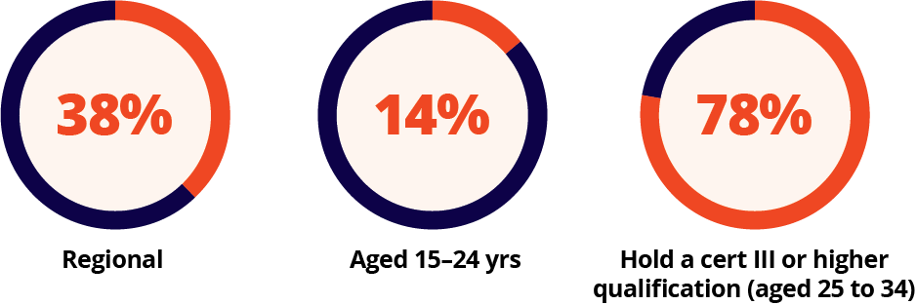

Employment by region, Northern Territory
 | Employment |  |  | Employment profile |  | Unemployment rate |  | Participation rate
 | Nov 2024 | Change over the year |  | Part-time | Female | Nov 2024 | Change over the year | Nov 2024 | Change  over the year
Region | ‘000 | ‘000 | % | % | % | % | % pts | % | % pts
Greater Darwin | 86.5 | 0.5 | 0.6 | 20 | 50 | 2.6 | -1.2 | 74.1 | -1.5
Northern Territory – Outback | 52.2 | 0.3 | 0.6 | 23 | 51 | 5.3 | -0.6 | 68.4 | -0.8
Northern Territory | 138.0 | 0.8 | 0.6 | 22 | 51 | 3.9 | 1.0 | 71.6 | -1.2
Australia | 14,535.5 | 334.5 | 2.4 | 31 | 48 | 3.9 | 0.0 | 67.0 | 0.0
ABS, Labour Force, Australia, November 2024; ABS, Labour Force, Australia, Detailed, November 2024; ABS, Education and Work, Australia, 2024; Jobs and Skills Australia, Internet Vacancy Index, seasonally adjusted and 3-month average data, December 2024.

Australian Capital Territory
The Australian Capital Territory has the most highly educated workforce in Australia, with around half of workers holding a bachelor degree or higher. Almost 30% of the Australian Capital Territory workforce is employed in the Public Administration and Safety industry. The second largest employing industry is Professional, Scientific and Technical Services, followed by Health Care and Social Assistance.

Current conditions
Labour market conditions were strong in the Australian Capital Territory over the year to November 2024. There were a record 273,400 people employed in the territory in November 2024, up by 8,200 (or 3.1%) over the year.
The unemployment rate in the Australian Capital Territory fell by 0.8 percentage points over the year, to 2.9% in November 2024, while the territory’s participation rate rose, by 0.1 percentage points, to 72.4% in November 2024, well above the 67.0% recorded nationally.

Top employing industries
 | Employ’t  Nov 2024 | Share of  state emp't | 5 year  change to  Nov 2024
Industries | ‘000 | % | ‘000 | %
Public Administration and Safety | 79.7 | 29 | 10.2 | 14.7
Professional, Scientific and Technical Services | 36.5 | 13 | 8.1 | 28.6
Health Care and Social Assistance | 34.6 | 13 | 7.2 | 26.4
Education and Training | 24.1 | 9 | 2.6 | 12.2
Construction | 17.2 | 6 | 0.1 | 0.4
Young people in the Australian Capital Territory also recorded solid employment growth over the year, up by 1,400 (or 3.2%), to stand at an equal record high, of 43,800 in November 2024. The youth unemployment rate in the territory rose by 1.4 percentage points over the year, to 8.8% in November 2024, although the participation rate also increased over the period, by 2.4 percentage points to 76.5%.
Over the year to December 2024, the number of job advertisements in the Australian Capital Territory fell by 19.4%. While the number of new advertisements has slowed in recent months, there remains plenty of job opportunities available. Over the year, vacancies in the Australian Capital Territory continued to increase for Chefs, Product Quality Controllers and General Practitioners and Resident Medical Officers. More information on these occupations can be found in the Occupation Matrix (page 126).
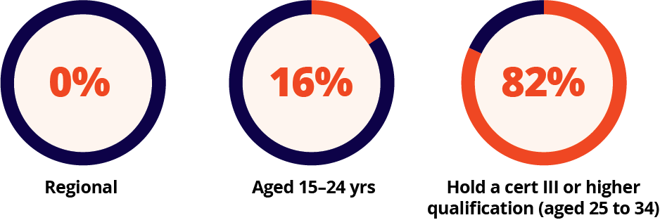
Employment by region, Australian Capital Territory
 | Employment |  |  | Employment profile |  | Unemployment rate |  | Participation rate
 | Nov 2024 | Change over the year |  | Part-time | Female | Nov 2024 | Change over the year | Nov 2024 | Change  over the year
Region | ‘000 | ‘000 | % | % | % | % | % pts | % | % pts
Australian Capital Territory | 273.4 | 8.2 | 3.1 | 23 | 49 | 2.9 | -0.8 | 72.4 | 0.1
Australia | 14,535.5 | 334.5 | 2.4 | 31 | 48 | 3.9 | 0.0 | 67.0 | 0.0
ABS, Labour Force, Australia, November 2024; ABS, Education and Work, Australia, 2024; Jobs and Skills Australia, Internet Vacancy Index, seasonally adjusted data, December 2024.

Jobs by industry
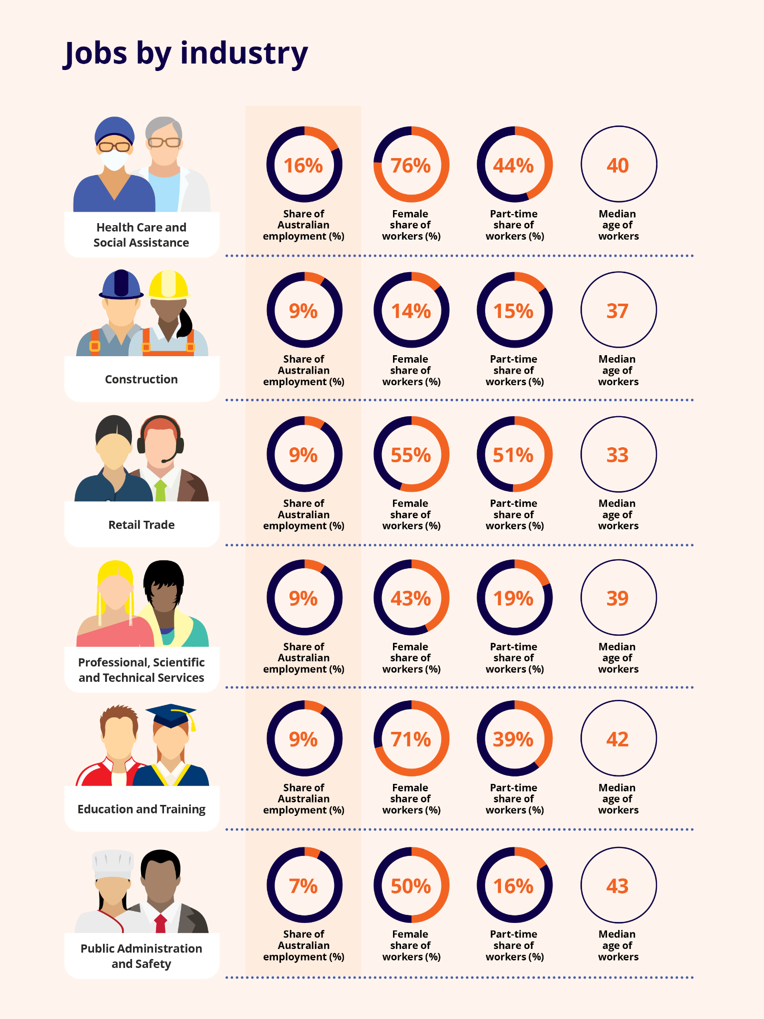

Industry overview

What is an industry
Industries are formed by grouping together businesses and other organisations that are mainly engaged in undertaking similar activities. Within each industry, workers are employed across a wide range of occupations of varying skill levels. For example, the Construction industry includes people employed as Carpenters and Joiners, Construction Managers, Accountants, Electricians, and Building and Plumbing Labourers.
There are 19 broad industries (divisions) in the Australian and New Zealand Standard Industrial Classification (ANZSIC) and these industries are discussed in more detail in this section of Australian Jobs (pages 64 to 104).

Which are the largest employing industries in Australia?
There are 5 industries that each provide jobs for more than one million workers. More than 50% of Australian workers are employed in one of these 5 industries.
- Health Care and Social Assistance (2,266,700)
- Construction (1,359,600)
- Retail Trade (1,352,000)
- Professional, Scientific and Technical Services (1,311,900)
- Education and Training (1,246,100)
Employment by industry
 | Employment |  |  | Employment profile |  |  | Workforce  educational profile |  |  | Projected employment
 | Nov 2024 | 1 year change to Nov 2024 |  | Part-time | Female | Aged 15 to 24 years | Bachelor degree or higher | Cert III or higher VET qual | No post-school qual | 5 year change to May 2029
Industry | ‘000 | ‘000 | % | % | % | % | % | % | % | %
Health Care and Social Assistance | 2,266.7 | 70.2 | 3.2 | 44 | 76 | 11 | 52 | 27 | 18 | 12.5
Construction | 1,359.6 | 31.7 | 2.4 | 15 | 14 | 16 | 14 | 47 | 33 | 7.0
Retail Trade | 1,352.0 | 25.2 | 1.9 | 51 | 55 | 32 | 21 | 20 | 55 | 3.5
Education and Training | 1,246.1 | 54.9 | 4.6 | 39 | 71 | 10 | 66 | 17 | 14 | 5.9
Public Administration and Safety | 965.9 | 34.6 | 3.7 | 16 | 50 | 7 | 51 | 27 | 19 | 4.4
Accommodation and Food Services | 965.9 | 42.7 | 4.6 | 61 | 53 | 47 | 19 | 21 | 56 | 5.9
Manufacturing | 891.7 | -16.4 | -1.8 | 16 | 29 | 12 | 25 | 33 | 37 | -0.2
Transport, Postal and Warehousing | 741.5 | 14.5 | 2.0 | 22 | 22 | 9 | 24 | 28 | 42 | 5.0
Other Services | 542.4 | 20.7 | 4.0 | 32 | 44 | 15 | 20 | 50 | 25 | 3.5
Financial and Insurance Services | 541.2 | -7.8 | -1.4 | 13 | 50 | 6 | 60 | 20 | 18 | 7.8
Administrative and Support Services | 431.9 | 3.0 | 0.7 | 41 | 52 | 11 | 29 | 29 | 37 | 3.4
Wholesale Trade | 367.5 | -1.7 | -0.5 | 17 | 34 | 9 | 30 | 27 | 39 | 7.2
Mining | 314.8 | 4.7 | 1.5 | 5 | 21 | 7 | 27 | 41 | 28 | 2.3
Agriculture, Forestry and Fishing | 309.4 | 0.0 | 0.0 | 29 | 32 | 10 | 16 | 28 | 48 | 2.3
Arts and Recreation Services | 267.6 | 10.1 | 3.9 | 46 | 50 | 29 | 34 | 29 | 33 | 5.2
Rental, Hiring and Real Estate Services | 244.0 | 14.1 | 6.1 | 23 | 48 | 11 | 39 | 30 | 25 | 8.4
Electricity, Gas, Water and Waste Services | 194.5 | 14.4 | 8.0 | 11 | 27 | 7 | 42 | 29 | 26 | 7.2
Information Media and Telecommunications | 185.6 | -2.3 | -1.2 | 20 | 41 | 11 | 56 | 24 | 19 | 6.6
All industries | 14,535.5 | 334.5 | 2.4 | 31 | 48 | 15 | 39 | 27 | 30 | 6.6
ABS, Labour Force, Australia, November 2024; ABS, Labour Force, Australia, Detailed, November 2024, ABS, Education and Work, Australia, 2024; Employment Projections produced by Victoria University for Jobs and Skills Australia (May 2024 to May 2034).

Which industries employ young people?
Young workers (aged 15 to 24 years) are employed across all industries, although some offer more opportunities for young people than others. Industries with large numbers of young workers include:
- Accommodation and Food Services (around 450,000 young workers)
- Retail Trade (440,000)
- Health Care and Social Assistance (250,000)
- Construction (220,000)
- Education and Training (120,000).

Australia’s changing industry structure
Australia’s industry structure has changed in recent decades, moving from an economy and jobs market that was more dependent on manufactured goods and agricultural produce, to today’s economy where service-based industries are increasingly important for employment.

Australia’s largest employing industry
Three decades ago, Manufacturing was the largest employing industry in Australia, accounting for 13% of total employment. Employment in this industry, however, has fallen over the past 30 years while most other industries have seen employment rise. Today, Manufacturing is the 8th largest employing industry and accounts for 6% of total employment.
The decline in Manufacturing employment has been caused by many factors, including increased competition from overseas manufacturers who often have lower production costs.
People are also less likely to be employed in Agriculture, Forestry and Fishing than they were 30 years ago. In 1994, around 5% of the Australia’s workforce was employed in this industry, compared with 2% in 2024. This has been due to a combination of factors, including technology and automation. Nonetheless, this important industry continues to provide employment for more than 300,000 workers, particularly in regional areas.
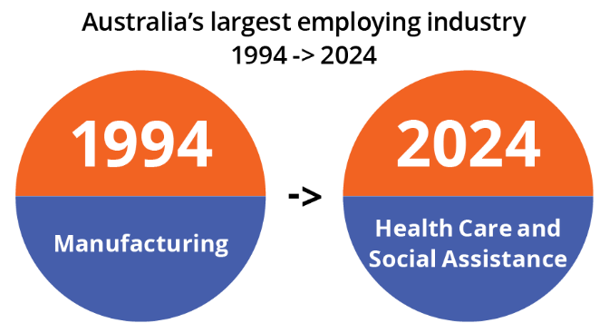
Share of national employment, selected industries, 2024 and 1994 (%)
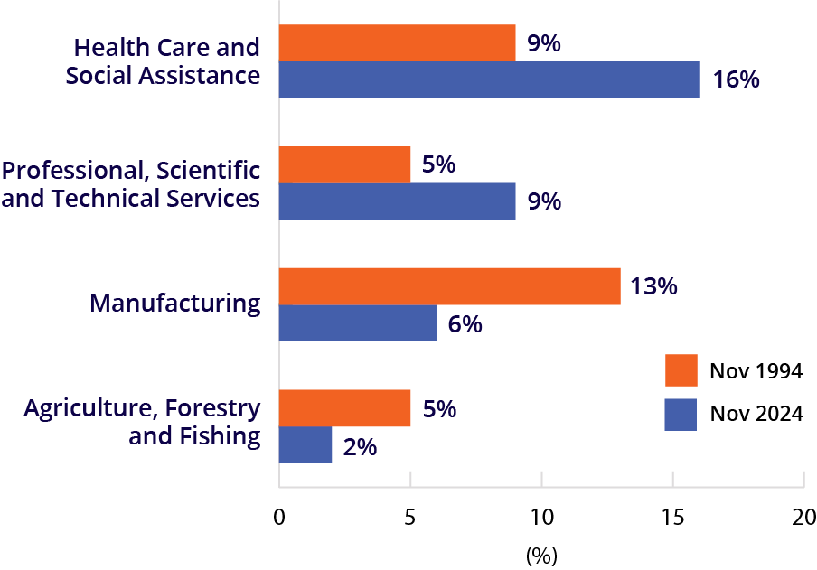
Employment in service-based industries has expanded rapidly in recent decades, offsetting falls in other industries. Today, more than 4 in every 5 Australian workers are employed in a service industry. Service industries can be considered to include all industries besides Manufacturing; Construction; Agriculture, Forestry and Fishing; and Mining, although, even within these industries, there are service components.

Share of national employment, service and producing industries, 1994 and 2024 (%)
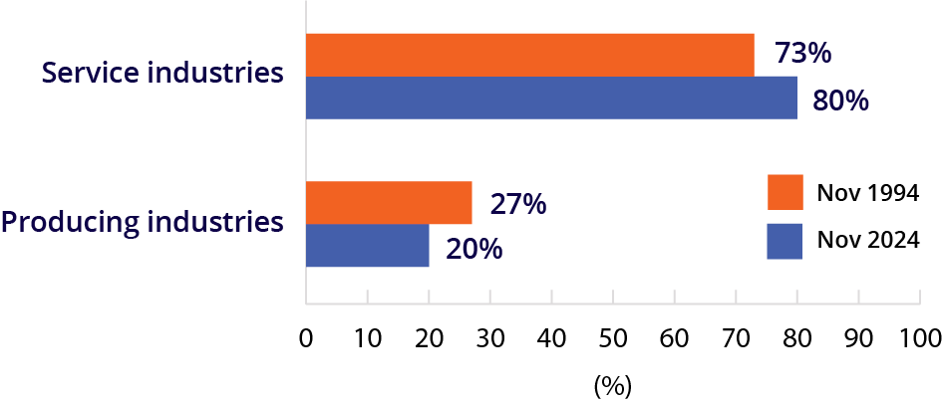
Much of the growth in service-based industry employment has been driven by Health Care and Social Assistance, with the demand for services provided by this industry growing strongly. The share of workers in this industry alone has increased from 9% 30 years ago to 16% now.
Professional, Scientific and Technical Services has also recorded strong employment growth and has almost doubled its share of employment over the past 30 years (from around 5% to 9%).
ABS, Labour Force, Australia, Detailed, November 2024

Health Care and Social Assistance
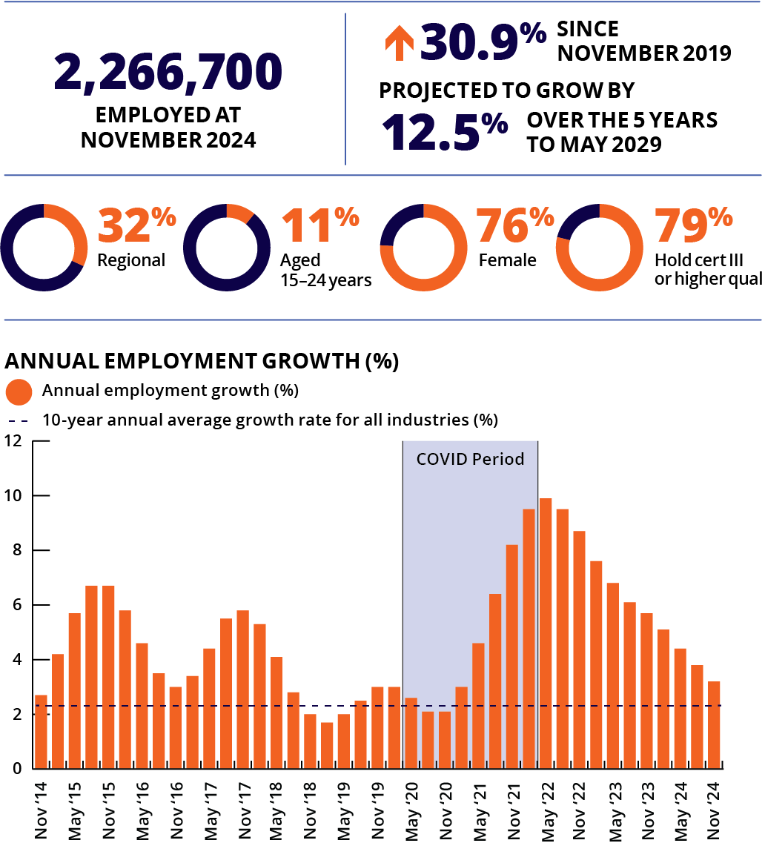
Note: Caution is recommended when using employment estimates from May 2020 to February 2022 inclusive.

Top employing occupations
- Registered Nurse
- Aged and Disabled Carers
- Child Carers
- Nursing Support and Personal Care Workers
- Receptionists
Health Care and Social Assistance is Australia’s largest employing industry, accounting for around 16% of national employment. It delivers medical and care services, and includes the work of aged and disabled carers, early childhood educators, doctors, nurses, allied health professionals, and more. Working in this industry can include community or home-based work and can be in a variety of locations, including childcare centres, aged care facilities, hospitals, medical centres, pharmacies and laboratories.
Health Care and Social Assistance employment grew strongly over the past year, up by 3.2%. This is consistent with a long-term trend of strong growth, with employment in this industry rising by 60% over the past 10 years. Strong employment growth in this industry is expected to continue, with employment projected to rise by 12.5% over the 5 years to May 2029.
The number of job vacancies in this industry fell over past year but remain historically high, at more than double the level recorded in February 2020 (prior to the COVID-19 pandemic), with this industry making up around 18% of total job vacancies.
There are currently skill shortages for some large-employing occupations in this industry, including Registered Nurses, Aged and Disabled Carers, Child Carers, Nursing Support and Personal Care Workers, and General Practitioners and Resident Medical Officers.

Education and Training
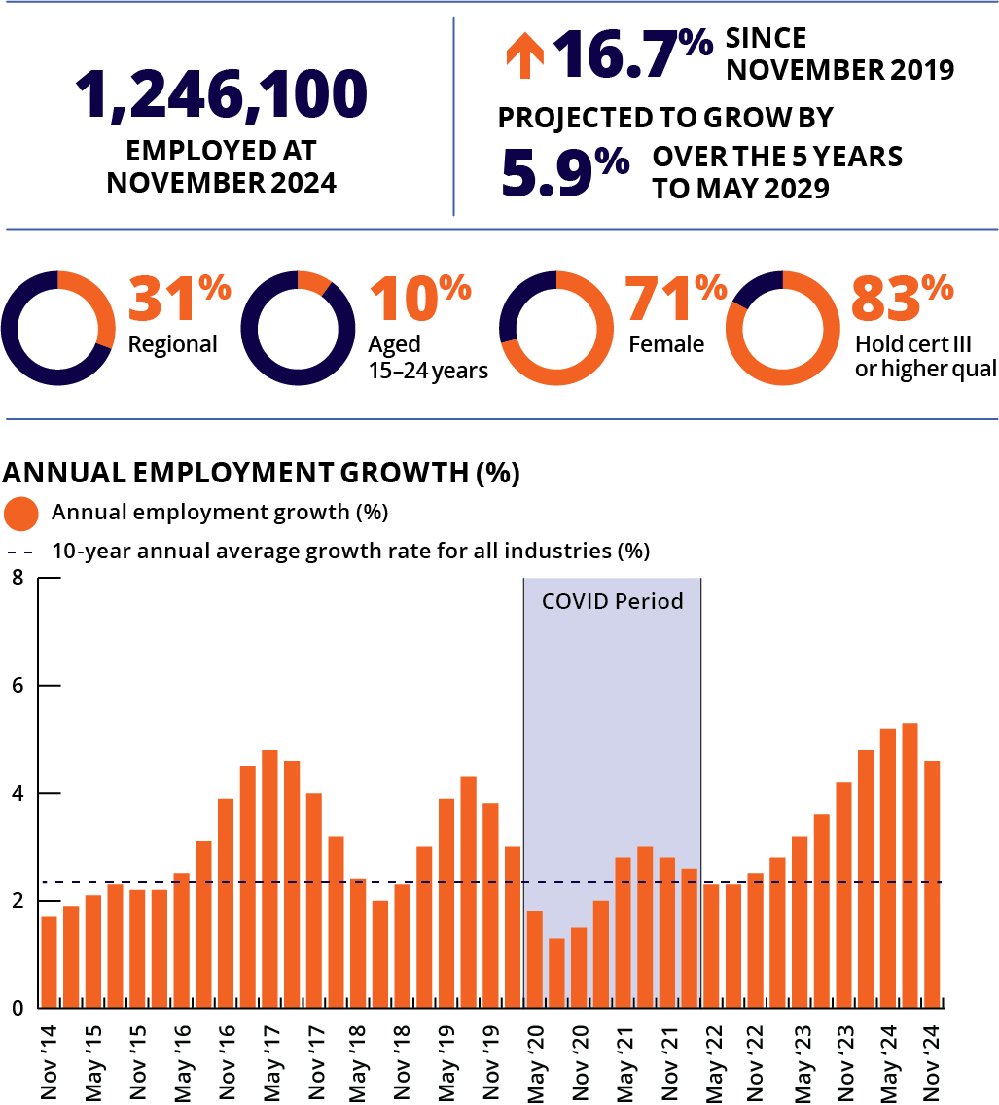
Note: Caution is recommended when using employment estimates from May 2020 to February 2022 inclusive.

Top employing occupations
- Primary School Teachers
- Secondary School Teachers
- Education Aides
- University Lecturers and Tutors
- Child Carers
The Education and Training industry provides teaching and training at all levels, from pre-school to secondary school, higher education, vocational education and training, adult and community education and private tutoring. Most people in this industry work as teachers, lecturers, trainers or instructors. A small number provide education support services, such as education aides, careers counsellors and laboratory technicians.
Education and Training accounts for around 9% of national employment. Employment in this industry grew strongly over the past year, up by 4.6%. This is consistent with a long-term trend, with Education and Training employment rising by more than 35% over the past 10 years.
Job vacancy numbers in this industry fell over the past year but remain around 75% above levels recorded in February 2020 (prior to the COVID-19 pandemic).
There are currently skill shortages for some large-employing occupations in this industry, including Early Childhood (Pre-primary School) Teachers, Primary School Teachers, Secondary School Teachers and Vocational Education Teachers.
ABS, Labour Force, Australia, Detailed, November 2024; ABS, Education and Work, Australia, 2024; ABS, Job Vacancies, Australia, November 2024; Employment Projections produced by Victoria University for Jobs and Skills Australia, 2024 (May 2024 to May 2034); Jobs and Skills Australia, Occupation Shortage List, 2024

Construction
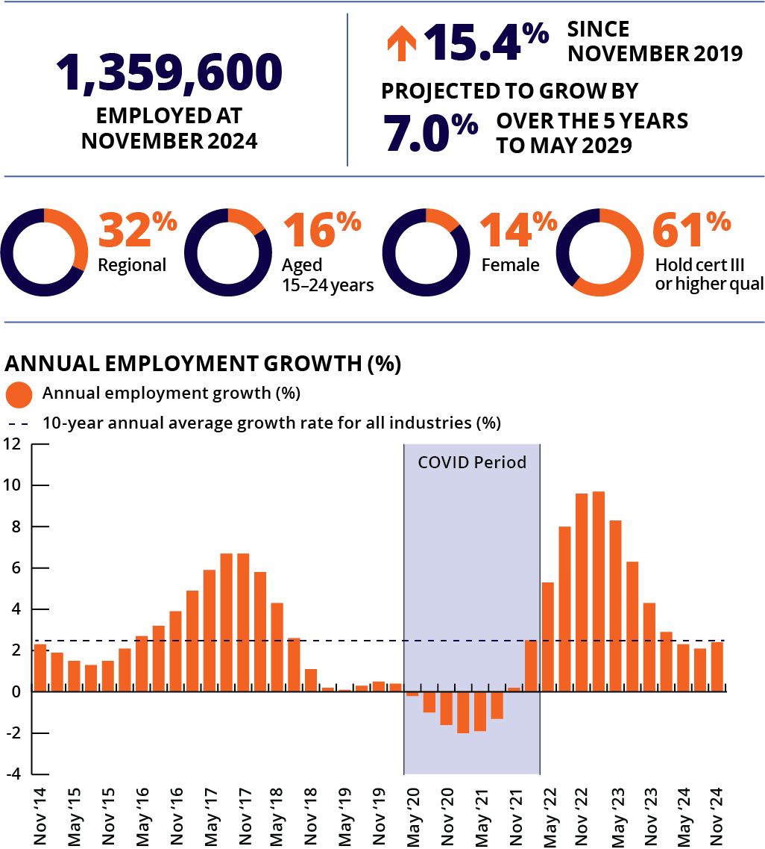
Note: Caution is recommended when using employment estimates from May 2020 to February 2022 inclusive.

Top employing occupations
- Electricians
- Carpenters and Joiners
- Construction Managers
- Plumbers
- Building and Plumbing Labourers
The Construction industry is one of Australia’s largest industries, representing 9% of national employment. It covers planning and building everything from homes to hospitals and office blocks, to roads and bridges and infrastructure for renewable energy. Sometimes it involves demolition and earthworks. Most of the people in this industry work on building or transport infrastructure sites.
Employment growth in the Construction industry is cyclical, meaning it often has periods of strong employment growth followed by periods when growth slows.
Construction employment grew by 2.4% over the past 12 months. Over the past 10 years, Construction has been one of Australia’s fastest growing industries, rising by more than 30% over this period.
Job vacancy numbers in this industry fell by 18% over the past year but remain 57% above levels recorded in February 2020 (pre COVID-19 pandemic).
There are currently skill shortages for some large-employing occupations in this industry, including Carpenters and Joiners, Electricians, Construction Managers, Plumbers and Painters.

Manufacturing
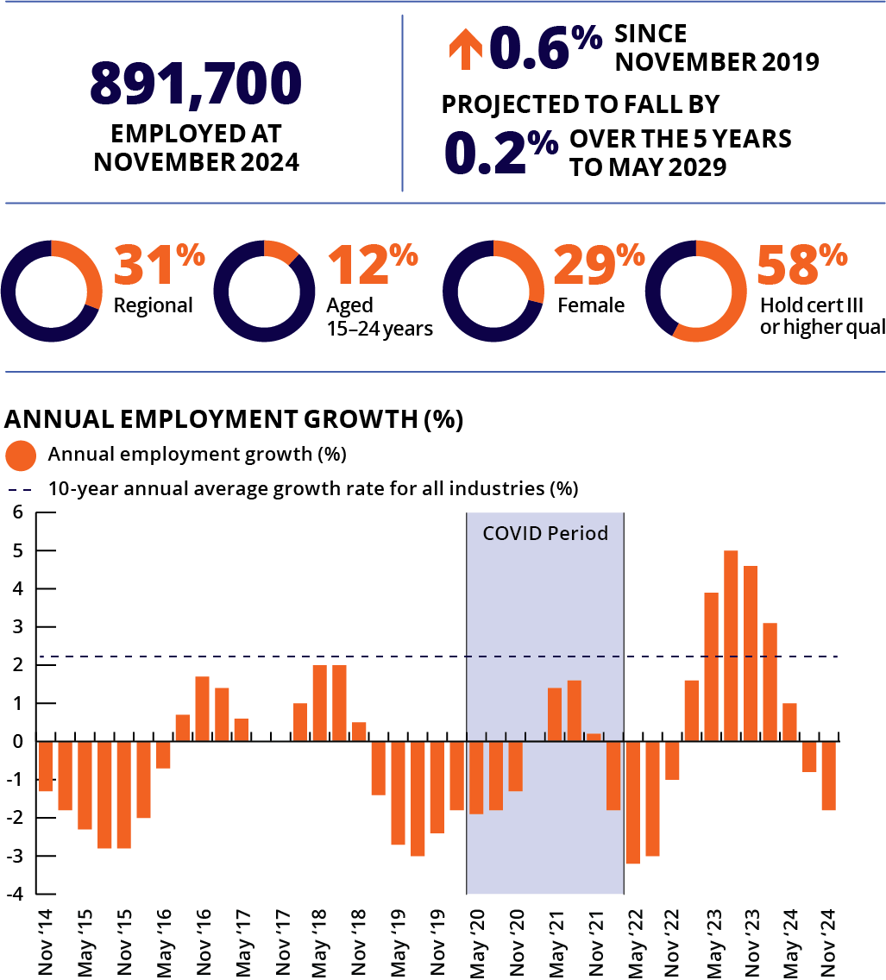
Note: Caution is recommended when using employment estimates from May 2020 to February 2022 inclusive.

Top employing occupations
- Structural Steel and Welding Trades Workers
- Production Managers
- Packers
- Metal Fitters and Machinists
- Cabinetmakers
The Manufacturing industry employs a large number of people and covers manufacturing processes for products such as food and beverages, clean energy, clothing and footwear, medicine, mineral and metals, machinery and equipment. The industry is moving towards a digital future creating new career opportunities in specialised processes, working with the latest technologies and manufacturing techniques. For more information, see page 39.
Manufacturing employment fell by 1.8% over the past year, following a period of relatively strong growth in the previous year. Employment in this industry has declined over much of the past 10 years, falling by 2.4% over the decade, but continues to make up around 6% of national employment.
Job vacancy numbers in this industry fell by 28% over the past year but remain 50% above the level recorded in February 2020 (pre COVID-19 pandemic).
Large-employing occupations in this industry that currently have a skills shortage include Structural Steel and Welding Trades Workers, Metal Fitters and Machinists and Cabinetmakers.
ABS, Labour Force, Australia, Detailed, November 2024; ABS, Education and Work, Australia, 2024; ABS, Job Vacancies, Australia, November 2024; Employment Projections produced by Victoria University for Jobs and Skills Australia, 2024 (May 2024 to May 2034); Jobs and Skills Australia, Occupation Shortage List, 2024

Professional, Scientific and Technical Services
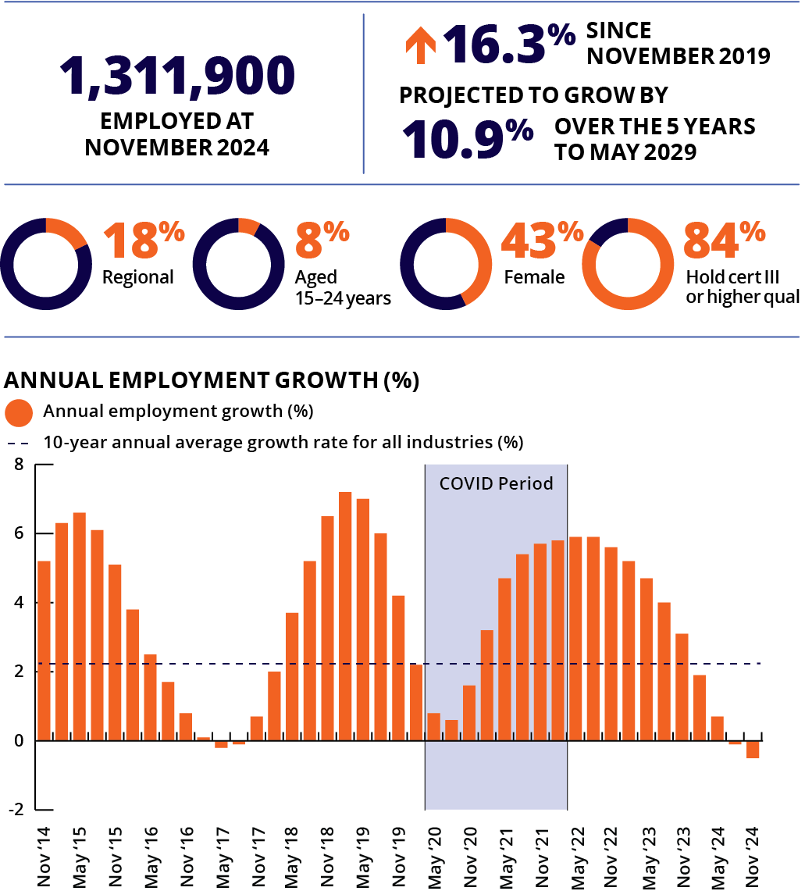
Note: Caution is recommended when using employment estimates from May 2020 to February 2022 inclusive.

Top employing occupations
- Software and Applications Programmers
- Accountants
- Solicitors
- Management and Organisation Analysts
- Advertising and Marketing Professionals
The major services provided by this industry are specialist professional, scientific and technical expertise that adds value to other businesses and individuals outside this sector. Jobs in this industry are related to scientific research, architecture, engineering, computer systems design, law, accountancy, advertising, market research, management and other consultancy, veterinary science and professional photography.
Professional, Scientific and Technical Services is a large employing industry in Australia, accounting for around 9% of national employment. Employment in this industry fell slightly over the past year (down by 0.5%). This, however, follows a long-term trend of strong employment growth, with Professional, Scientific and Technical Services employment rising by almost 40% over the past decade.
Job vacancy numbers in this industry fell by 12% over the past year but remain around 50% above the level recorded in February 2020 (pre COVID-19 pandemic).
Large-employing occupations in this industry that currently have a skills shortage include Software and Applications Programmers and Solicitors.

Financial and Insurance Services
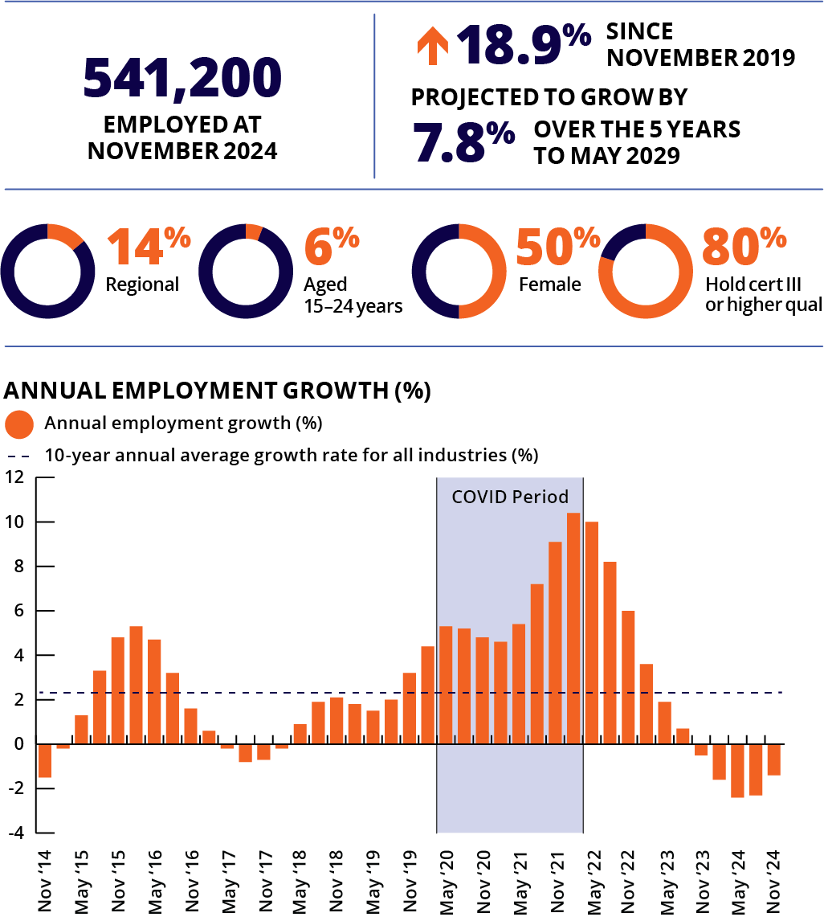
Note: Caution is recommended when using employment estimates from May 2020 to February 2022 inclusive.

Top employing occupations
- Financial Investments Advisers and Managers
- Bank Workers
- Financial Brokers
- Credit and Loans Officers
- Insurance, Money Markey and Statistical Clerks
Working in the Financial and Insurance Services industry often means being responsible for the management of money, with jobs including those that create, facilitate and manage financial assets and transactions, and the management of risks and liabilities. Jobs can be in the public sector or private companies.
In the public sector (government), occupations cover areas like financial policy and regulation, managing government funds and economy, and monitoring large financial movements and companies. In the private sector, services can range from lending finances and operating money transfer systems, dealing stocks, foreign currency exchanges, providing financial advice planning to companies and people, and managing risk and assets. Jobs can be in banks, credit unions, superannuation and insurance providers, investment managers and stockbrokers.
Financial and Insurance Services employment fell by 1.4% over the past year. However, this industry has seen a longer-term trend of strong growth, with employment in this industry rising by more than 30% over the past 10 years Job vacancy numbers in this industry also fell by 9% over the past year.
ABS, Labour Force, Australia, Detailed, November 2024; ABS, Education and Work, Australia, 2024; ABS, Job Vacancies, Australia, November 2024; Employment Projections produced by Victoria University for Jobs and Skills Australia, 2024 (May 2024 to May 2034); Jobs and Skills Australia, Occupation Shortage List, 2024

Retail Trade
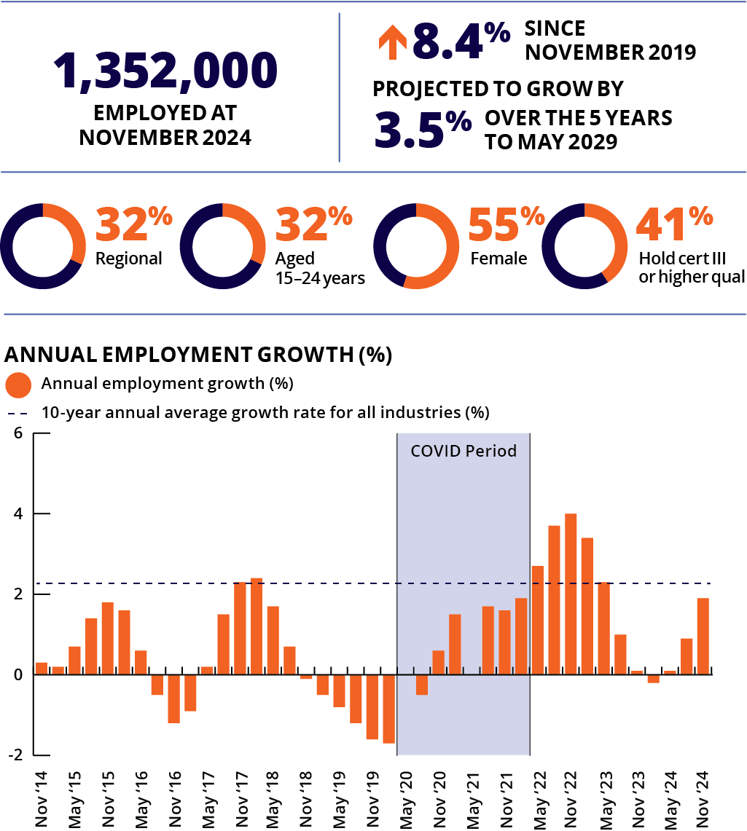
Note: Caution is recommended when using employment estimates from May 2020 to February 2022 inclusive. Data has been suppressed for some quarters during this period.

Top employing occupations
- Sales Assistants (General)
- Retail Managers
- Checkout Operators and Office Cashiers
- Shelf Fillers
- Storepersons
Retail Trade is one of Australia’s largest employing industries with more than 1.3 million workers (around 9% of national employment). This industry covers the display and sale of new or used goods to consumers, for personal or household use, including online sales. It also includes purchase and on-selling, commission-based buying, and commission-based selling of goods (without significant transformation).
Jobs are in any retail setting that offers goods for public sale, including department stores, non-store retailing and retail commission-based buying and/or selling. Jobs involve selling food, fuel, motor vehicles and their parts, pharmaceuticals, hardware, building and garden supplies, clothing, footwear and personal accessories, recreational goods, furniture, floor coverings, houseware and textile goods, and electrical and electronic goods.
Retail Trade employs more young people than most other industries (32% are aged 15 to 24) because entry level roles within the industry generally do not require prior experience or qualifications and flexible work conditions are common.
Retail Trade employment grew by 1.9% over the past year, and by 9.8% over the past decade.
Job vacancy numbers in this industry fell by 17% over the past year but remain more than 40% above the level recorded in February 2020 (pre COVID-19 pandemic).

Wholesale Trade
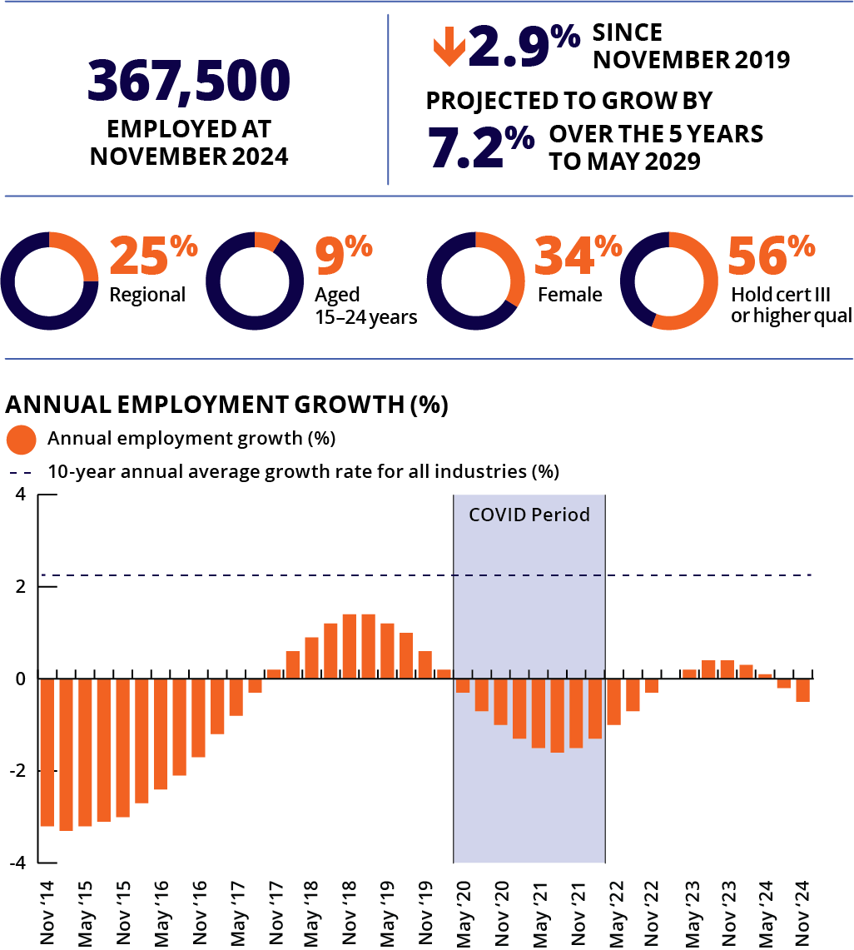
Note: Caution is recommended when using employment estimates from May 2020 to February 2022 inclusive.

Top employing occupations
- Storepersons
- Advertising, Public Relations and Sales Managers
- Sales Representatives
- Purchasing and Supply Logistics Clerks
- Technical Sales Representatives
Businesses in the Wholesale Trade industry sell and distribute goods to other businesses (in both the private sector and the public sector). They sell (or arrange the purchase or sale of) goods for resale as well as raw and intermediate materials and supplies that are used in production.
Wholesaling involves high value and/or bulk volume transactions, and customers are generally reached through trade-specific contacts. Therefore, wholesalers do not usually have a shop front to sell their items; they are the middle step between producers and retailers. Premises usually include warehouses or large storage facilities, or offices with little or no display of goods.
Wholesale Trade employment fell by 0.5% over the past 12 months. Employment in this industry has declined over much of the past decade, with employment around 5% below the level recorded 10 years ago.
Job vacancy numbers in this industry fell by 17% over the past year but remain 15% above levels recorded in February 2020 (pre COVID-19 pandemic).
ABS, Labour Force, Australia, Detailed, November 2024; ABS, Education and Work, Australia, 2024; ABS, Job Vacancies, Australia, November 2024; Employment Projections produced by Victoria University for Jobs and Skills Australia, 2024 (May 2024 to May 2034); Jobs and Skills Australia, Occupation Shortage List, 2024

Mining
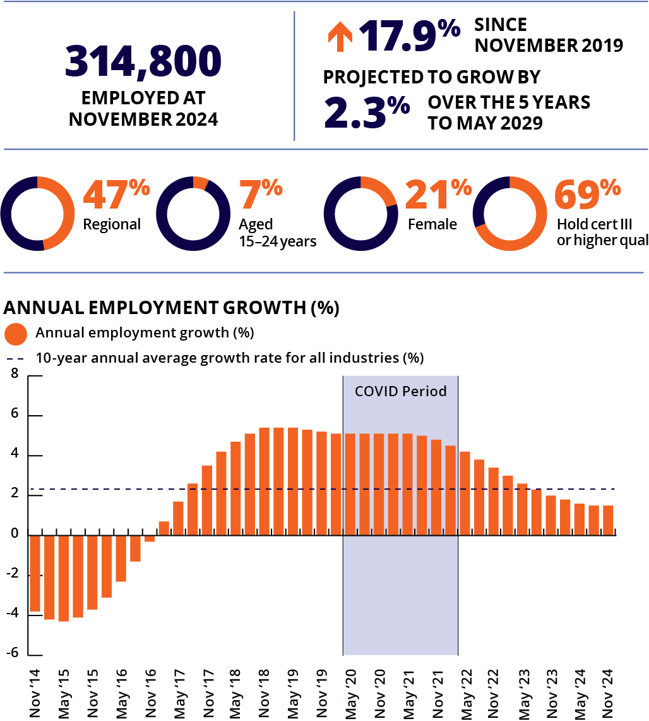
Note: Caution is recommended when using employment estimates from May 2020 to February 2022 inclusive.

Top employing occupations
- Drillers, Miners and Shot Firers
- Metal Fitters and Machinists
- Other Building and Engineering Technicians
- Truck Drivers
- Electricians
The Mining industry extracts naturally occurring mineral solids such as coal and ores, liquid minerals such as crude petroleum, and gases such as natural gas. Mining activities include underground or open cut mining, dredging, quarrying, well operations or evaporation pans, recovery from ore dumps or tailings as well as beneficiation (or improvement) activities (preparing, including crushing, screening, washing and flotation). Other preparation work is customarily performed at the mine site and as a part of mining activity.
Mining is an important industry in terms of its export revenue, but it is a relatively small employing industry, accounting for around 2% of Australian jobs. Mining employment rose by 1.5% over the past year. Relatively strong employment growth has been recorded in this industry since 2017, although this growth has slowed over the last few years.
Job vacancy numbers in this industry fell by 18% over the past year but are around 50% above the level recorded in February 2020 (pre COVID-19 pandemic).
Large-employing occupations in this industry that currently have a skills shortage include Drillers, Miners and Shot Firers, Metal Fitters and Machinists, Truck Drivers, Electricians and Mining Engineers.

Agriculture, Forestry and Fishing
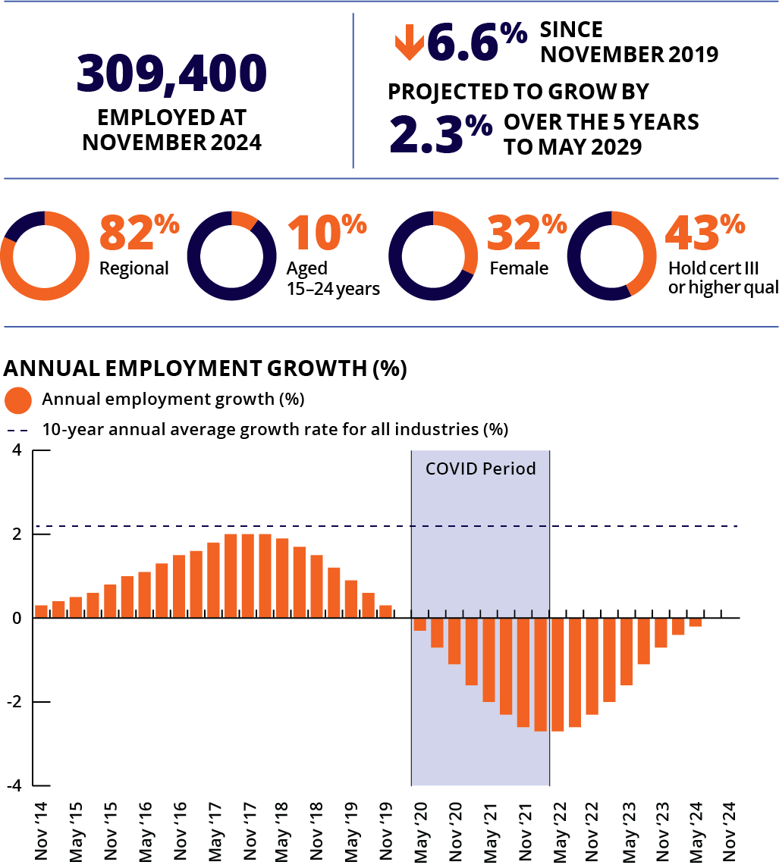
Note: Caution is recommended when using employment estimates from May 2020 to February 2022 inclusive

Top employing occupations
- Livestock Farmers
- Crop Farmers
- Mixed Crop and Livestock Farmers
- Livestock Farm Workers
- Crop Farm Workers
The Agriculture, Forestry and Fishing industry uses natural resources (land and water) to produce food, raw material and goods for sale in Australia and overseas. Work in this industry is diverse. Agriculture can involve the production of crops and farming of animals. Forestry can include growing, maintaining and harvesting forests. Fishing activities include breeding and farming of seafood.
Sustainable management of natural resources is a key responsibility of the industry and technology is changing crop production, farming of animals, and the management of our forests and fisheries.
Agriculture, Forestry and Fishing employment has declined over the past 5 years (down by 6.6%). This follows employment growth over the previous 5 years, with employment in this industry currently at a similar level recorded a decade ago. Employment in this industry is projected to rise by 2.3% over the 5 years to May 2029.
ABS, Labour Force, Australia, Detailed, November 2024; ABS, Education and Work, Australia, 2024; ABS, Job Vacancies, Australia, November 2024; Employment Projections produced by Victoria University for Jobs and Skills Australia, 2024 (May 2024 to May 2034); Jobs and Skills Australia, Occupation Shortage List, 2024

Accommodation and Food Services
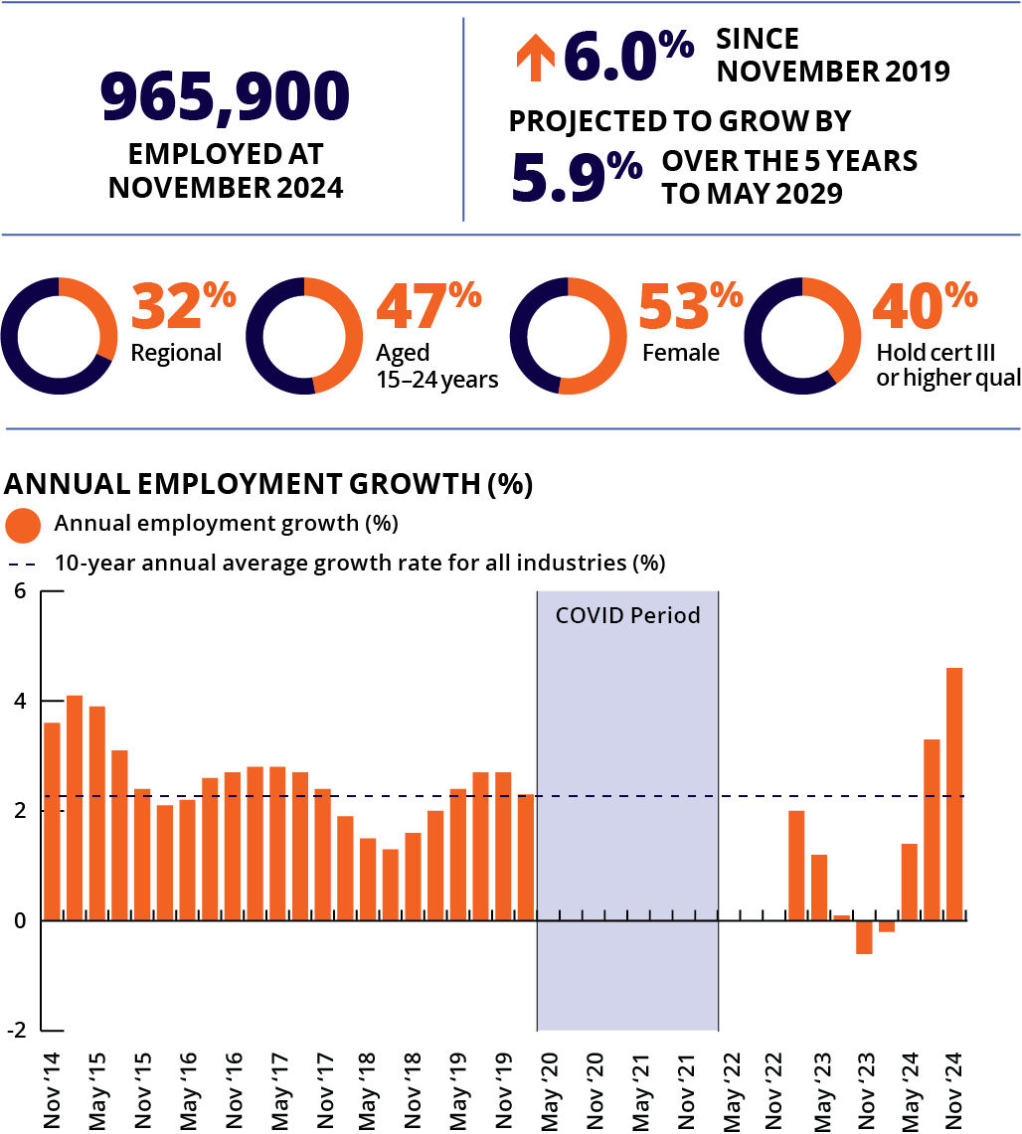
Note: Caution is recommended when using employment estimates from May 2020 to February 2022 inclusive. Data has been suppressed for some quarters during this period.

Top employing occupations
- Waiters
- Chefs
- Bar Attendants and Baristas
- Kitchenhands
- Sales Assistants (General)
The Accommodation and Food Services industry provides hospitality services, with most jobs in hotels, motels, cafes, restaurants, take-away shops, bars and pubs. Other businesses providing hospitality services include catering, short-stay accommodation such as bed and breakfast and serviced apartments, caravan parks, holiday houses, ski lodges, student and youth hostels.
Accommodation and Food Services provides many opportunities for young people looking for their first job, or for mature aged workers looking to re-enter the workforce. Almost half of workers in this industry are young (aged 15 to 24 years), the largest share of any industry.
Accommodation and Food Services was one of the industries most impacted by the COVID-19 pandemic, but employment has since rebounded strongly. Employment in this industry grew by 4.6% over the past year, almost double the rate recorded across all industries.
Job vacancy numbers in this industry fell by 21% over the past year but remain more than double the level recorded in February 2020 (pre COVID-19 pandemic).
Large-employing occupations in this industry that currently have a skills shortage include Chefs and Cooks.

Arts and Recreation Services
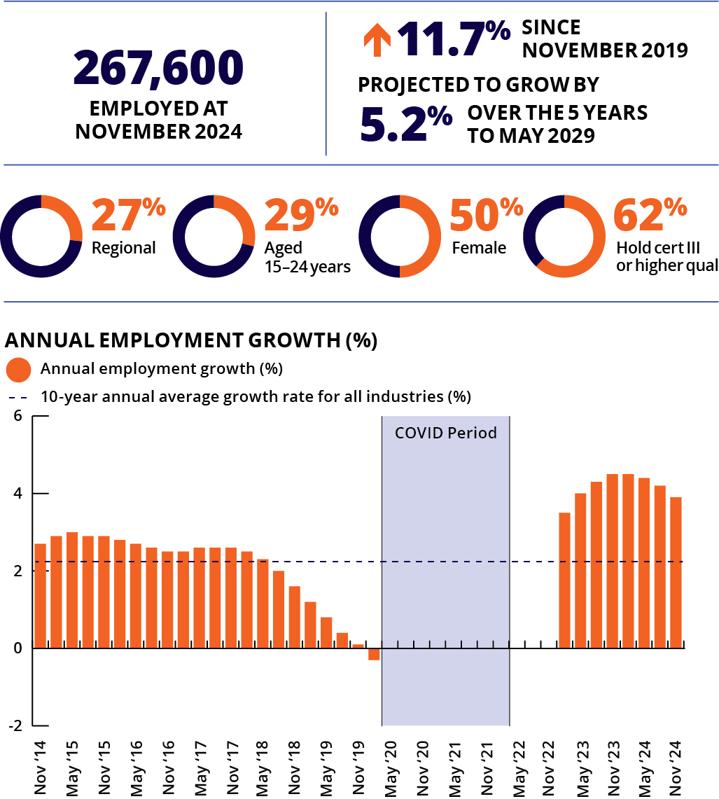
Note: Caution is recommended when using employment estimates from May 2020 to February 2022 inclusive. Data has been suppressed for some quarters during this period.

Top employing occupations
- Sports Coaches, Instructions and Officials
- Fitness Instructors
- Amusement, Fitness and Sports Centre Managers
- Sportspersons
- Receptionists
The Arts and Recreation Services industry supports, fosters and showcases our creative, sporting and cultural resources. Arts industry jobs range from cultural, creative and performing arts, and include work in theatre and TV, music and visual arts, museums and libraries. Recreational jobs cover sports and fitness and the support and management of community spaces and activities.
Jobs in this industry can be located within museums, art galleries, zoos, parks, botanical gardens, sports centres, theatres, studios, libraries, and various entertainment venues.
This is a relatively small employing industry, accounting for around 2% of Australian jobs. Along with Accommodation and Food Services, this was one of the industries most impacted by the COVID-19 pandemic, but employment has since rebounded strongly. Employment in this industry grew by 3.9% over the past year.
Job vacancy numbers in this industry fell by 22% over the past year but remain around double the level recorded in February 2020 (pre COVID-19 pandemic).
ABS, Labour Force, Australia, Detailed, November 2024; ABS, Education and Work, Australia, 2024; ABS, Job Vacancies, Australia, November 2024; Employment Projections produced by Victoria University for Jobs and Skills Australia, 2024 (May 2024 to May 2034); Jobs and Skills Australia, Occupation Shortage List, 2024

Transport, Postal and Warehousing
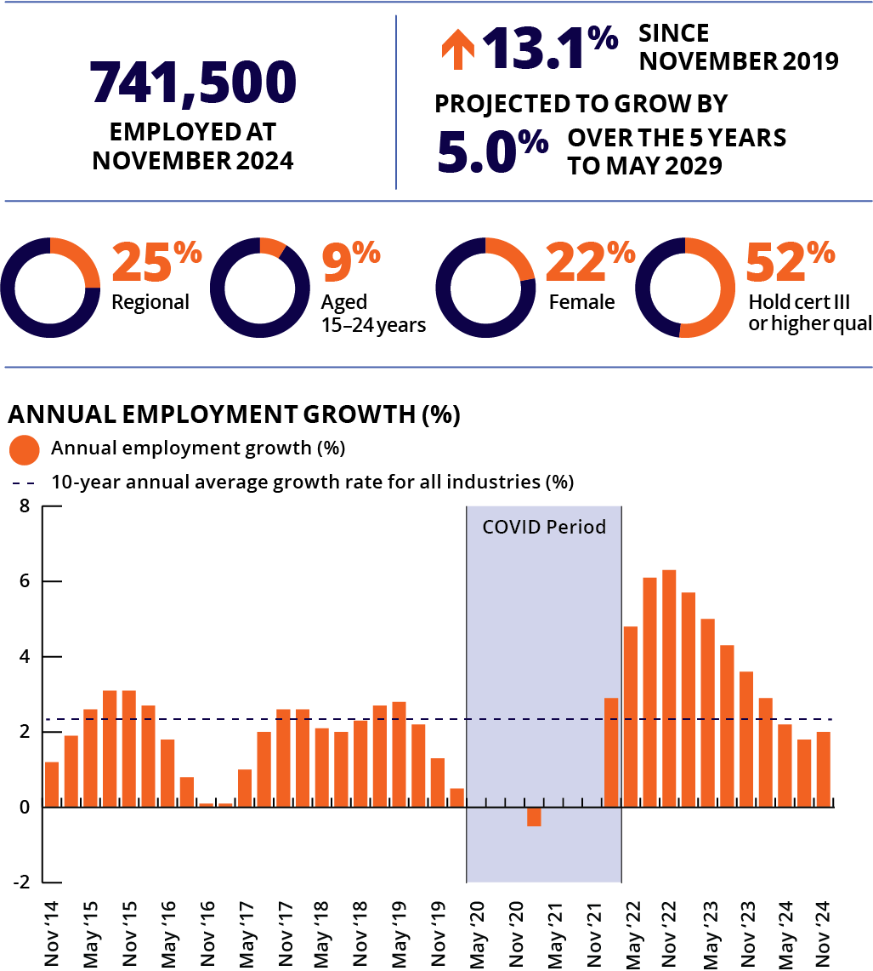
Note: Caution is recommended when using employment estimates from May 2020 to February 2022 inclusive. Data has been suppressed for some quarters during this period.

Top employing occupations
- Truck Drivers
- Storepersons
- Automobile Drivers
- Delivery Drivers
- Couriers and Postal Deliverers
The Transport, Postal and Warehousing industry includes businesses engaged in providing transportation of passengers and freight by road, rail, water or air. This industry also includes other transportation activities such as postal services, pipeline transport and scenic and sightseeing transport, warehousing and storage.
Businesses that facilitate the movement of freight, such as import/export agents, freight forwarders, and shipping agents, are also part of this industry.
Most jobs are in air, road and rail transport, scenic and sightseeing transport, postal and courier pick-up and delivery services, transport support services, warehousing and storage services and water transport.
Transport, Postal and Warehousing employment has grown strongly in the years following the COVID-19 pandemic. Over the past year, employment in this industry rose by 2.0%.
Job vacancy numbers in this industry fell by 22% over the past year but remain 45% above the level recorded in February 2020 (pre COVID-19 pandemic).
Large-employing occupations in this industry that currently have a skills shortage include Truck Drivers and Train and Tram Drivers.

Electricity, Gas, Water and Waste Services
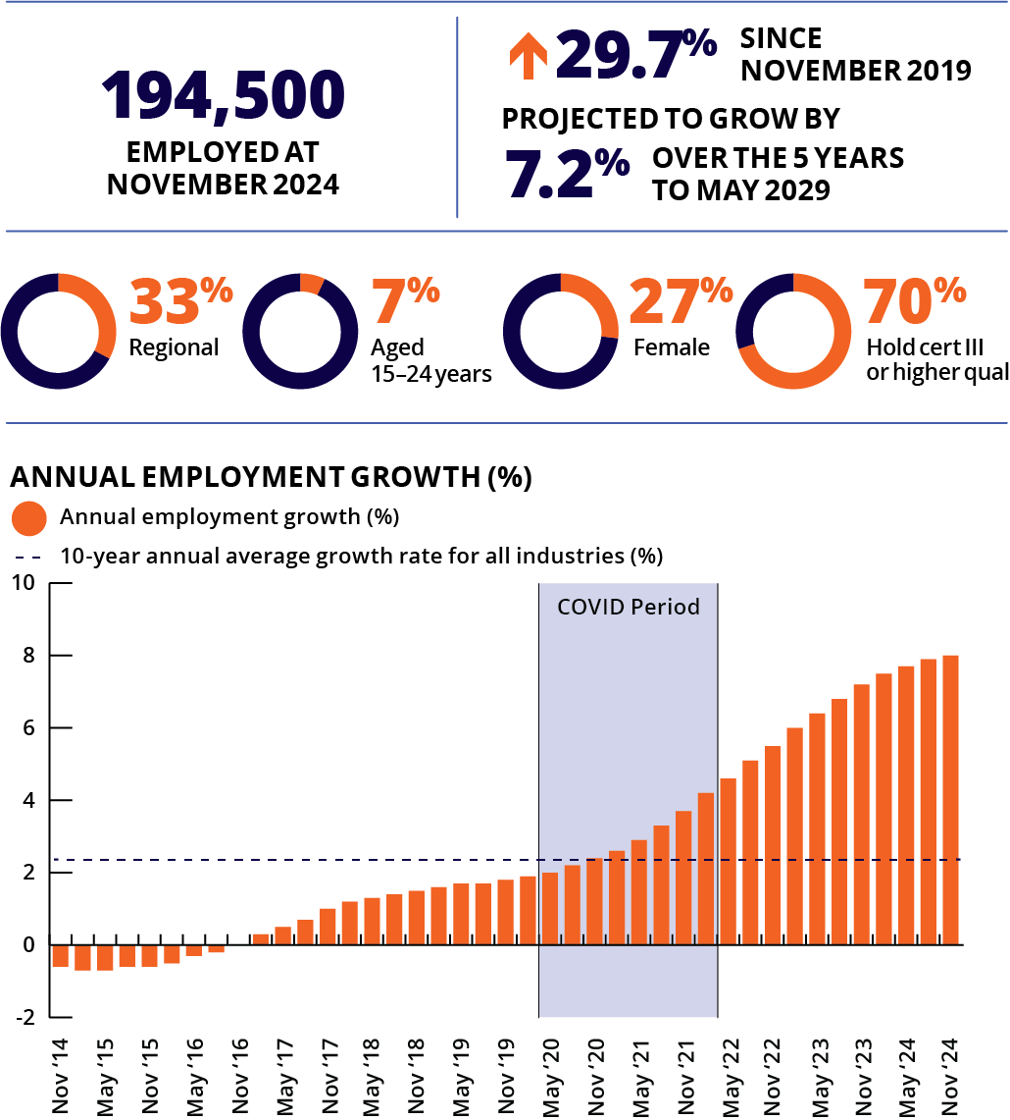
Note: Caution is recommended when using employment estimates from May 2020 to February 2022 inclusive.

Top employing occupations
- Truck Drivers
- Electricians
- Electrical Distribution Trades Workers
- Contract, Program and Project Administrators
- Electrical Engineers
The Electricity, Gas, Water and Waste Services industry is evolving with the growth in renewable sources of energy. The industry includes the generation, transmission and distribution of electricity, the supply of gas and water, sewerage systems and treatment and waste disposal services.
Jobs can be located at power or gas extraction plants and also hydro-electric, solar or wind generation facilities.
Electricity, Gas, Water and Waste Services is a relatively small employing industry, accounting for around 1% of Australian jobs. Employment in this industry has grown strongly in recent years, rising by 8.0% over the past year (the strongest growth of any industry over this period). This is a continuation of strong employment growth over the past 5 years, rising by almost 30% over this period.
Job vacancy numbers in this industry fell by 6% over the past year but remain more than double the level recorded in February 2020 (pre COVID-19 pandemic).
Large-employing occupations in this industry that currently have a skills shortage include Electricians, Electrical Engineers, Electrical Distribution Trades Workers and Truck Drivers.
ABS, Labour Force, Australia, Detailed, November 2024; ABS, Education and Work, Australia, 2024; ABS, Job Vacancies, Australia, November 2024; Employment Projections produced by Victoria University for Jobs and Skills Australia, 2024 (May 2024 to May 2034); Jobs and Skills Australia, Occupation Shortage List, 2024

Administrative and Support Services
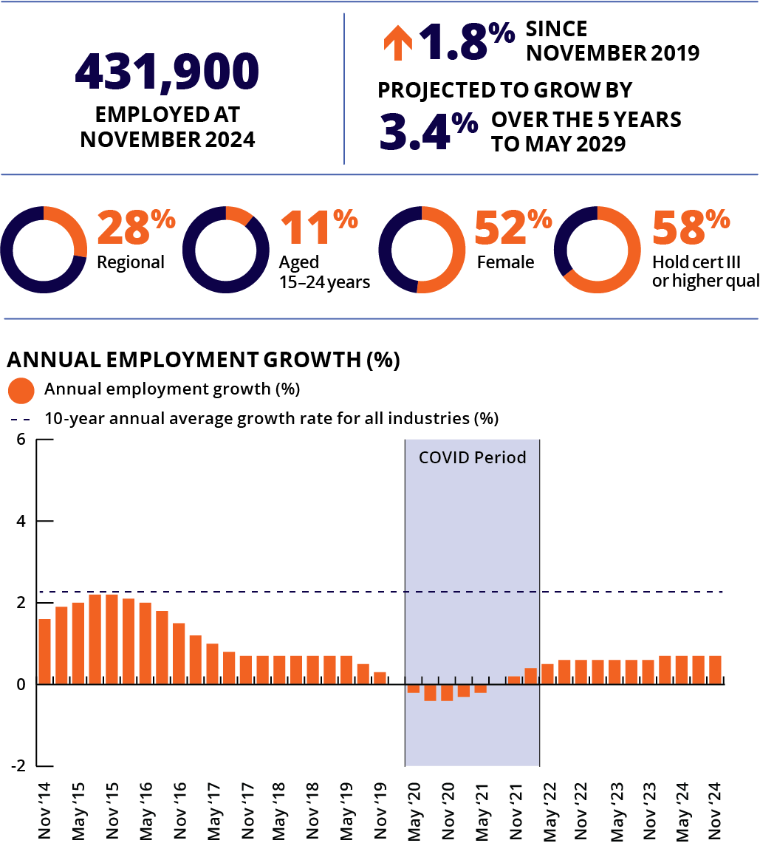
Note: Caution is recommended when using employment estimates from May 2020 to February 2022 inclusive.

Top employing occupations
- Commercial Cleaners
- Gardeners
- Domestic Cleaners
- Human Resource Professionals
- Tourism and Travel Advisers
The Administrative and Support Services industry provides important services to support the operation of businesses, government bodies and other organisations.
Roles in this small but essential industry can include office administration, call centres, debt collection, hiring personnel, taking sales orders, providing credit reporting, arranging travel, cleaning services, pest control and gardening businesses.
Employment growth in this industry has been relatively subdued in recent years. Administrative and Support Services employment rose by just 1.8% over the past 5 years, compared with 12.8% recorded across all industries. Over the past year, employment in this industry rose by 0.7%.
Job vacancy numbers in this industry fell by 23% over the past year, reflecting subdued employment growth in recent years.

Public Administration and Safety
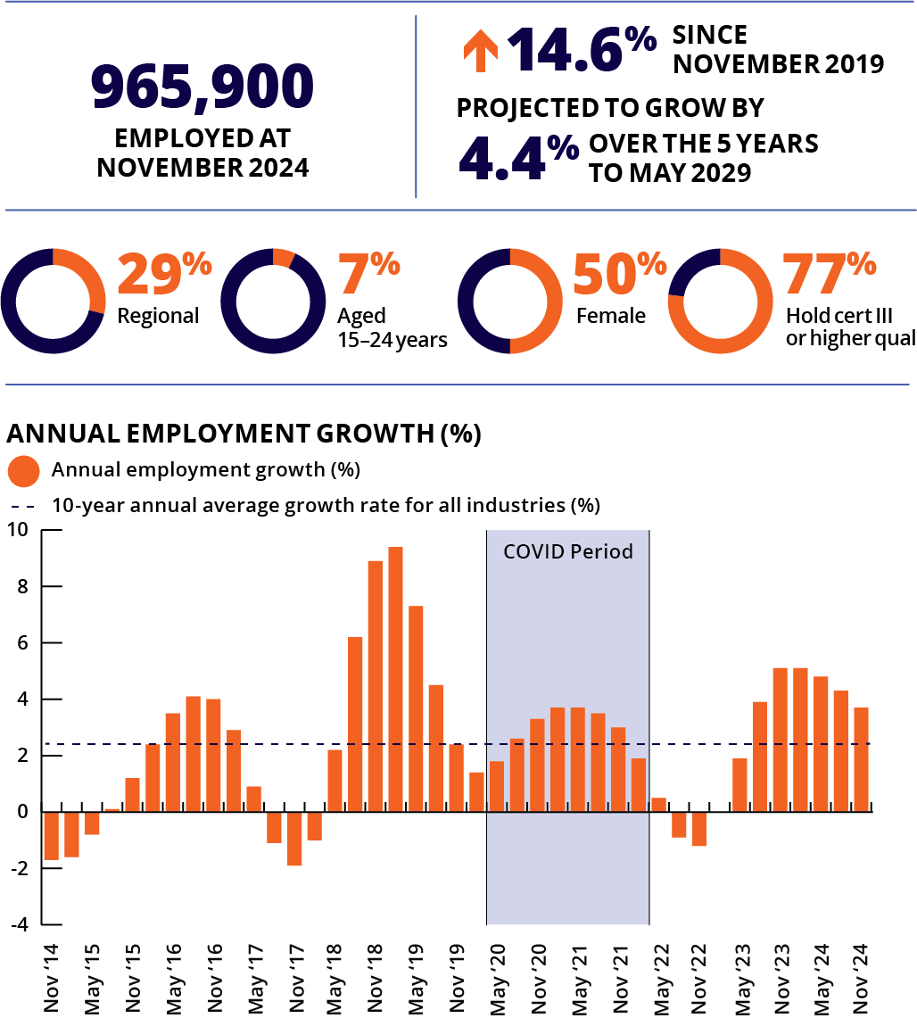
Note: Caution is recommended when using employment estimates from May 2020 to February 2022 inclusive.

Top employing occupations
- General Clerks
- Police
- Contract, Program and Project Administrators
- Security Officers and Guards
- Intelligence and Police Analysts
The Public Administration and Safety industry provides services that support physical, social and economic interactions; general public safety and security services; and the enforcing of regulations.
Most jobs are in federal, state and local government administration, the defence force and services like the police force that supports public order.
Public Administration and Safety employment grew by 3.7% over the past year. Employment in this industry grew strongly early in the COVID-19 pandemic, particularly compared with most other industries, as part of key Government program responses to support citizens, before declining for most of 2022.
Job vacancy numbers in this industry fell by 15% over the past year but remain more than 60% above the level recorded in February 2020 (pre COVID-19 pandemic).
ABS, Labour Force, Australia, Detailed, November 2024; ABS, Education and Work, Australia, 2024; ABS, Job Vacancies, Australia, November 2024; Employment Projections produced by Victoria University for Jobs and Skills Australia, 2024 (May 2024 to May 2034); Jobs and Skills Australia, Occupation Shortage List, 2024

Information Media and Telecommunications
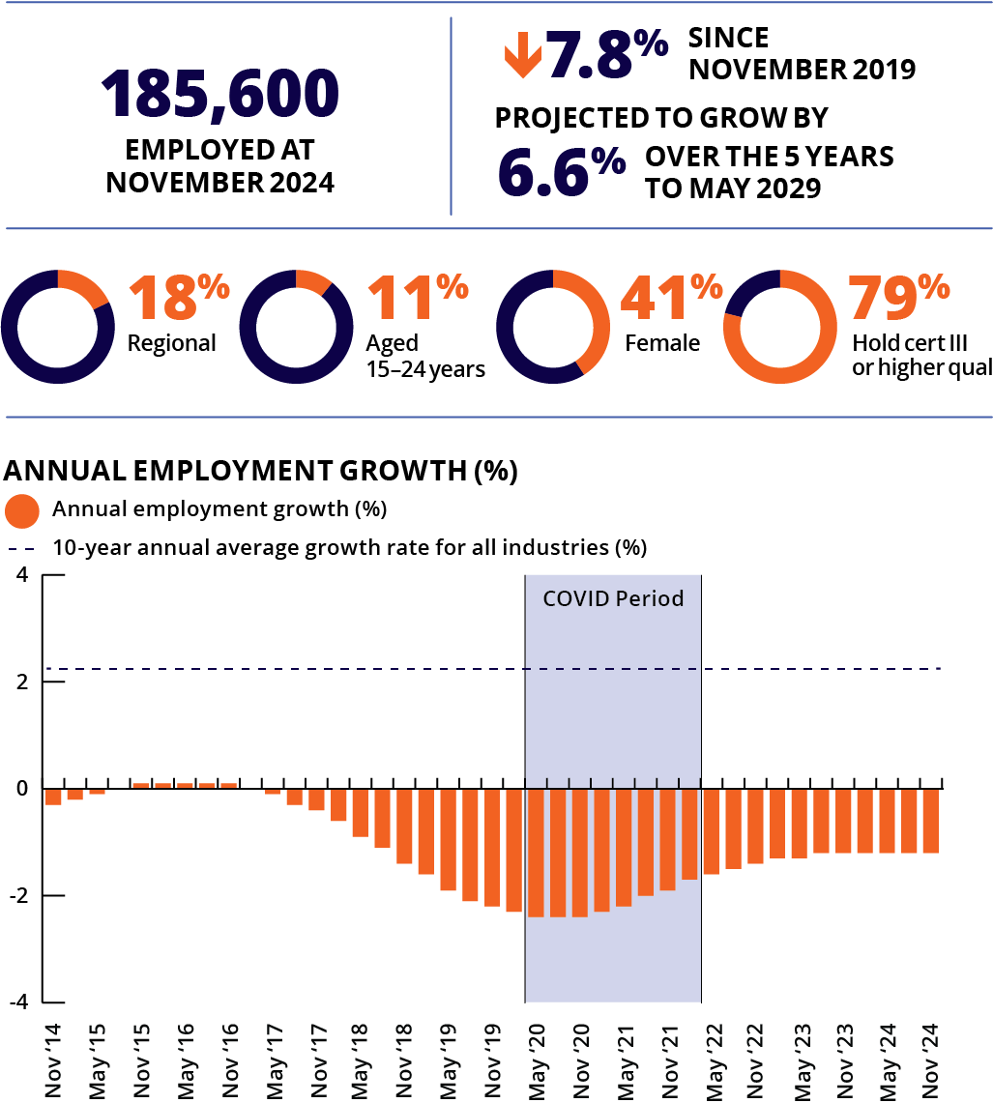
Note: Caution is recommended when using employment estimates from May 2020 to February 2022 inclusive.

Top employing occupations
- Telecommunications Trades Workers
- Film, Television, Radio and Stage Directors
- Journalists and Other Writers
- Artistic Directors, and Media Producers and Presenters
- Performing Arts Technicians
The Information Media and Telecommunications industry is responsible for a wide range of activities. In media, the industry is responsible for online media and publishing, television and film production and distribution, sound and music recording, print publications such as newspapers and books and the management and storage of information. In telecommunications, the industry is responsible for the design, construction, installation and servicing of telecommunications equipment, systems and facilities.
Jobs in this industry are located in television and radio studios, news companies, libraries, film studios, graphic design companies, advertising companies, publisher houses and telecommunication companies.
Information Media and Telecommunications is a relatively small employing industry, representing around 1% of national employment. Employment in this industry has fallen for much of the past 10 years, with employment declining by around 11% over the decade. Over the past year, employment in this industry fell by 1.2%.
Job vacancy numbers in this industry remained stable over past year but have grown by around 20% since February 2020 (pre COVID-19 pandemic)

Rental, Hiring and Real Estate Services
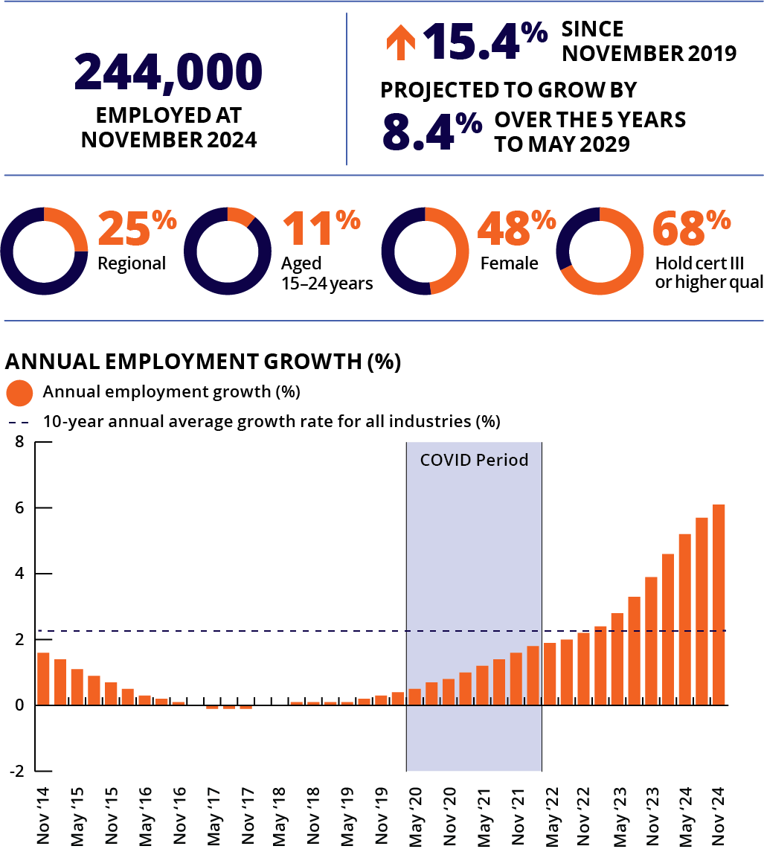
Note: Caution is recommended when using employment estimates from May 2020 to February 2022 inclusive.

Top employing occupations
- Real Estate Sales Agents
- Other Hospitality, Retail and Service Managers
- Land Economists and Valuers
- General Clerks
- Advertising, Public Relations and Sales Managers
The Rental, Hiring and Real Estate Services industry includes businesses engaged in selling, buying and managing assets. Real Estate Services include the selling or renting of property, the management of rental properties, and property valuations. Rental and Hiring includes car hiring, farm animal and bloodstock leasing, and leasing of other goods like fashion or heavy machinery. It also includes the hire and lease of assets such as brand names, patents, trademarks and franchise agreements, plus the rental, valuation, selling and management of domestic, commercial and industrial real estate.
This is a relatively small employing industry, accounting for around 2% of national employment. Rental, Hiring and Real Estate Services employment has grown strongly in recent years. Over the past year, employment increased by 6.1%, with Rental, Hiring and Real Estate Services recording stronger growth than almost all other industries in Australia over this period.
Job vacancy numbers in this industry increased by 6% over the past year (while job vacancy levels fell across most other industries) and have grown by almost 70% since February 2020 (pre COVID-19 pandemic).
ABS, Labour Force, Australia, Detailed, November 2024; ABS, Education and Work, Australia, 2024; ABS, Job Vacancies, Australia, November 2024; Employment Projections produced by Victoria University for Jobs and Skills Australia, 2024 (May 2024 to May 2034); Jobs and Skills Australia, Occupation Shortage List, 2024

Jobs by major occupational group
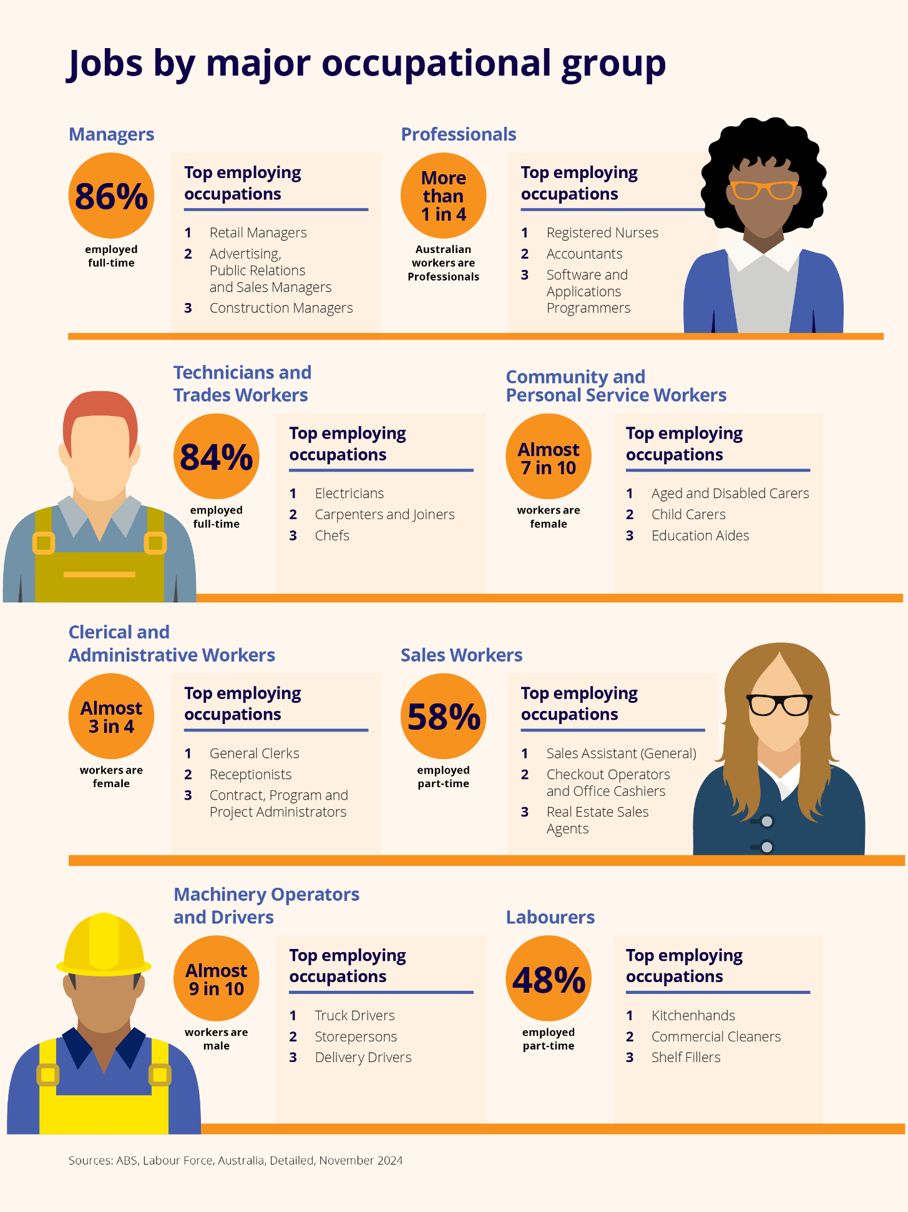

Occupational overview

What is an occupation
Occupations are a way of defining and grouping jobs that require the performance of similar or identical sets of tasks. There are 8 major occupation groups defined by the Australian and New Zealand Standard Classification of Occupations (ANZSCO); which is the classification system currently used in datasets.
ANZSCO groups occupations according to their tasks and skill level. The most highly skilled groups are Managers, Professionals, and Technicians and Trades Workers (large shares of workers in these groups hold post-school qualifications). The lowest skilled are Labourers, Machinery Operators and Drivers, and Sales Workers (less than half of workers in these groups hold post-school qualifications).
It is important to recognise the wide range of occupations and employment opportunities available in Australia. The Occupation Matrix on page 126 includes data for around 320 occupations covering the whole labour market. Further information is available at jobsandskills.gov.au/data/occupation-and-industry-profiles/occupations.

Large employing occupations
The occupation groups which account for the largest numbers of workers are:
- Professionals (around 3.9 million, or more than one in 4 Australian workers)
- Technicians and Trades Workers (almost 2 million workers)
- Clerical and Administrative Workers (almost 1.9 million).
The specific occupations with the largest worker numbers are:
- Sales Assistants (General) (552,100)
- Registered Nurses (346,700)
- Aged and Disabled Carers (344,400)
- General Clerks (283,300)
- Retail Managers (250,300).

In which occupations do young people work?
Young workers (aged 15 to 24 years) are predominantly employed in occupations which do not typically require post-school qualifications, often working and gaining experience while undertaking study or training. Consistent with this, young people account for 40% of all Sales Workers.
Specific occupations with large numbers of young workers include:
- Sales Assistants (General) (around 300,000 young workers)
- Waiters (around 85,000)
- Kitchenhands (around 83,000)
- Checkout Operators and Office Cashiers (around 75,000)
- Bar Attendants and Baristas (around 70,000).

Shift towards higher-skilled occupations
Over the past 30 years, there has been a shift towards higher-skilled occupations. Employment in higher-skilled occupations (particularly at the highest skill level) has grown strongly in recent decades, while employment growth in lower-skilled occupations has been relatively subdued.
- Skill Level 1 occupations (the highest skill level, commensurate with a bachelor degree or higher) accounted for 35% of Australian employment in 2024, up from 24% 30 years ago.
- Skill Level 5 occupations (the lowest skill level, commensurate with certificate I or secondary education) accounted for 14% of Australian employment in 2024, down from 21% in 1994.
For more information on pathways and training options, visit yourcareer.gov.au/occupations.
Share of national employment, skill level, 1994 and 2024 (%)
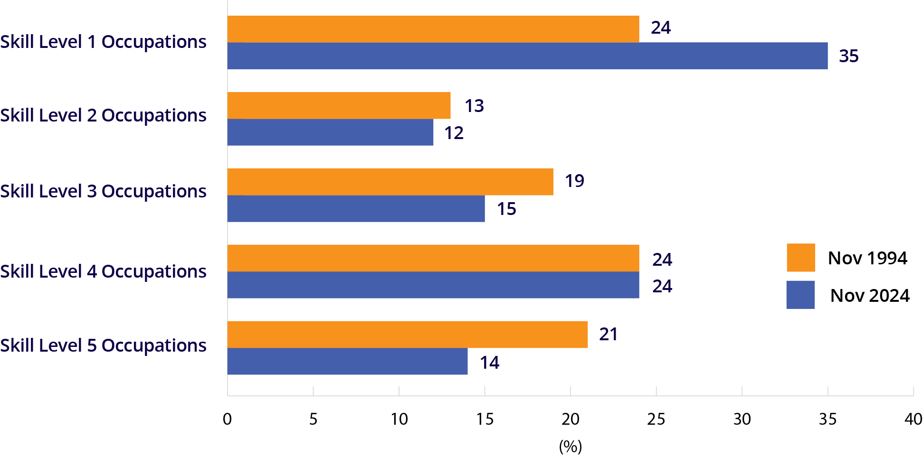
Note: Skill Level 1 is commensurate with a bachelor degree or higher qualification; Skill Level 2 is commensurate with an advanced diploma or diploma; Skill Level 3 is commensurate with a certificate IV or III (including at least 2 years’ on-the-job training); skill Level 4 is commensurate with a certificate II or III; Skill Level 5 is commensurate with a certificate I or secondary education.

Employment by occupation on group
 | Employment |  |  | Employment profile |  |  | Workforce  educational profile |  |  | Projected employ't
 | Nov 2024 | 1 year change  to Nov 2024 |  | Part-time | Female | Aged 15 to 24 years | Bachelor degree or higher | Cert III or higher VET qual | No post-school qual | 5 year change to May 2029
Occupation group | ‘000 | ‘000 | % | % | % | % | % | % | % | %
Managers | 1,837.8 | 4.3 | 0.2 | 14 | 41 | 4 | 47 | 27 | 24 | 8.2
Professionals | 3,867.3 | 136.1 | 3.6 | 24 | 55 | 7 | 80 | 12 | 8 | 10.9
Technicians and Trades Workers | 1,969.7 | 45.2 | 2.3 | 16 | 17 | 18 | 13 | 56 | 28 | 4.2
Community and Personal Service Workers | 1,673.2 | 60.1 | 3.7 | 55 | 69 | 26 | 26 | 39 | 32 | 8.8
Clerical and Administrative Workers | 1,886.9 | 26.6 | 1.4 | 33 | 72 | 11 | 33 | 29 | 35 | 3.7
Sales Workers | 1,136.0 | 17.0 | 1.5 | 58 | 59 | 40 | 18 | 20 | 59 | 3.6
Machinery Operators and Drivers | 916.5 | 11.1 | 1.2 | 21 | 13 | 13 | 13 | 31 | 53 | 4.3
Labourers | 1,234.9 | 25.3 | 2.1 | 48 | 36 | 27 | 13 | 23 | 61 | 0.8
All occupations | 14,535.5 | 334.5 | 2.4 | 31 | 48 | 15 | 39 | 27 | 30 | 6.6
ABS, Labour Force, Australia, November 2024; ABS, Labour Force, Australia, Detailed, November 2024; ABS, Education and Work, Australia, 2024; Employment Projections produced by Victoria University for Jobs and Skills Australia (May 2024 to May 2034)

Managers
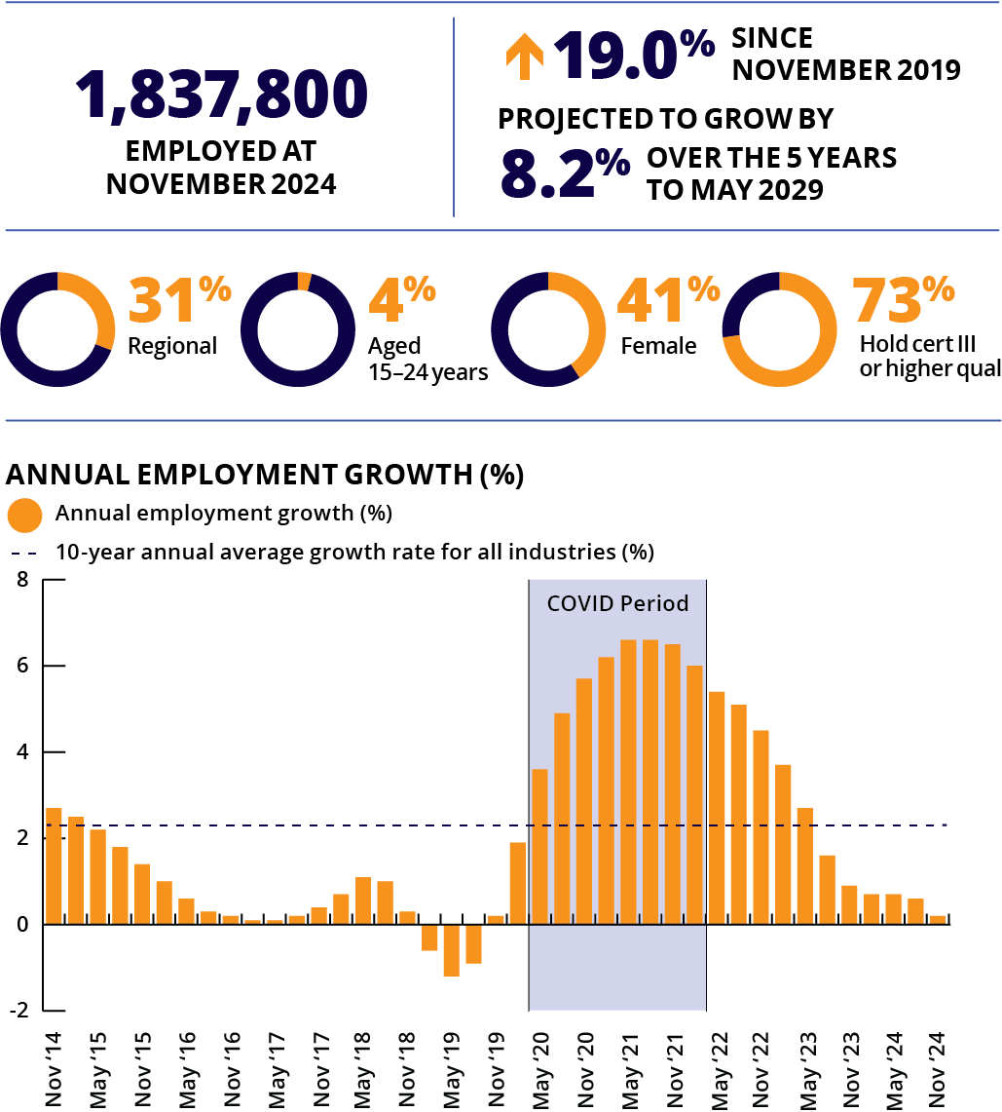
Note: Caution is recommended when using employment estimates from May 2020 to February 2022 inclusive.
Top employing occupations
1 | Retail Managers | 250,300
2 | Advertising, Public Relations and Sales Managers | 166,300
3 | Construction Managers | 130,700
4 | Other Hospitality, Retail and Service Managers | 94,900
5 | Human Resource Managers | 94,500
There are more than 1.8 million workers employed in Manager roles in Australia. Managers work across a diverse range of organisations and industries and are typically skilled in communication and building relationships, planning, budgeting and problem solving. This is a relatively skilled group, as Managers generally hold senior positions, taking responsibility for staff and operations.
Employment in the Managers group has risen strongly over the past 5 years (up by 19.0%), although this growth has slowed recently, rising by just 0.2% over the past year. Managers make up around 13% of national employment. Reflecting the experience often required for these roles, young workers (aged 15 to 24 years) account for a relatively low share of Managers (4%).
JSA Internet Vacancy Index data showed that online job advertisements for Managers fell by 12.9% over the 12 months to December 2024, with roles for Managers making up around 12% of total online job advertisements.

Professionals
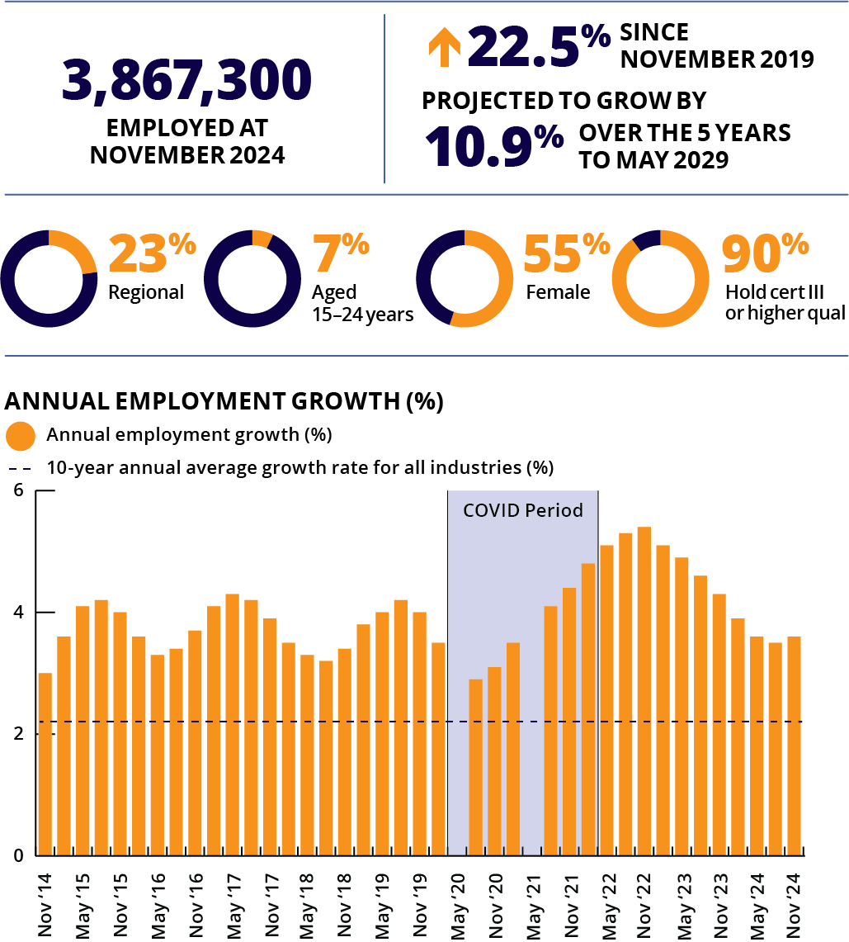
Note: Caution is recommended when using employment estimates from May 2020 to February 2022 inclusive. Data has been suppressed for some quarters during this period.
Top employing occupations
1 | Registered Nurses | 346,700
2 | Accountants | 198,300
3 | Software and Applications Programmers | 189,100
4 | Primary School Teachers | 164,600
5 | Secondary School Teachers | 145,900
Professionals is the largest employing occupation group in Australia (accounting for more than one in every 4 workers). Professionals perform analytical, conceptual and creative tasks across a range of industries, including the arts, media, business, design, engineering, the physical and life sciences, transport, education, health, information and communication technology, the law, social sciences and social welfare.
Employment for Professionals grew by 3.6% over the past year. This is consistent with a long-term trend of strong growth, with Professionals employment rising by almost 50% over the past 10 years (the strongest growth of any major occupation group over the decade).
JSA Internet Vacancy Index data showed online job vacancies for Professionals fell by 19.8% over the 12 months to December 2024. However, roles for Professionals still accounted for a large share of all job ads (around 29% of total online job vacancies).
A number of large-employing Professional occupations currently have a skills shortage, including a wide range of Engineering, Information and Communications Technology, Education and Health roles.
ABS, Labour Force, Australia, Detailed, November 2024; ABS, Education and Work, Australia, 2024; ABS, Job Vacancies, Australia, November 2024; Employment Projections produced by Victoria University for Jobs and Skills Australia, 2024 (May 2024 to May 2034); Jobs and Skills Australia, Occupation Shortage List, 2024

Technicians and Trade Workers
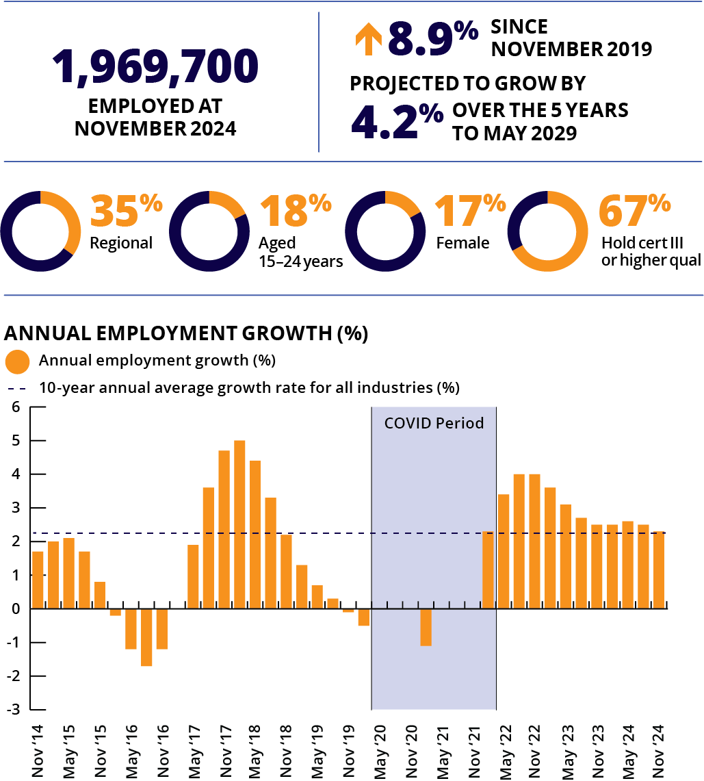
Note: Caution is recommended when using employment estimates from May 2020 to February 2022 inclusive. Data has been suppressed for some quarters during this period.
Top employing occupations
1 | Electricians | 185,200
2 | Carpenters and Joiners | 143,900
3 | Chefs | 125,300
4 | Metal Fitters and Machinists | 122,200
5 | Motor Mechanics | 107,200
Technicians and Trades Workers undertake a variety of skilled manual tasks. They apply technical, trade or industry specific knowledge in construction, manufacturing, scientific, engineering and other activities.
There are almost 2 million Technicians and Trades Workers in Australia, accounting for around 14% of national employment. Employment of these workers grew by 2.3% over the past year.
A number of large-employing Technician and Trade Worker occupations currently have a skills shortage, including Motor Mechanics, Structural Steel and Welding Trades Workers, Plumbers, Electricians, Carpenters and Joiners, and Hairdressers.
JSA Internet Vacancy Index data showed online job vacancies for Technicians and Trades Workers declined by 15.3% over the 12 months to December 2024, but these roles still make up around 14% of total online job vacancies.

Community and Personal Service Workers
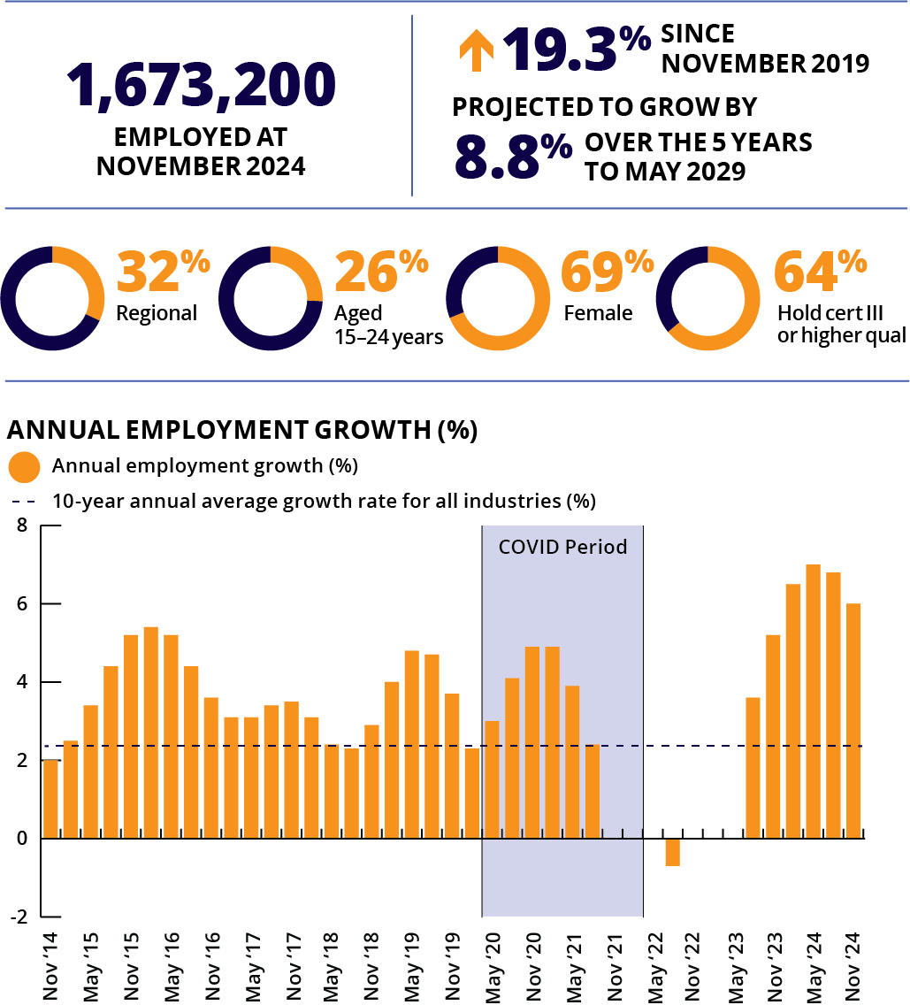
Note: Caution is recommended when using employment estimates from May 2020 to February 2022 inclusive. Data has been suppressed for some quarters during this period.
Top employing occupations
1 | Aged and Disabled Carers | 344,400
2 | Child Carers | 170,700
3 | Education Aides | 133,300
4 | Waiters | 125,900
5 | Bar Attendants and Baristas | 119,000
Community and Personal Service Workers provide a wide range of services, including aged and disability care, health and social welfare, child care, hospitality, policing, tourism, fitness, sports and personal services.
Community and Personal Service Workers employment grew by 3.7% over the past year, the strongest growth of any major occupation group over this period. This is consistent with a long-term trend of strong growth, with Community and Personal Service Workers employment rising by more than 40% over the past 10 years. These workers make up around 12% of national employment.
A number of large-employing Community and Personal Service Worker occupations currently have a skills shortage, particularly in the care sector (such as Child Carers and Aged and Disabled Carers).
JSA Internet Vacancy Index data showed that online job vacancies for Community and Personal Services Workers declined by 24.2% over the 12 months to December 2024. However, vacancy numbers overall remain at relatively high levels with plenty of opportunities available (particularly in the health and care sectors). Roles for Community and Personal Services Workers still make up around 10% of total online job vacancies.
ABS, Labour Force, Australia, Detailed, November 2024; ABS, Education and Work, Australia, 2024; ABS, Job Vacancies, Australia, November 2024; Employment Projections produced by Victoria University for Jobs and Skills Australia, 2024 (May 2024 to May 2034); Jobs and Skills Australia, Occupation Shortage List, 2024

Clerical and Administrative Workers
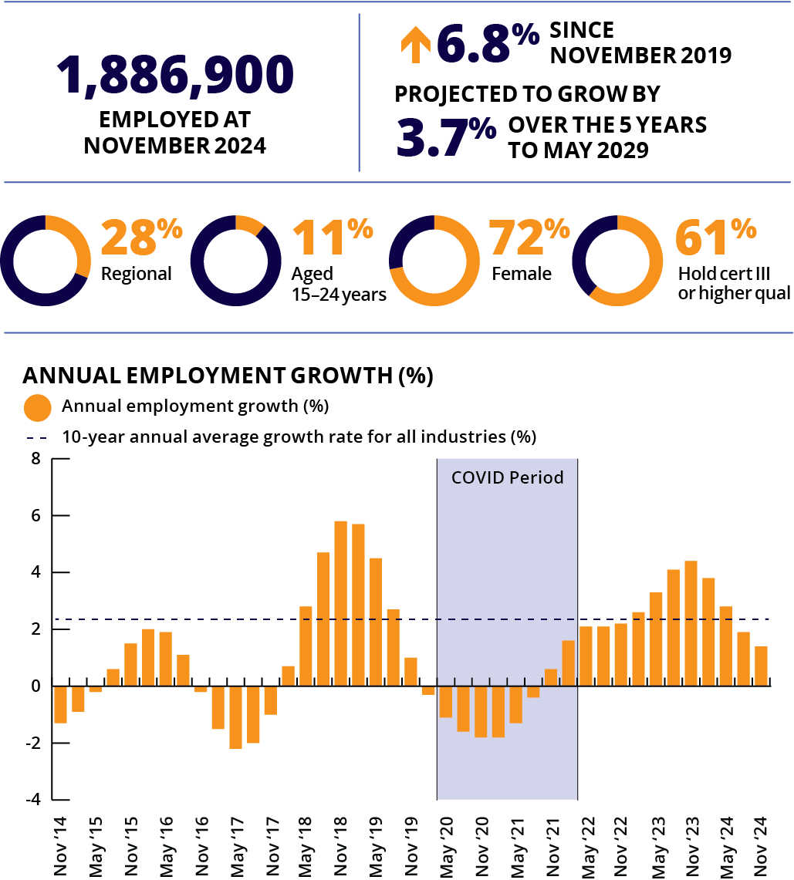
Note: Caution is recommended when using employment estimates from May 2020 to February 2022 inclusive.
Top employing occupations
1 | General Clerks | 283,300
2 | Receptionists | 190,600
3 | Contract, Program and Project Administrators | 170,500
4 | Accounting Clerks | 147,400
5 | Office Managers | 126,800
Clerical and Administrative Workers provide support to businesses by organising, storing, manipulating and retrieving information.
Clerical and Administrative Workers employment grew by 1.4% over the past year, with Clerical and Administrative Workers making up around 13% of national employment. A large share of this workforce is female (72%), the largest female share of any major occupation group.
JSA Internet Vacancy Index data showed online job vacancies for Clerical and Administrative Workers declined by 16.6% over the 12 months to December 2024, but these roles still make up around 15% of total online job vacancies.

Sales Workers
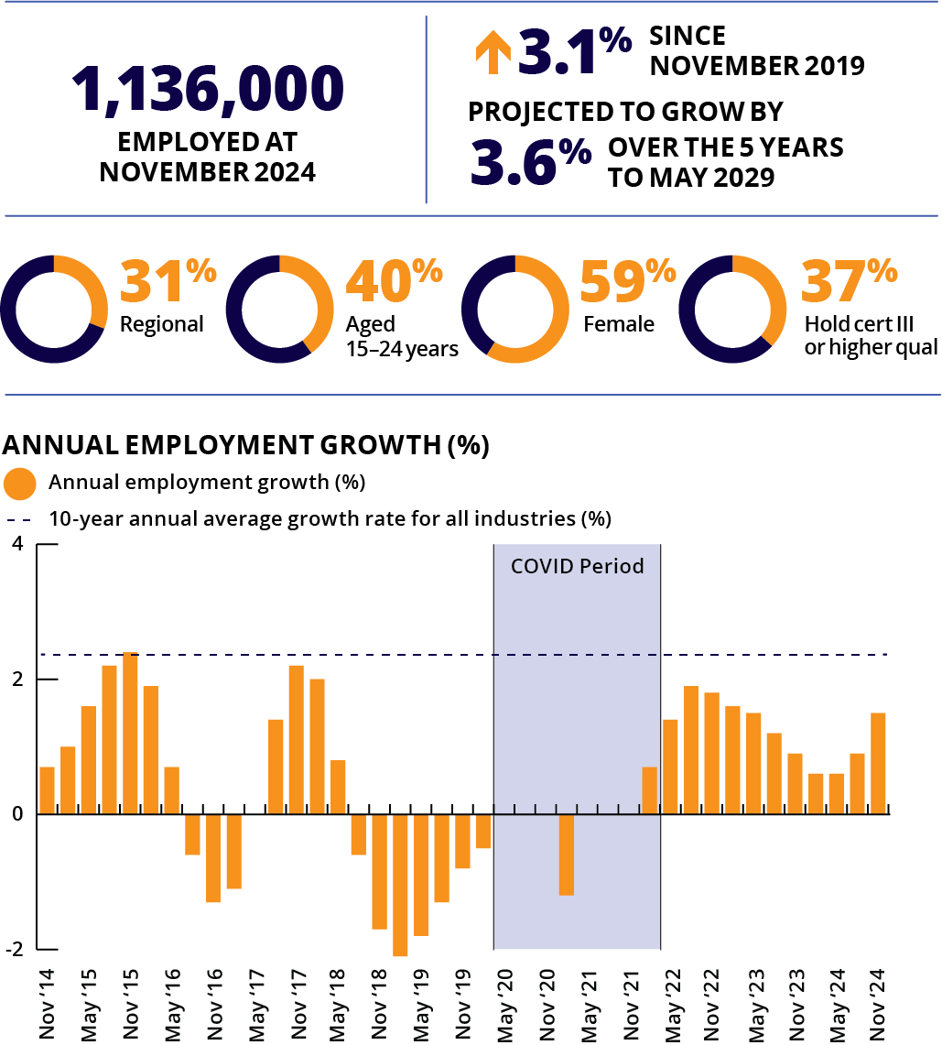
Note: Caution is recommended when using employment estimates from May 2020 to February 2022 inclusive. Data has been suppressed for some quarters during this period.
Top employing occupations
1 | Sales Assistants (General) | 552,100
2 | Checkout Operators and Office Cashiers | 125,600
3 | Real Estate Sales Agents | 107,800
4 | Sales Representatives | 76,900
5 | Retail Supervisors | 44,200
Sales Workers sell goods, services and property, and provide sales support.
Sales Workers employment grew by 1.5% over the past year. Over the past 10 years, employment growth of these workers has been modest, rising by less than 4% over the decade. Despite this, Sales Workers continue to make up a large share of national employment (around 8%), with more than 1.1 million Sales Workers employed in Australia.
Around 40% of these workers are aged 15 to 24 years, with Sales Workers having the largest share of young workers of any occupation major group. A Sales Worker job is often a person’s first job, with post-school education often not required and part-time work common (almost 60% of Sales Workers are employed part-time).
JSA Internet Vacancy Index data showed online job vacancies for Sales Workers declined by 14.8% over the 12 months to December 2024, but these roles still make up around 8% of total online job vacancies.
ABS, Labour Force, Australia, Detailed, November 2024; ABS, Education and Work, Australia, 2024; ABS, Job Vacancies, Australia, November 2024; Employment Projections produced by Victoria University for Jobs and Skills Australia, 2024 (May 2024 to May 2034); Jobs and Skills Australia, Occupation Shortage List, 2024

Machinery Operators and Drivers
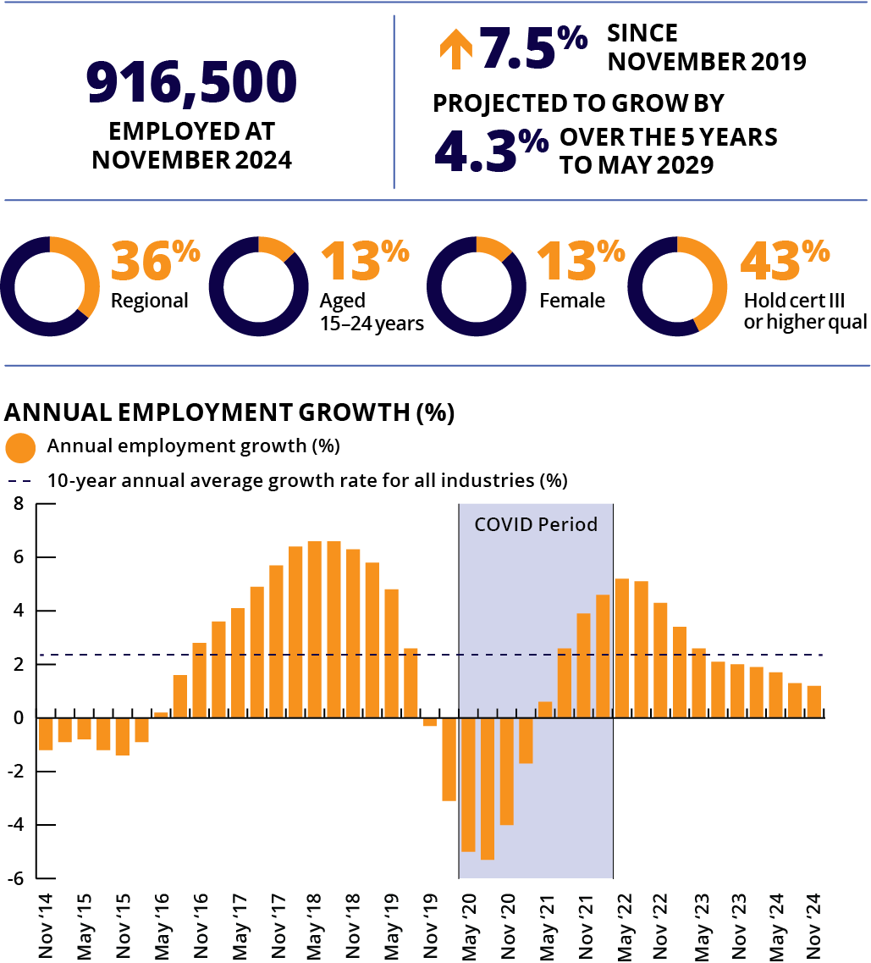
Note: Caution is recommended when using employment estimates from May 2020 to February 2022 inclusive.
Top employing occupations
1 | Truck Drivers | 181,300
2 | Storepersons | 171,800
3 | Delivery Drivers | 88,600
4 | Forklift Drivers | 72,800
5 | Drillers, Miners and Shot Firers | 64,600
Machinery Operators and Drivers operate machines, vehicles and other equipment to perform a range of agricultural, manufacturing and construction functions, move materials, and to transport passengers and freight.
Employment of these workers grew by 1.2% over the past year, with Machinery Operators and Drivers making up around 6% of national employment.
JSA Internet Vacancy Index data showed that online job vacancies for Machinery Operators and Drivers declined by 13.3% over the 12 months to December 2024 and that these roles make up around 6% of total online job vacancies.
A number of large-employing Machinery Operator and Driver occupations currently have a skills shortage, including Truck Drivers, Earthmoving Plant Operators, and Drillers, Miners and Shot Firers, and Crane, Hoist and Lift Operators.

Labourers
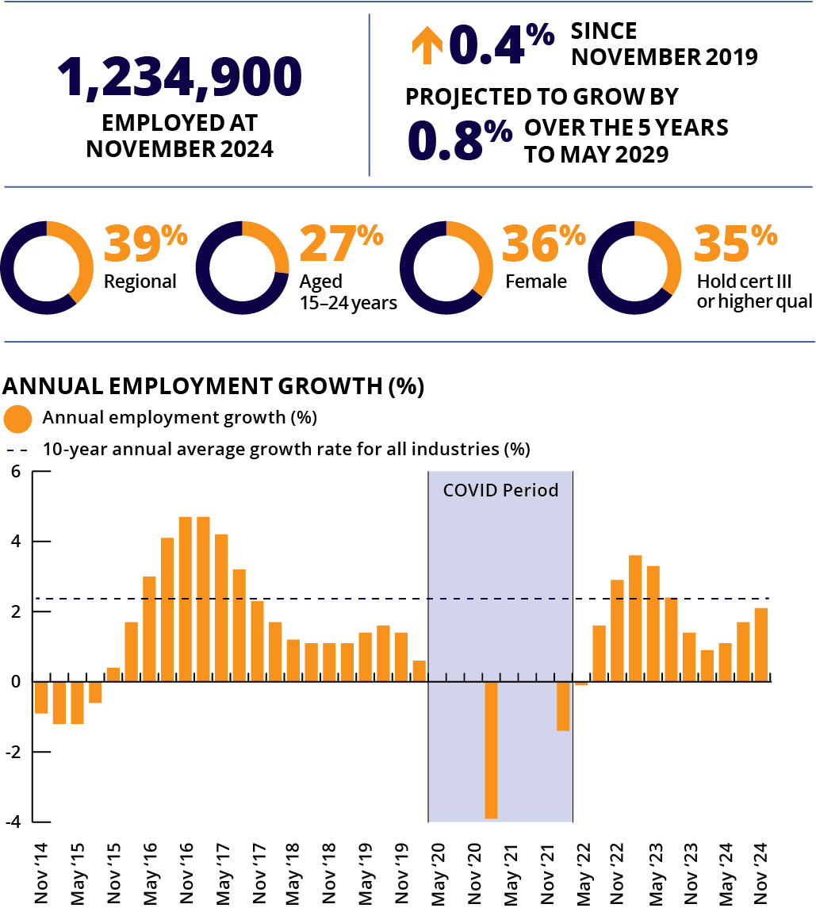
Note: Caution is recommended when using employment estimates from May 2020 to February 2022 inclusive. Data has been suppressed for some quarters during this period.
Top employing occupations
1 | Kitchenhands | 153,000
2 | Commercial Cleaners | 150,000
3 | Shelf Fillers | 73,400
4 | Building and Plumbing Labourers | 71,900
5 | Other Miscellaneous Labourers | 68,000
Labourers perform a variety of routine and repetitive physical tasks. Some Labourer jobs require physical fitness (like Building and Plumbing Labourers) but not all involve heavy work (for example, Fast Food Cooks).
Labourers employment grew by 2.1% over the past year, with these workers making up around 9% of national employment.
JSA Internet Vacancy Index data showed online job vacancies for Labourers declined by 17.4% over the 12 months to December 2024, but these roles still make up around 6% of total online job vacancies.
ABS, Labour Force, Australia, Detailed, November 2024; ABS, Education and Work, Australia, 2024; ABS, Job Vacancies, Australia, November 2024; Employment Projections produced by Victoria University for Jobs and Skills Australia, 2024 (May 2024 to May 2034); Jobs and Skills Australia, Occupation Shortage List, 2024

Occupation Matrix

Guide to the Occupation Matrix

How do I use the Matrix?
Employment and training decisions should be made after consideration of all relevant issues, including aptitude, interests, expectations about pay and working conditions, training requirements and goals.
The Occupation Matrix (the Matrix) includes summary statistical information for around 320 occupations, which can provide useful background, but it needs to be read in conjunction with other occupational resources.
Titles in the Matrix have been grouped into broad categories based on field of work to assist users to better explore the labour market.
There are 21 groupings.
- Accounting, Banking and Financial Services
- Administration and Human Resources
- Advertising, Public Relations, Media and Arts
- Agriculture, Animal and Horticulture
- Automotive, Transport and Logistics
- Construction, Architecture and Design
- Education and Training
- Electrical and Electronics
- Engineers and Engineering Trades
- Executive and General Management
- Government, Defence and Protective Services
- Health and Community Services
- Hospitality, Food Services and Tourism
- Information and Communication Technology (ICT)
- Legal and Insurance
- Manufacturing
- Mining and Energy
- Personal Services
- Sales, Retail, Wholesale and Real Estate
- Science
- Sports and Recreation
Some titles appear in more than one category.
The relevant occupation major group is listed in brackets after each occupation title. These refer to the groups on pages 106 to 126.
Key | Occupation
M | Managers
P | Professionals
TT | Technicians and Trades Workers
CP | Community and Personal Service Workers
CA | Clerical and Administrative Workers
SW | Sales Workers
MO | Machinery Operators and Drivers
L | Labourers

Employment and employment change
Employment information gives the total number of people employed in the occupation at November 2024. It includes both full-time and part-time workers.
Employment change refers to levels of employment increasing or decreasing, as well as the percentage change, over the 5 years to November 2024.
Data Source: ABS, Labour Force Survey, Detailed, November 2024, data trended by Jobs and Skills Australia

Working part-time
This column shows the proportion of workers in the occupation who work part-time. The information uses the ABS definition of part-time, which is working less than 35 hours per week.
Data Source: ABS, Labour Force, Detailed (2025 custom report), 2024 annual averages of original data

Female
This shows the proportion of those employed in the occupation who are female.
Data Source: ABS, Labour Force, Detailed (2025 custom report), 2024 annual averages of original data

Aged 15 to 24 years
This shows the proportion of those employed in the occupation who are aged 15 to 24 years.
Data Source: ABS, Labour Force, Detailed (2025 custom report), 2024 annual averages of original data

Unemployment rate
The unemployment rate is the number of unemployed persons as a percentage of the labour force (employed plus unemployed). The unemployment rate is presented in 3 categories: below average, average and above average. These categories are based on the occupation’s average unemployment rate in 2024 relative to the average across all occupations. Occupational unemployment rates do not reflect underutilised skills (such as an Accountant working as an Accounting Clerk).
The occupational unemployment rate may be lower than the published national unemployment rate as it does not include first-time job seekers and those who have not worked full-time or part-time in the past 2 years. An occupation may have a high unemployment rate but also be experiencing shortages for particular skills.
Data Source: ABS, Labour Force, Detailed (2025 custom report), 2024 annual averages of original data

Median earnings
Median weekly earnings are before tax and are for full-time workers. The median earnings ranges are for all ages and levels of experience. They are indicative only and cannot be used to determine what a worker will actually earn. Data are not available for all occupations.
Key | Median weekly earnings
$ | <1250
$$ | 1250–1530
$$$ | 1531–1900
$$$$ | 1901–2460
$$$$$ | >2460
Data Source: ABS Survey of Employee Earnings and Hours, May 2023 (2023 custom report)

Skill level
Skill level reflects the range and complexity of the set of tasks performed in a particular occupation. The greater the range and complexity of the set of tasks, the greater the amount of formal education and training, and the greater the skill level of an occupation. There are 5 skill levels within the occupation classification.
- Skill Level 1 is commensurate with a Bachelor degree or higher qualification
- Skill Level 2 is commensurate with an Advanced Diploma or Diploma
- Skill Level 3 is commensurate with a Certificate IV or III (including at least 2 years’ on-the-job training)
- Skill Level 4 is commensurate with a Certificate II or III
- Skill Level 5 is commensurate with a Certificate I or secondary education.

Projected employment change
This presents the percentage change in employment projected over the 5 years to May 2029.
A large projected percentage growth in a small occupation can yield fewer new jobs than low projected growth in large occupations.
- For example, 20% projected growth in an occupation that employs 300 people will likely result in 60 new jobs. However, 5% projected growth in an occupation that employs 10,000 people will likely result in 500 new jobs.
These estimates do not provide any guidance about the number of job seekers in each occupation. Although there may be a large number of new jobs, there may be strong applicant competition for available positions.
Data Source: Employment Projections produced by Victoria University for Jobs and Skills Australia

Skills Australia
 | Employ’t Nov 2024 | 5 year change to Nov 2024 |  | Working part-time | Female | Aged 15 to 24 years | Unemploy’t rate 2024 | Median earnings | Skill level | Projected employ’t change 5 years to May 2029
Occupation | ‘000 | ‘000 | % | % | % | % |  |  |  | %
Roof Tilers (TT) | 11.0 | 1.2 | 12.5 | 14 | 4 | 26 | Below Average | - | 3 | 0.3
Safety Inspectors (TT) | 7.4 | 1.8 | 31.5 | 8 | 20 | 1 | Average | $$$$$ | 2 | 4.3
Structural Steel Construction Workers (L) | 25.7 | 1.0 | 4.2 | 9 | 1 | 13 | Above Average | $$$$$ | 4 | 1.0
Urban and Regional Planners (P) | 20.1 | 5.2 | 34.8 | 14 | 46 | 2 | Average | $$$$ | 1 | 8.2
Wall and Floor Tilers (TT) | 21.6 | 0.2 | 1.0 | 11 | 3 | 13 | Average | - | 3 | 2.0
Education and Training
Driving Instructors (CP) | 6.1 | 0.2 | 4.0 | 49 | 17 | 0 | Below Average | - | 3 | 4.5
Early Childhood (Pre-primary School) Teachers (P) | 73.1 | 26.7 | 57.4 | 50 | 97 | 9 | Average | $$$ | 1 | 3.0
Education Advisers and Reviewers (P) | 24.8 | -0.3 | -1.3 | 26 | 71 | 0 | Below Average | $$$$$ | 1 | 7.4
Education Aides (CP) | 133.3 | 31.6 | 31.1 | 69 | 86 | 16 | Below Average | $ | 4 | 5.5
Librarians (P) | 11.2 | -1.1 | -9.0 | 31 | 66 | 5 | Below Average | $$$ | 1 | 16.9
Library Assistants (CA) | 6.8 | -0.2 | -2.6 | 68 | 86 | 23 | Below Average | $$ | 4 | 1.2
Primary School Teachers (P) | 164.6 | 4.4 | 2.7 | 35 | 85 | 6 | Below Average | $$$$ | 1 | 2.9
Private Tutors and Teachers (P) | 45.1 | 1.4 | 3.2 | 80 | 66 | 39 | Average | $$$ | 1 | 6.8
School Principals (M) | 29.7 | 5.2 | 21.1 | 5 | 65 | 0 | Below Average | - | 1 | 6.2
Secondary School Teachers (P) | 145.9 | 7.5 | 5.4 | 22 | 62 | 4 | Below Average | $$$$ | 1 | 2.9
Special Education Teachers (P) | 29.7 | 4.8 | 19.1 | 36 | 83 | 6 | Below Average | $$$$ | 1 | 4.2
Teachers of English to Speakers of Other Languages (P) | 3.9 | -0.3 | -8.1 | 76 | 89 | 0 | Average | $$$$ | 1 | 7.5
Training and Development Professionals (P) | 32.9 | 9.8 | 42.5 | 19 | 53 | 7 | Average | $$$$ | 1 | 8.1
University Lecturers and Tutors (P) | 65.8 | 7.3 | 12.4 | 29 | 49 | 4 | Average | $$$$$ | 1 | 13.2
Vocational Education Teachers (P) | 36.1 | 3.3 | 10.1 | 30 | 44 | 3 | Below Average | $$$ | 1 | 11.1
Electrical and Electronics
Airconditioning and Refrigeration Mechanics (TT) | 26.1 | -2.2 | -7.6 | 7 | 2 | 23 | Below Average | $$$$ | 3 | 0.6
Electrical Distribution Trades Workers (TT) | 10.6 | 1.2 | 13.1 | 3 | 3 | 8 | Below Average | $$$$$ | 3 | 1.1
Electrical Engineering Draftspersons and Technicians (TT) | 10.2 | 0.2 | 1.6 | 8 | 0 | 8 | Average | $$$$$ | 2 | 4.9
Electrical Engineers (P) | 28.8 | 7.0 | 32.2 | 8 | 12 | 8 | Below Average | - | 1 | 10.7
Electricians (TT) | 185.2 | 30.4 | 19.6 | 7 | 4 | 29 | Below Average | $$$$ | 3 | 7.0
Electronic Engineering Draftspersons and Technicians (TT) | 5.5 | -0.5 | -7.9 | 13 | 12 | 4 | Above Average | $$$$$ | 2 | 2.4
Electronics Engineers (P) | 6.3 | 0.3 | 5.3 | 14 | 14 | 11 | Below Average | $$$ | 1 | 8.8
Electronics Trades Workers (TT) | 32.0 | 4.2 | 15.0 | 18 | 7 | 9 | Below Average | $$ | 3 | 0.1
Engineers and Engineering Trades
Aircraft Maintenance Engineers (TT) | 10.2 | -0.9 | -8.5 | 7 | 5 | 8 | Average | $$$$ | 3 | 4.4
Chemical and Materials Engineers (P) | 7.0 | 1.1 | 17.9 | 7 | 22 | 9 | Below Average | - | 1 | 10.5
Civil Engineering Professionals (P) | 72.3 | 14.3 | 24.6 | 10 | 17 | 12 | Below Average | $$$$ | 1 | 11.3
Electrical Engineers (P) | 28.8 | 7.0 | 32.2 | 8 | 12 | 8 | Below Average | - | 1 | 10.7
Electronics Engineers (P) | 6.3 | 0.3 | 5.3 | 14 | 14 | 11 | Below Average | $$$ | 1 | 8.8
Engineering Managers (M) | 33.5 | 9.8 | 41.4 | 9 | 17 | 1 | Below Average | $$$$$ | 1 | 8.4
Industrial, Mechanical and Production Engineers (P) | 38.5 | 3.4 | 9.7 | 8 | 7 | 4 | Below Average | $$$$ | 1 | 8.6
Mechanical Engineering Draftspersons and Technicians (TT) | 5.9 | 0.7 | 14.0 | 12 | 14 | 2 | Average | $$$ | 2 | 2.4
Metal Casting, Forging and Finishing Trades Workers (TT) | 3.1 | -0.6 | -16.1 | 14 | 21 | 35 | Above Average | - | 3 | -1.0
Metal Fitters and Machinists (TT) | 122.2 | 9.7 | 8.6 | 5 | 4 | 17 | Below Average | $$$$ | 3 | 0.5
Mining Engineers (P) | 15.2 | 3.8 | 33.6 | 7 | 11 | 10 | Above Average | $$$$$ | 1 | 9.3
Precision Metal Trades Workers (TT) | 7.5 | 0.1 | 1.5 | 12 | 13 | 20 | Below Average | - | 3 | 0.5
Sheetmetal Trades Workers (TT) | 6.0 | 0.0 | -0.2 | 7 | 0 | 16 | Average | $$ | 3 | -2.0
Structural Steel and Welding Trades Workers (TT) | 77.4 | 1.4 | 1.9 | 4 | 2 | 20 | Average | $$$ | 3 | -1.4
Telecommunications Engineering Professionals (P) | 13.3 | -0.7 | -4.7 | 6 | 21 | 2 | Average | $$$$$ | 1 | 12.9
Toolmakers and Engineering Patternmakers (TT) | 3.8 | 0.6 | 18.6 | 13 | 0 | 0 | Below Average | - | 3 | -2.7
Executive and General Management
Chief Executives and Managing Directors (M) | 55.8 | 9.4 | 20.2 | 14 | 30 | 1 | Below Average | - | 1 | 5.8
General Managers (M) | 71.5 | 18.2 | 34.1 | 11 | 38 | 2 | Below Average | - | 1 | 5.5
Policy and Planning Managers (M) | 38.3 | 13.9 | 56.8 | 10 | 56 | 0 | Average | $$$$$ | 1 | 11.9
Research and Development Managers (M) | 18.4 | 4.7 | 34.0 | 17 | 60 | 2 | Average | $$$$ | 1 | 13.7
Government, Defence and Protective Services
Commissioned Officers (Management) (M) | 4.1 | 0.1 | 1.2 | 9 | 29 | 32 | Below Average | - | 1 | 7.9
Fire and Emergency Workers (CP) | 17.5 | 0.6 | 3.3 | 6 | 7 | 4 | Average | $$$$ | 3 | 4.7
Inspectors and Regulatory Officers (CA) | 46.9 | 13.1 | 38.9 | 11 | 44 | 9 | Below Average | $$$ | 4 | 1.2
Intelligence and Policy Analysts (P) | 43.1 | 13.7 | 46.7 | 19 | 65 | 7 | Average | $$$$ | 1 | 14.8
Police (CP) | 67.1 | 0.4 | 0.5 | 6 | 29 | 8 | Below Average | $$$$ | 2 | 4.1
Prison Officers (CP) | 20.1 | -0.8 | -4.0 | 5 | 24 | 4 | Average | $$$ | 4 | 3.2
Security Officers and Guards (CP) | 65.2 | 8.1 | 14.2 | 23 | 17 | 11 | Above Average | $$$ | 4 | 4.7
Health and Community Services
Aged and Disabled Carers (CP) | 344.4 | 137.7 | 66.7 | 60 | 76 | 13 | Average | $$$ | 4 | 16.7
Ambulance Officers and Paramedics (CP) | 26.6 | 8.1 | 43.9 | 14 | 44 | 7 | Average | $$$$$ | 2 | 9.0
Anaesthetists (P) | 6.9 | 2.3 | 48.8 | 13 | 33 | 0 | Below Average | - | 1 | 15.2
Child Care Centre Managers (M) | 19.7 | 3.4 | 20.7 | 24 | 94 | 5 | Below Average | $$ | 1 | 6.3
Child Carers (CP) | 170.7 | 29.5 | 20.9 | 55 | 94 | 30 | Average | $ | 3 | -1.1
Chiropractors and Osteopaths (P) | 7.2 | 0.6 | 9.7 | 40 | 45 | 6 | Below Average | - | 1 | 17.7
Counsellors (P) | 34.3 | 5.3 | 18.2 | 40 | 71 | 4 | Average | $$ | 1 | 15.3
Dental Assistants (CP) | 26.3 | -0.7 | -2.6 | 55 | 97 | 35 | Average | $ | 4 | 14.3
Dental Hygienists, Technicians and Therapists (CP) | 7.7 | 0.4 | 5.9 | 34 | 61 | 8 | Below Average | $$$ | 1 | 3.3
Dental Practitioners (P) | 21.2 | 5.7 | 36.7 | 37 | 52 | 4 | Below Average | $$$$$ | 1 | 17.6
Enrolled and Mothercraft Nurses (CP) | 19.4 | -5.1 | -20.9 | 52 | 84 | 13 | Average | $$$ | 2 | 10.0
Generalist Medical Practitioners (P) | 87.5 | 21.2 | 32.0 | 22 | 48 | 2 | Below Average | $$$$$ | 1 | 15.1
Health and Welfare Services Managers (M) | 41.5 | 13.8 | 49.6 | 18 | 71 | 3 | Below Average | $$$$ | 1 | 16.2
Massage Therapists (CP) | 21.1 | 2.8 | 15.1 | 67 | 77 | 4 | Below Average | $$ | 2 | 8.7
Medical Imaging Professionals (P) | 22.9 | 4.2 | 22.7 | 34 | 74 | 5 | Below Average | $$$$ | 1 | 16.4
Medical Technicians (TT) | 39.0 | 6.8 | 21.2 | 38 | 72 | 12 | Below Average | $$ | 2 | 6.2
Midwives (P) | 19.9 | 0.1 | 0.6 | 52 | 99 | 9 | Below Average | $$$$ | 1 | 11.1
Ministers of Religion (P) | 19.7 | 0.4 | 2.2 | 34 | 32 | 3 | Below Average | $$ | 1 | 12.1
Nurse Educators and Researchers (P) | 8.6 | 1.1 | 14.4 | 41 | 89 | 1 | Average | $$$$ | 1 | 10.5
Nurse Managers (P) | 20.0 | 0.5 | 2.6 | 23 | 90 | 3 | Below Average | $$$$$ | 1 | 11.2
Nursing Support and Personal Care Workers (CP) | 103.5 | 10.2 | 10.9 | 57 | 76 | 14 | Average | $$ | 4 | 16.0
Nutrition Professionals (P) | 10.4 | 2.0 | 24.0 | 56 | 86 | 5 | Below Average | $$$$ | 1 | 15.6
Occupational & Environmental Health Professionals (P) | 39.2 | 11.1 | 39.4 | 11 | 46 | 5 | Average | $$$$ | 1 | 10.6
Occupational Therapists (P) | 29.6 | 9.4 | 46.7 | 37 | 89 | 7 | Below Average | $$ | 1 | 17.2
Optometrists and Orthoptists (P) | 9.6 | 2.3 | 30.9 | 25 | 58 | 17 | Below Average | $$$$ | 1 | 16.4
Personal Care Consultants (CP) | 5.0 | -0.6 | -11.1 | 69 | 78 | 11 | Below Average | - | 4 | 9.8
Pharmacists (P) | 41.7 | 10.7 | 34.3 | 35 | 66 | 10 | Below Average | $$$$ | 1 | 10.8
Physiotherapists (P) | 45.8 | 16.7 | 57.3 | 34 | 56 | 6 | Below Average | $$$ | 1 | 17.6
Podiatrists (P) | 5.9 | 0.5 | 8.8 | 35 | 48 | 13 | Below Average | - | 1 | 17.7
Practice Managers (CA) | 31.0 | 5.9 | 23.4 | 37 | 85 | 4 | Below Average | $$$ | 2 | 7.0
Psychiatrists (P) | 5.4 | 1.9 | 55.1 | 36 | 55 | 0 | Below Average | - | 1 | 14.9
Psychologists (P) | 51.3 | 20.0 | 64.0 | 46 | 84 | 3 | Below Average | $$$$ | 1 | 16.1
Registered Nurses (P) | 346.7 | 56.2 | 19.3 | 45 | 87 | 9 | Below Average | $$$$ | 1 | 11.3
Social Professionals (P) | 16.1 | 1.7 | 12.0 | 44 | 71 | 2 | Above Average | $$$ | 1 | 12.3
Social Workers (P) | 46.3 | 11.1 | 31.7 | 32 | 83 | 5 | Below Average | $$$ | 1 | 16.4
Specialist Physicians (P) | 15.4 | 5.2 | 51.0 | 16 | 47 | 0 | Average | $$$$$ | 1 | 15.1
Speech Pathologists and Audiologists (P) | 20.1 | 9.0 | 81.5 | 38 | 90 | 8 | Below Average | $$$$ | 1 | 16.6
Surgeons (P) | 10.8 | 3.8 | 54.8 | 14 | 21 | 0 | Below Average | - | 1 | 15.2
Welfare Support Workers (CP) | 96.4 | 33.5 | 53.1 | 33 | 69 | 7 | Above Average | $$$ | 2 | 8.4
Welfare, Recreation and Community Arts Workers (P) | 41.6 | 7.5 | 22.1 | 33 | 68 | 9 | Average | $$$$ | 1 | 15.2
Hospitality, Food Services and Tourism
Bakers and Pastrycooks (TT) | 33.0 | 1.1 | 3.3 | 28 | 39 | 17 | Below Average | $$ | 3 | 4.3
Bar Attendants and Baristas (CP) | 119.0 | 15.6 | 15.1 | 69 | 55 | 59 | Above Average | $ | 4 | 7.9
Butchers and Smallgoods Makers (TT) | 14.2 | -2.1 | -12.9 | 13 | 11 | 17 | Above Average | - | 3 | 6.4
Cafe and Restaurant Managers (M) | 67.4 | -0.7 | -1.1 | 23 | 57 | 12 | Below Average | $$ | 2 | 3.7
Cafe Workers (CP) | 34.2 | 5.0 | 17.0 | 77 | 77 | 56 | Above Average | $ | 5 | 7.8
Caravan Park and Camping Ground Managers (M) | 3.3 | 0.8 | 32.9 | 4 | 53 | 0 | Below Average | - | 2 | 1.2
Chefs (TT) | 125.3 | 20.7 | 19.8 | 22 | 26 | 14 | Average | $$ | 2 | 8.0
Conference and Event Organisers (M) | 31.8 | -0.8 | -2.4 | 22 | 71 | 16 | Above Average | $$$ | 2 | 6.8
Cooks (TT) | 39.8 | 0.0 | 0.1 | 63 | 58 | 28 | Above Average | $ | 3 | 7.9
Fast Food Cooks (L) | 49.0 | -0.3 | -0.7 | 84 | 33 | 79 | Above Average | $ | 5 | 4.7
Food Trades Assistants (L) | 5.1 | -0.1 | -1.2 | 60 | 69 | 44 | Below Average | - | 5 | 2.2
Gallery, Museum and Tour Guides (CP) | 6.2 | -0.5 | -8.0 | 49 | 70 | 7 | Above Average | - | 3 | 4.0
Gaming Workers (CP) | 5.9 | -0.1 | -2.2 | 43 | 29 | 16 | Below Average | $$ | 4 | 8.5
Hotel and Motel Managers (M) | 19.9 | 0.6 | 3.1 | 16 | 41 | 4 | Average | - | 2 | 2.7
Hotel Service Managers (CP) | 10.8 | 3.3 | 44.3 | 33 | 62 | 23 | Below Average | $$ | 2 | 7.1
Kitchenhands (L) | 153.0 | 12.0 | 8.5 | 80 | 54 | 54 | Above Average | $$ | 5 | 5.4
Licensed Club Managers (M) | 6.7 | 0.0 | 0.8 | 12 | 36 | 16 | Average | - | 2 | 3.5
Tourism and Travel Advisers (CP) | 19.1 | -1.1 | -5.6 | 25 | 78 | 6 | Average | $$ | 3 | 4.3
Travel Attendants (CP) | 9.6 | -0.6 | -5.9 | 36 | 69 | 20 | Average | $$ | 3 | 11.9
Waiters (CP) | 125.9 | -7.9 | -5.9 | 84 | 72 | 68 | Above Average | $ | 4 | 8.0
Information and Communication Technology (ICT)
Computer Network Professionals (P) | 43.6 | 4.9 | 12.7 | 4 | 15 | 3 | Below Average | $$$$ | 1 | 14.7
Database and Systems Administrators, and ICT Security Specialists (P) | 72.6 | 23.7 | 48.5 | 6 | 24 | 4 | Below Average | $$$$ | 1 | 14.2
Graphic and Web Designers, and Illustrators (P) | 54.2 | -2.8 | -4.9 | 23 | 50 | 6 | Average | $$ | 1 | 9.7
ICT Business and Systems Analysts (P) | 49.4 | 12.2 | 32.7 | 6 | 34 | 5 | Above Average | $$$$$ | 1 | 14.1
ICT Managers (M) | 85.7 | 22.2 | 34.9 | 6 | 27 | 1 | Average | $$$$$ | 1 | 15.2
ICT Sales Professionals (P) | 20.0 | 4.1 | 25.5 | 7 | 33 | 2 | Average | $$$$$ | 1 | 15.4
ICT Support and Test Engineers (P) | 13.6 | 2.0 | 16.8 | 4 | 29 | 7 | Below Average | $$$$ | 1 | 15.0
ICT Support Technicians (TT) | 73.1 | 7.5 | 11.3 | 10 | 22 | 10 | Average | $$ | 2 | 8.9
ICT Trainers (P) | 3.0 | 0.2 | 8.6 | 20 | 24 | 1 | Above Average | - | 1 | 9.8
Multimedia Specialists and Web Developers (P) | 15.0 | 2.4 | 19.4 | 8 | 21 | 5 | Average | $$$$ | 1 | 15.1
Software and Applications Programmers (P) | 189.1 | 57.8 | 44.0 | 6 | 18 | 7 | Average | $$$$$ | 1 | 14.8
Telecommunications Trades Workers (TT) | 19.4 | -4.2 | -17.8 | 10 | 3 | 2 | Average | $$$ | 3 | 0.0
Legal and Insurance
Actuaries, Mathematicians and Statisticians (P) | 11.8 | 1.5 | 14.4 | 9 | 48 | 1 | Average | $$$$ | 1 | 18.7
Barristers (P) | 9.2 | -0.7 | -7.3 | 13 | 35 | 8 | Below Average | - | 1 | 11.7
Conveyancers and Legal Executives (CA) | 19.6 | 4.3 | 28.3 | 40 | 84 | 34 | Below Average | $$ | 2 | 4.2
Court and Legal Clerks (CA) | 18.5 | 3.6 | 24.2 | 35 | 76 | 29 | Below Average | $$ | 3 | 2.5
Insurance Agents (SW) | 17.0 | 4.3 | 34.0 | 19 | 53 | 12 | Below Average | $$ | 3 | -0.7
Insurance Investigators, Loss Adjusters and Risk Surveyors (CA) | 7.8 | 1.6 | 26.8 | 11 | 43 | 0 | Above Average | $$$ | 3 | 4.2
Solicitors (P) | 95.6 | 17.4 | 22.2 | 13 | 61 | 4 | Below Average | $$$ | 1 | 12.4
Manufacturing
Boat Builders and Shipwrights (TT) | 4.0 | -1.1 | -21.6 | 15 | 0 | 11 | Below Average | - | 3 | -3.9
Canvas and Leather Goods Makers (TT) | 1.3 | -0.8 | -38.6 | 0 | 26 | 0 | Below Average | - | 3 | -0.6
Clay, Concrete, Glass & Stone Processing Machine Operators (MO) | 2.3 | -0.9 | -28.9 | 9 | 0 | 0 | Below Average | $$ | 4 | -0.9
Clothing Trades Workers (TT) | 8.4 | 0.8 | 10.1 | 32 | 73 | 3 | Above Average | - | 3 | -1.7
Engineering Production Workers (MO) | 22.4 | 4.5 | 25.0 | 5 | 3 | 15 | Below Average | $$ | 4 | -0.6
Food and Drink Factory Workers (L) | 29.7 | -1.0 | -3.1 | 25 | 37 | 15 | Average | $$ | 5 | -0.4
Industrial Spraypainters (MO) | 6.3 | 0.0 | 0.0 | 7 | 5 | 5 | Above Average | $$$$ | 4 | -1.7
Manufacturers (M) | 21.9 | -1.9 | -7.9 | 17 | 18 | 4 | Average | - | 1 | 4.5
Meat Boners and Slicers, and Slaughterers (L) | 5.8 | -3.9 | -39.9 | 5 | 17 | 8 | Above Average | $$ | 4 | 0.2
Meat, Poultry and Seafood Process Workers (L) | 13.0 | -5.1 | -28.2 | 17 | 31 | 14 | Above Average | $ | 5 | 0.2
Metal Engineering Process Workers (L) | 9.2 | -0.4 | -4.4 | 20 | 8 | 21 | Below Average | $$ | 5 | -5.1
Packers (L) | 61.6 | -2.7 | -4.2 | 41 | 59 | 25 | Above Average | $ | 5 | 0.0
Paper and Wood Processing Machine Operators (MO) | 5.8 | -0.8 | -12.8 | 16 | 11 | 13 | Above Average | $$ | 4 | -0.8
Plastics and Rubber Factory Workers (L) | 2.0 | -0.5 | -19.5 | 22 | 28 | 36 | Below Average | $$$ | 5 | -6.9
Plastics and Rubber Production Machine Operators (MO) | 7.3 | -0.3 | -4.2 | 10 | 7 | 3 | Average | - | 4 | -2.8
Print Finishers and Screen Printers (TT) | 3.0 | -0.9 | -23.7 | 26 | 9 | 0 | Below Average | $$ | 3 | 0.3
Printers (TT) | 11.4 | -0.6 | -4.8 | 13 | 13 | 3 | Average | $$ | 3 | 0.7
Printing Assistants and Table Workers (L) | 2.3 | -0.1 | -2.5 | 44 | 40 | 20 | Above Average | $ | 4 | -4.0
Product Assemblers (L) | 22.3 | -5.2 | -18.8 | 18 | 29 | 14 | Above Average | $ | 5 | -5.1
Product Quality Controllers (L) | 12.4 | -0.4 | -3.4 | 13 | 37 | 10 | Above Average | $$ | 4 | -3.9
Production Managers (M) | 57.5 | -3.1 | -5.1 | 5 | 20 | 1 | Below Average | $$$$$ | 1 | 6.7
Sewing Machinists (MO) | 5.3 | -3.3 | -38.6 | 33 | 87 | 0 | Above Average | $ | 4 | -3.7
Textile & Footwear Production Machine Operators (MO) | 2.1 | 0.9 | 77.0 | 8 | 56 | 0 | Above Average | - | 4 | -2.4
Timber and Wood Process Workers (L) | 4.5 | -0.7 | -14.2 | 15 | 14 | 5 | Above Average | $ | 5 | -3.7
Upholsterers (TT) | 2.5 | -0.7 | -20.8 | 32 | 0 | 0 | Above Average | - | 3 | -3.0
Wood Machinists and Other Wood Trades Workers (TT) | 2.6 | -1.6 | -38.2 | 24 | 5 | 7 | Above Average | - | 3 | 1.3
Mining and Energy
Chemical, Gas, Petroleum and Power Generation Plant Operators (TT) | 9.5 | -0.6 | -5.5 | 5 | 13 | 1 | Below Average | $$$$$ | 3 | 3.0
Drillers, Miners and Shot Firers (MO) | 64.6 | 3.0 | 4.9 | 3 | 11 | 6 | Average | $$$$$ | 4 | -0.6
Geologists and Geophysicists (P) | 14.0 | 2.2 | 19.0 | 10 | 23 | 2 | Average | $$$$$ | 1 | 5.6
Mining Engineers (P) | 15.2 | 3.8 | 33.6 | 7 | 11 | 10 | Above Average | $$$$$ | 1 | 9.3
Personal Services
Beauty Therapists (CP) | 40.4 | 1.4 | 3.7 | 61 | 97 | 19 | Above Average | $ | 3 | 5.2
Car Detailers (L) | 18.1 | 0.2 | 1.3 | 43 | 8 | 19 | Above Average | $ | 5 | -2.1
Caretakers (L) | 7.2 | 1.0 | 15.9 | 40 | 32 | 0 | Below Average | $$ | 5 | 0.1
Commercial Cleaners (L) | 150.0 | -5.9 | -3.8 | 60 | 59 | 14 | Above Average | $ | 5 | -0.6
Domestic Cleaners (L) | 34.6 | -0.5 | -1.4 | 81 | 82 | 7 | Above Average | - | 5 | 0.1
Funeral Workers (CP) | 4.0 | 0.0 | -0.2 | 30 | 60 | 0 | Below Average | $$ | 2 | 5.2
Gardeners (TT) | 85.1 | 9.6 | 12.7 | 30 | 12 | 17 | Above Average | - | 3 | 4.0
Hairdressers (TT) | 62.8 | -1.7 | -2.6 | 48 | 77 | 17 | Average | $ | 3 | 1.1
Handypersons (L) | 44.9 | 3.1 | 7.4 | 46 | 8 | 6 | Below Average | $$ | 5 | 3.4
Housekeepers (L) | 33.4 | 5.6 | 20.1 | 75 | 83 | 18 | Above Average | $$ | 5 | -1.3
Laundry Workers (L) | 11.1 | -1.6 | -12.7 | 43 | 64 | 10 | Average | $ | 5 | 0.1
Sales, Retail, Wholesale and Real Estate
Advertising, Public Relations and Sales Managers (M) | 166.3 | 18.0 | 12.1 | 10 | 43 | 1 | Average | $$$$ | 1 | 9.4
Auctioneers, and Stock and Station Agents (SW) | 3.5 | -0.5 | -11.5 | 10 | 10 | 14 | Below Average | $$$ | 3 | -0.3
Checkout Operators and Office Cashiers (SW) | 125.6 | -29.5 | -19.0 | 82 | 69 | 62 | Above Average | $ | 5 | 1.7
Florists (TT) | 6.2 | -0.7 | -10.3 | 52 | 94 | 10 | Average | - | 3 | 1.7
ICT Sales Assistants (SW) | 16.9 | 1.5 | 9.5 | 28 | 26 | 19 | Average | $ | 5 | 5.4
Importers, Exporters and Wholesalers (M) | 18.5 | -3.3 | -15.2 | 23 | 32 | 2 | Below Average | $$$ | 1 | 9.9
Models and Sales Demonstrators (SW) | 10.9 | -1.5 | -11.8 | 67 | 69 | 11 | Below Average | - | 5 | 0.2
Motor Vehicle and Vehicle Parts Salespersons (SW) | 31.7 | -4.1 | -11.6 | 14 | 17 | 21 | Average | $$ | 4 | 3.7
Pharmacy Sales Assistants (SW) | 39.9 | 3.8 | 10.6 | 69 | 82 | 46 | Average | $ | 4 | 3.7
Real Estate Sales Agents (SW) | 107.8 | 14.5 | 15.6 | 18 | 50 | 6 | Below Average | $$ | 3 | 9.2
Retail and Wool Buyers (SW) | 8.2 | 0.9 | 11.7 | 5 | 72 | 1 | Below Average | $$ | 3 | -0.2
Retail Managers (M) | 250.3 | 21.5 | 9.4 | 19 | 49 | 11 | Below Average | $$ | 2 | 2.6
Retail Supervisors (SW) | 44.2 | 4.6 | 11.7 | 33 | 58 | 22 | Below Average | $$ | 4 | 3.9
Sales Assistants (General) (SW) | 552.1 | 82.2 | 17.5 | 75 | 64 | 54 | Above Average | $ | 5 | 4.0
Sales Representatives (SW) | 76.9 | -3.3 | -4.1 | 15 | 36 | 7 | Average | $$$ | 4 | -1.3
Service Station Attendants (SW) | 13.5 | 0.7 | 5.5 | 70 | 56 | 28 | Above Average | $$ | 5 | 3.7
Shelf Fillers (L) | 73.4 | 7.7 | 11.8 | 78 | 40 | 51 | Above Average | - | 5 | -2.2
Storepersons (MO) | 171.8 | 37.5 | 27.9 | 30 | 29 | 27 | Above Average | $ | 4 | 9.0
Street Vendors and Related Salespersons (SW) | 4.9 | -1.7 | -25.7 | 54 | 38 | 13 | Above Average | - | 5 | 5.0
Technical Sales Representatives (P) | 28.1 | -3.2 | -10.2 | 7 | 27 | 5 | Average | $$$$$ | 1 | 12.9
Telemarketers (SW) | 4.7 | -1.3 | -21.7 | 43 | 53 | 16 | Above Average | $ | 5 | 1.3
Ticket Salespersons (SW) | 21.4 | 1.9 | 9.5 | 46 | 63 | 22 | Below Average | $ | 5 | 1.5
Vending Machine Attendants (L) | 3.9 | -1.5 | -27.3 | 76 | 61 | 64 | Above Average | $$ | 5 | 1.3
Science
Agricultural and Forestry Scientists (P) | 9.4 | -0.2 | -1.7 | 18 | 30 | 8 | Below Average | $$$$ | 1 | 7.9
Chemists, and Food and Wine Scientists (P) | 10.2 | 0.7 | 6.9 | 13 | 43 | 11 | Below Average | $$$ | 1 | 5.9
Environmental Scientists (P) | 29.6 | 3.9 | 15.0 | 22 | 44 | 8 | Below Average | $$$ | 1 | 6.5
Geologists and Geophysicists (P) | 14.0 | 2.2 | 19.0 | 10 | 23 | 2 | Average | $$$$$ | 1 | 5.6
Life Scientists (P) | 9.9 | 0.9 | 9.9 | 21 | 51 | 5 | Average | $$$$ | 1 | 9.3
Medical Laboratory Scientists (P) | 29.5 | 4.1 | 16.3 | 25 | 65 | 6 | Below Average | $$$$ | 1 | 11.3
Science Technicians (TT) | 20.9 | 3.7 | 21.5 | 27 | 62 | 14 | Above Average | $$$ | 2 | 2.0
Surveyors and Spatial Scientists (P) | 17.2 | 2.2 | 15.0 | 7 | 12 | 4 | Below Average | $$$$ | 1 | 9.4
Sports and Recreation
Amusement, Fitness and Sports Centre Managers (M) | 19.8 | 5.6 | 39.6 | 26 | 38 | 15 | Below Average | $$$ | 2 | 6.4
Fitness Instructors (CP) | 36.4 | 2.3 | 6.9 | 68 | 63 | 19 | Below Average | $$ | 4 | 8.3
Greenkeepers (TT) | 13.0 | -2.8 | -17.6 | 20 | 4 | 22 | Below Average | $$ | 3 | 2.0
Outdoor Adventure Guides (CP) | 3.6 | -0.7 | -16.0 | 23 | 44 | 27 | Above Average | - | 3 | 7.4
Sports Coaches, Instructors and Officials (CP) | 54.6 | 6.7 | 14.0 | 80 | 57 | 62 | Above Average | $$ | 4 | 7.7
Sportspersons (CP) | 13.7 | 2.1 | 18.2 | 65 | 40 | 60 | Above Average | - | 3 | 7.5

Useful websites and links
Your Career
yourcareer.gov.au
The Your Career website assists Australians of all ages and circumstances better plan and manage their career. Your Career provides evidence-based careers information, resources and advice that provide education, training and career options. Visit the Your Career website to be connected to further education, training or work options to support your current career needs or goals.
ComparED
www.compared.edu.au
ComparED lets you explore and compare the quality of higher education institutions and study areas you are interested in, based on the experiences of current students and graduates.
Course Seeker
www.courseseeker.edu.au
Course Seeker helps potential students make informed decisions about future study. It provides clear, meaningful and transparent information about ATARs, pre-requisites and enrolment practices and policies of higher education providers across Australia.
What’s Next
whatsnext.dewr.gov.au
What’s Next? helps you decide what to do if you have been retrenched or are looking for a new career. There is help for finding a job, getting some training and looking after yourself. The choice is yours.
Australian Apprenticeships
apprenticeships.gov.au
The Australian Apprenticeships website provides information on apprenticeships and traineeships, including factsheets and links. An Australian Apprenticeship offers job seekers the opportunity to explore a new job, gain new skills, work flexible hours and receive a qualification. Eligible employers can receive financial incentives to help take on an apprentice, particularly if the apprenticeship is in a trade experiencing a skill shortage.
Workforce Australia
workforceaustralia.gov.au
Workforce Australia is the employment service delivered by the Department of Employment and Workplace Relations, and helps Australians find and keep a job, change jobs or create their own job. Workforce Australia includes a new online service and a network of providers to deliver personalised support.
Transition to Work
dewr.gov.au/transition-work
Transition to Work helps young people aged 15–24 into work (including apprenticeships and training) or education. Transition to Work participants receive intensive, pre-employment support to develop practical skills to get a job, connect with education or training, find local job opportunities and connect with relevant local community services.
Disability Employment Services
dss.gov.au/our-responsibilities/disability-and-carers/programmes-services/disability-employment-services
Disability Employment Services help people with disability find work and keep a job. Through Disability Employment Services, people with disability, injury or health condition may be able to receive assistance to prepare for, find and keep a job.
Community Development Program
niaa.gov.au/indigenous-affairs/employment/cdp
The Community Development Program (CDP) supports job seekers in remote Australia to build skills, address barriers to employment and contribute to their communities through a range of flexible activities. A new remote employment service will begin on 1 November 2025 to replace the CDP. The new remote employment service will support people who are currently looking for work or may need help to become job ready, to get the skills and resources they need to take up job opportunities, including those created through the Remote Jobs and Economic Development (RJED) program.
Jobs and Skills Atlas
jobsandskills.gov.au/jobs-and-skills-atlas-dashboard
The Jobs and Skills Atlas provides an overview of the labour market at national, state and regional level by occupations, skills and industries.
National Training Register
training.gov.au
Training.gov.au is the National Register on vocational education and training in Australia, and provides information on training packages, qualifications, courses, units of competency and Registered Training Organisations.
National Centre for Vocational Education Research
ncver.edu.au
The National Centre for Vocational Education Research (NCVER) is the national professional body responsible for collecting, managing, analysing and communicating research and statistics on the Australian VET sector.
Quality Indicators for Learning and Teaching
qilt.edu.au
Quality Indicators for Learning and Teaching (QILT) are a suite of government endorsed surveys for higher education, across the student life cycle from commencement to employment. QILT makes available robust, nationally consistent performance data for Australian higher education, helping drive quality improvement.
Sources
Data sources are referenced on each page of use throughout the publication. See below for further information.
Australian Bureau of Statistics (ABS)
abs.gov.au
Employment, employment change, and employment profile (female and part-time shares) data for states and territories and Australia are seasonally adjusted ABS data (ABS, Labour Force, Australia, November 2024, seasonally adjusted estimates).
Regional employment and employment change figures at the SA4 level are modelled estimates of ABS data (ABS, Labour Force, Australia, Detailed, November 2024, table MRM1 – Modelled estimates of labour force status by SA4).
Part-time and female employment shares for regional areas at the SA4 level are 6-month averages of original direct survey estimates (ABS, Labour Force, Australia, Detailed, November 2024, 6-month averages of original direct survey estimates).
Industry and occupation employment and employment change figures are ABS data trended by Jobs and Skills Australia (ABS, Labour Force, Australia, Detailed, November 2024, data trended by Jobs and Skills Australia).
Employment profile data for occupations and industries (female, part-time, regional, aged 15 to 24 years) are annual averages of original ABS data (ABS, Labour Force, Australia, Detailed, November 2024, annual averages of original data).
Annual employment change charts for occupation groups and industries use ABS data trended by Jobs and Skills Australia (ABS, Labour Force, Australia, Detailed, November 2024, data trended by Jobs and Skills Australia). Given large quarter-to-quarter changes (for industry and occupation data) during the COVID-19 pandemic, resulting in multiple trend breaks, the ABS recommends caution when using trend estimates during the period from May 2020 to February 2022 inclusive. Data have been suppressed for some quarters for during this period.
Educational attainment shares for industries, occupation groups, states, territories and Australia use data from ABS, Education and Work, 2024. The ‘no post-school qualification’ figures are for employed persons who have not completed education other than pre-primary, primary or secondary education. The ‘other qualification’ figures include – vocational education and training certificate I, II and not further defined; and level not determined.
Job vacancy data for industries are annual averages of original ABS data (ABS, Job Vacancies, Australia, November 2024).
Department of Education
education.gov.au/higher-education-statistics
Higher education enrolments data are for all students and providers (Department of Education, Higher Education Statistics, 2023 Student Data).
Quality Indicators for Learning and Teaching (QILT)
qilt.edu.au
Higher Education graduate employment outcomes are a proportion of those who were available for work when surveyed 4 to 6 months after completing their course (QILT, 2023 Graduate Outcomes Survey) and 3 years after completing their course (QILT, 2023 Graduate Outcomes Survey – Longitudinal).
National Centre for Vocational Education Research (NCVER)
ncver.edu.au
Vocational Education and Training (VET) enrolment data relate to program enrolments (that is, study for a qualification, course or skill set) (NCVER, Total VET students and courses 2023).
Vocational Education and Training student outcomes survey data are for students who completed their vocational education and training in the previous year, i.e. 2023 (NCVER, VET student outcomes 2024).
Jobs and Skills Australia (JSA)
jobsandskills.gov.au
Employment Projections are produced by Victoria University for Jobs and Skills Australia. Employment is projected from May 2024 to May 2029 and May 2034.
Occupation shortages are from research conducted by Jobs and Skills Australia in 2024. JSA defines an occupation shortage as when employers are unable to fill, or have considerable difficulty filling, vacancies for an occupation or cannot meet significant specialised skill needs within that occupation, at current levels of remuneration, at current conditions of employment, and in reasonably accessible locations (Jobs and Skills Australia, Occupation Shortage List, 2024).
Job vacancy data for occupations, states, territories and Australia are seasonally adjusted data from Jobs and Skills Australia (Jobs and Skills Australia, Internet Vacancy Index, December 2024, seasonally adjusted data). Job vacancy data for regions at the SA4 level are 3-month moving averages (Jobs and Skills Australia, Internet Vacancy Index, December 2024, 3-month average data).
Recruitment experiences data in the Job Search and Skills section are from employer surveys conducted by Jobs and Skills Australia (Jobs and Skills Australia, Recruitment Experiences and Outlook Survey, 2024).



